Run Me a Hypothesis Test

Topic Areas:
Hypothesis Testing
- Constructing a statistical test forusing a small sample
- Constructing a statistical test involving paired differences with dependent samples

Objectives:
- To provide practice in determining which type of hypothesis test to run given certain background information
- To provide practice towards understanding the meaning of “rejecting” or “failing to reject” a given hypothesis as it relates to the z or t value and the P value

Introduction:
This is a two part activity during which the students determine what type of hypothesis test to run given a problem and data. It will expose your students to using the list feature and collecting their own data. This activity could very easily be broken down into two separate activities and adjusted to meet the needs of the students. It utilizes the activity center within Navigator which allows for elevated accountability and authentic engagement in the classroom.

Prerequisites and Materials:
Prerequisites: These activities assume a basic understanding of hypothesis testing.
Materials: The Activity Settings Files located on the CD and rulers

Setting up the activities:
- Handout student worksheets
- Open TI-Navigator and begin class
- Have the students log on and go to the Activity Center
- From the TI-Navigator teacher home screen open the Activity Center, .

Activity 1: Constructing a statistical test forusing a small sample
Problem:
USA Today reported that the state with the longest mean life span is Hawaii, where the population mean life span is 77 years. A random sample of 20 obituary notices in the Honolulu Advertiser gave the following information about life span (in years) of Honolulu residents:
72 68 81 93 56 19 78 94 83 84
77 69 85 97 75 71 86 47 66 88
Assuming that life span in Honolulu is normally distributed; does this information indicate that the population mean life span for Honolulu residents is less than 77 years? Use a 5% level of significance.

Starting Activity 1:

- Clear activity data: Go to Edit>Clear Activity Data
- Load Activity Settings: Hypoth1.act by going to File>Load>Load Activity Settings
- Send the students the list by starting the activity
- Stop the activity once all of the students have received it 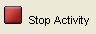

The list should appear on their screen. Have them exit NavNet by pressing   and
option 4: Exit App or the soft key quit (above ).

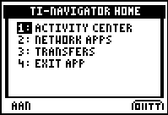

This will take them out of NavNet but not log them out. They can now go to their list and see the list that has been sent to them. Have them complete the student worksheet. Once all of the students have figured out which test to run and have run the test on their calculator. This is a great opportunity to use the Screen Capture Feature, .
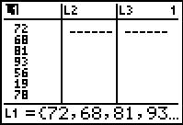 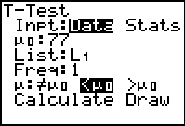 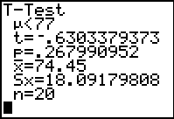

After you have completed Activity 1, have the students return to NavNet and the Activity Center.
Activity 2: Constructing a statistical test involving paired differences with dependent samples
Problem:
A shoe manufacturer claims that among the general adult population in the United States that the length of the left foot is longer than the length of the right foot. To compare the average length of the left foot with that of the right foot, we will take a random sample of adults and measure the length of the left foot and then the length of the right foot. Based on our sample, does the data indicate that the length of the left foot is greater than the length of the right foot? Use a 1% level of significance.

Starting Activity 2:

- Clear activity data: Go to Edit>Clear Activity Data
- Load Activity Settings: Hypoth2.act by going to File>Load>Load Activity Settings
- Send the students the blank list by starting the activity
- Instruct the students to measure both feet to the nearest centimeter. Have them place the length of their left foot in  and the length of their right foot in .
- Once they have done this have them send this back to you by pressing the soft key
Send (above □ ).
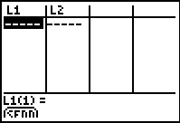
TI-Navigator (within Activity Center) will aggregate this list for you.

- Send the aggregated list back to the students by configuring (this will open a screen)
go down to students start with and check existing activity lists.

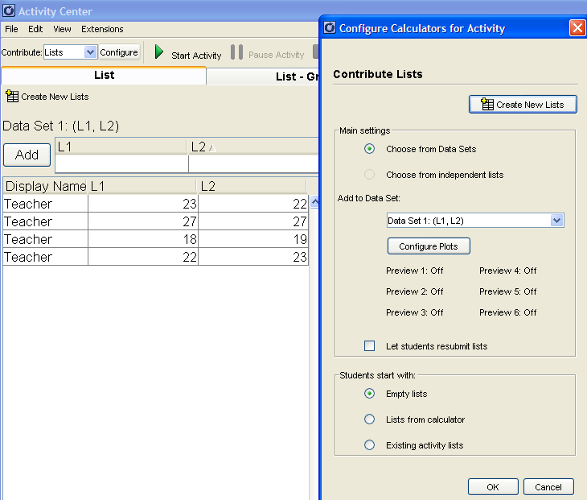

- Click OK and start the activity.
- Don’t forget to end the activity once all the students have received it. The list should appear on their screen. Have them exit NavNet by pressing   and option 4: Exit App or the soft key quit (above ).

Again, this will take them out of NavNet but not log them out. They can now go to their list and see the list that has been sent to them. Have them complete the student worksheet. Once all of the students have figured out which test to run and have run the test on their calculator, this is a great opportunity to use the Screen Capture Feature, .

