Solving Quadratic Equations by Graphing

The need for finding the roots of a quadratic equation may occur in different situations:

- find the roots of an equation.
- finding the x-intercepts of the graph.
- finding the zeros of the function.
- finding the points of intersection of the graph and the x-axis.

The x and y-intercepts are the directed distances from the origin to the point where the graph crosses or touches the x-axis and y-axis respectively.

Graphing Using the TI- NSpire Handheld

Begin by pressing the home key c then select New Document. Do not save any existing document. Select a Graph page.

Example: Solve by graphing the related function,

- in the function entry line, enter the function and then press the enter key.
- Select menu and Window to adjust the window settings to include the vertex of the graph. You may also grab the background to adjust window settings.

To find the x-intercepts or zeros of the function:
- press menu: 7. Points and Lines :2. Point on
- using the touchpad, move the curser to place a point on the quadratic function graph. Be sure to press enter to set the point on the graph.

Press the escape key d, to close the point on tool. Grab the point and move the point towards the x-intercept, until the word zero appears.
Press the escape key d. Repeat the process to find the second zero. You may also use the Analyze tool to determine each of the x-intercepts.

The zeros of the function are -4 and 3. The roots to the related equation are
x = -4 and x = 3.
Pressing home and selecting Graph opens a new page.

1. The path of a ball that is kicked across a field is represented by the function , where y is the height in metres and x is the elapsed time in seconds after it is kicked. An observer would like to know when the ball will land. One method to solve this problem is to graph the function and approximate the x-intercepts. These values of x make the function equal to zero and are called the zeros of the function.
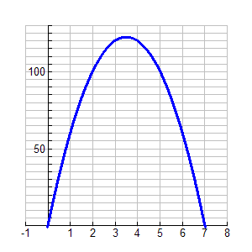

• Determine the maximum height of the ball.

• After how many seconds does the maximum
height occur?

• Determine the length of time the ball is in the air.

Note that the ball will land when the height of the ball is 0 metres; that is when y = 0. Substituting 0 into the function for y yields the equation . The value(s) of x which makes the quadratic equation zero are known as the roots of the equation.

2. Solve by graphing a related function. (Sketch the graph and label the solutions.)

a) b)
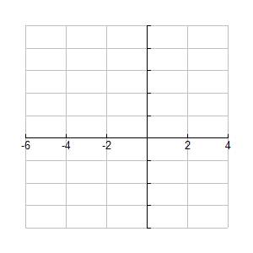
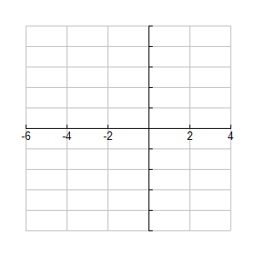

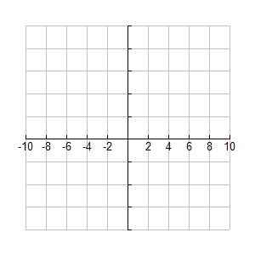
3. Sketch the following related functions and find the zeros of the functions.

a)

State the roots of the equation.

How many roots are there to the equation?

b)

State the roots of the equation.

How many roots are there to the equation?

c)

State the roots of the equation.

How many roots are there to the equation?

What conclusions can you make about the number of roots of a quadratic equation?

4. Find the roots of each of the following equations by graphing the related function.
a) . b)

c) d)

5. A cannon ball is fired from ground level on an arc described by , where h is the height in metres and t is the time in seconds. How many seconds after firing will the cannon ball land?

6. The width of a rectangle is 2m less than its length. The area of the rectangle is 48m². Find the dimensions of the rectangle.

7. The smaller of two integers is 5 less than the larger integer. If the sum of the square of the smaller integer plus four times the larger is equal to eighty. Find the integers.

