Activity Overview
In Problem 1, students explore the logarithm (base 10) function and compare the functions y = 10^{x} and y = log 10^{x} first by a table of values and then by a graph. Negative and fractional
values of the function are highlighted. Then, students use the Calculator application to evaluate logarithms with base 10 and visually connect logarithm expressions with their equivalent exponential equations. In Problem 2, students explore logarithms with other bases via tables, graphs, the calculator application and the change of base formula.

Topic: Exponential & Logarithmic Functions & Equations
- Evaluate the logarithmic function f(x) = log_{a}(x) for any value of x.
- Graph exponential functions of the form f(x) = ab^{x} where a and b are positive real numbers and b ≠ 1.
- Express the inverse of a given exponential function as a logarithmic function and graph it.

Teacher Preparation and Notes
- This activity is appropriate for students in Algebra 2 or as a review for Precalculus. Prior to beginning this activity, students should be familiar with the definition of a logarithm and have experience with simple exponential equations of the form a^{x} = b, as well as the exponent rules.
- This activity requires students to graph functions, add a function table to a graph, and drag items on a Graphs & Geometry screen. If students have not had experience with these functions of the handheld, extra time should be taken to explain them.
- Notes for using the TI-Nspire™ Navigator™ System are included throughout the activity. The use of the Navigator System is not necessary for completion of this activity.

Associated Materials
- EvaluatingLogarithms_Student.doc
- EvaluatingLogarithms.tns
- EvaluatingLogarithms_Soln.tns

Problem 1 – Logarithms base 10
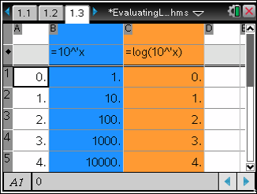
To begin the activity, students first build a function table for the functions y = 10^{x} and y = log (10^{x}) using Columns B and C on page 1.3.
Also, be sure to emphasize the importance of having student select Variable Reference in the subsequent dialog box.
TI-Nspire Navigator Opportunity: Screen Capture
See Note 1 at the end of this lesson.

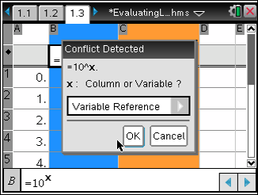
Page 1.4 asks several questions about the table. Students should realize that the numbers in Column A and Column C are the same (leading them to recognize that log (10^{x}) = x).

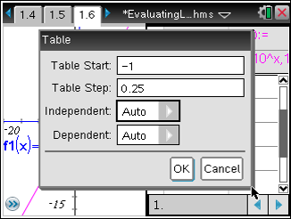
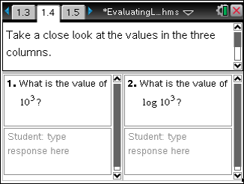
Page 1.5 prompts students to graph these two equations on page 1.6. They should see that the graph of y = log (10^{x}) appears to be the same as the graph of y = x. Students may need to adjust the window settings to zoom in on the graphs.
TI-Nspire Navigator Opportunity: Quick Poll
See Note 2 at the end of this lesson.
Next, students add a function table the graph. To get a closer look at the log function, in particular how it behaves with negative and non-integer values, students should change the table settings so that the table starts with a whole number less than 0 (such as –2) and the table step is between 0 and 1 (such as 0.25). They will see that the relationship between the columns for x and f2(x) still holds.
Note: Due to the compact nature of the contents of the table’s three columns in this problem, you may need to advise that the students position the cursor within the cells to reveal the complete decimal values of x and f2(x).

TI-Nspire Navigator Opportunity: Screen Capture
See Note 3 at the end of this lesson.

Page 1.10 prompts students to evaluate a log₁₀ (x) expression in the math box. To evaluate log₁₀100, students should enter log(100) with parentheses. The handheld will automatically add the base of the log to the expression. Remind students that the symbol log without a subscript means log₁₀.

As a review of the meaning of log₁₀, students are to match log expressions with their equivalent exponential equations. After they have matched all the expressions on page 1.13, they use the Calculate tool from the Actions menu to evaluate each log expression.
Finally, students are reminded that numbers other than powers of 10 have logarithms base 10. They are given an example of such a logarithm and prompted to evaluate the log base 10 of other numbers that are not powers of 10.
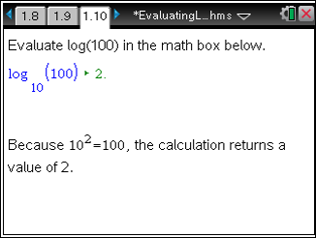
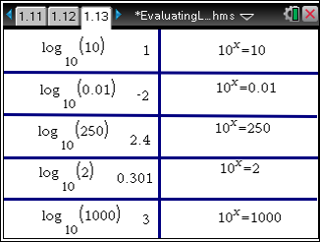
Correct Order

TI-Nspire Navigator Opportunity: Screen Capture
See Note 4 at the end of this lesson.

Problem 2 – Logarithms with other bases
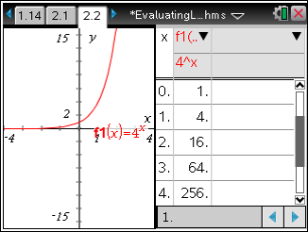
Students begin this problem by graphing and viewing a table of values for the equation y = log₄ x. Students may need to adjust the window settings to view the graph.

The change of base formula is introduced on page 2.4. Students use it to evaluate log₄ (64) on page 2.5. An alternative way to calculate log₄ (64) directly using the Calculator template is introduced on page 2.6. (To access the log template, press t, and choose it from the menu.)

Students are again directed to match log expressions with their equivalent exponential equations on page 2.7. After they have matched all the expressions on page 2.8, they use the Calculate tool to evaluate each log expression.

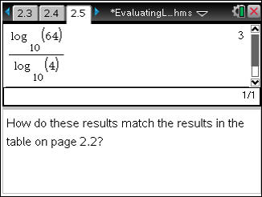
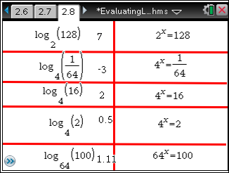
Correct Order

TI-Nspire Navigator Opportunity: Screen Capture
See Note 5 at the end of this lesson.

TI-Nspire Navigator Opportunities

Note 1
Problem 1, Screen Capture
This would be a good place to do a screen capture to verify students have entered the equations using the correct syntax into the formula cells and that they selected Variable Reference.

Note 2
Problem 1, Quick Poll
You may want to use Quick Poll to determine if the responses to Questions 1 and 2 are correct.

Note 3
Problem 1, Screen Capture
It may be helpful to look at the students’ screens to verify they are making the appropriate adjustments to their Table Setup.

Note 4
Problem 1, Screen Capture
This would be a good place to do a screen capture to verify students have reordered the logarithm expressions in the correct locations to match the exponential equations to the right.

Note 5
Problem 2, Screen Capture
This would be a good place to do a screen capture to verify students have reordered the logarithm expressions in the correct locations to match the exponential equations to the right.

