Maximizing Your Efforts  TI-Nspire™ CX Family | Time required  30 minutes
Activity Overview
In this activity, students first write an objective function for the profit from selling two types of game players. They then write a system of inequalities to represent the constraints in the problem situation, graph the system of inequalities, find the vertices of the feasible region, and substitute their coordinates into the objective function to find the maximum profit.

Topic: Linear Systems
- Graph a linear inequality in two variables; identify the regions into which it divides the plane.
- Graph a system of linear inequalities and identify the solution set.

Teacher Preparation and Notes
- Prior to beginning the activity, students should have experience writing, solving, and graphing linear inequalities in two variables.
- This activity is designed to have students explore individually and in pairs. However, an alternate approach would be to use the activity in a whole-class format. By using the computer software and the questions found in the student TI-NspireTM document (.tns file), you can lead an interactive class discussion on linear programming.
- The TI-Nspire solution document (.tns file) Maximizing_Your_Efforts_Soln.tns shows the expected results of working through the activity.
- Notes for using the TI-Nspire™ Navigator™ System are included throughout the activity. The use of the wireless TI-Nspire Navigator System is not necessary for completion of this activity.

Associated Materials
- Maximizing_Your_Efforts_Student.doc
- Maximizing_Your_Efforts.tns
- Maximizing_Your_Efforts_Soln.tns

Problem
In this problem, students are given a real-world situation of a video game factory and the goal of maximizing monthly profits. Pages 1.2 through 1.5 state the problem. On page 1.5, students are prompted to write an objective function to represent the factory’s monthly profit. | 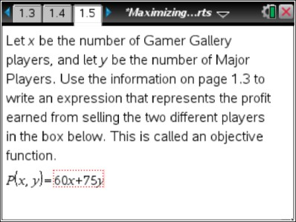
On page 1.6, they are prompted to evaluate the objective function for a particular combination of products: 50 Gamer Gallery players and 100 Major Player players.  Students may employ a variety of techniques to perform this calculation depending on their comfort level with the TI-Nspire handheld’s features. One method is suggested: copy and paste the expression 60x+75y to the right of the equals sign in the Math Expression Box containing P(x,y)=. Replace the variables with numbers, and press Enter to evaluate.  Note: Alternatively, to evaluate, press MENU > Actions > Evaluate. | 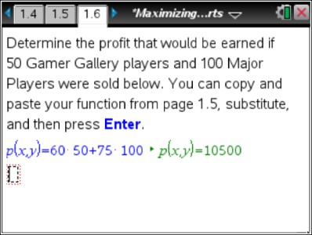
TI-Nspire Navigator Opportunity: Class Capture
See Note 1 at the end of this lesson.
Page 1.7 directs students to write a set of constraints for the problem situation on page  1.8. They should solve the constraints for y on page 1.9 in order to graph them on page 1.11. Once they have graphed the constraints, students should follow the directions on page  1.12 to place a point at each of the four vertices of the feasible area and find their  coordinates. | 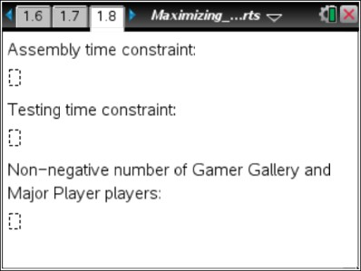

At this point, you may wish to discuss why the maximum profit is sure to occur at a vertex.  Using the graph, discuss questions like: What happens to the monthly profit as you move to the right on the graph? As you move to the left? Up? Down?  The graph contains a hidden feature to assist the discussion. Direct students to go to MENU  > Actions > Hide/Show and click on the point to the left of the P(x, y) and on the number to the right of P(x, y). Then press d to exit the Hide/Show mode. Students can drag this point to different regions of the screen and see how the profit changes. | 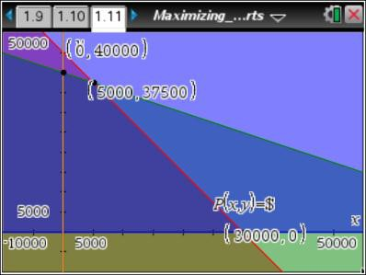
TI-NspireTM NavigatorTM Opportunity: Quick Poll
See Note 2 at the end of this lesson.
Students should substitute the values from the coordinates of the vertices into the objective function on page 1.13 to find where the profit is maximized and record their answer on page 1.14.  Tech Tip: Students may need to change the Attributes for the coordinate points or lines on page 1.11. If the numbers appear in scientific notation, have students reduce the number of decimal places from 3 to 0 (MENU > Actions > Attributes). | 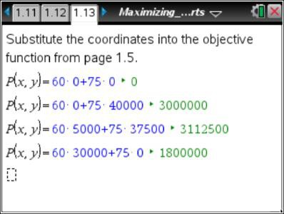  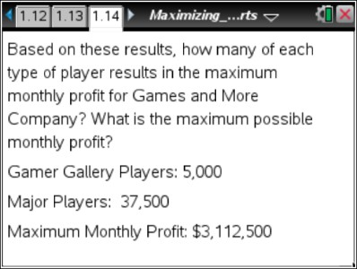

TI-NspireTM NavigatorTM Opportunities
Note 1: Class Capture
Throughout the lesson, use Class Capture to verify students have entered the correct inequalities and graphed the system correctly.

Note 2: Quick Poll
You might want to use Quick Poll to aid the discussion and ensure student understanding. Possible questions include:
- We would make a much larger profit choosing a point in the lighter region above the graphs. Why can't we do that?
Answer: We would be using more assembly time and/or testing time than allowed under the constraints. (This could lead to a discussion about the limits of a business. There is always limited time and resources, so every business has to take into account these constraints limiting possible profits.)
- How many vertices are in the feasible region?
Answer: 4 vertices. (Make sure students are looking at the correct region, taking into account the x ≥ 0 constraint.)
- What are the vertices for the feasible region?
Answer: (0, 0), (0, 40,000), (5,000, 37,500), and (30,000, 0)

