Objective: To review placement of lines.
Academic vocabulary: parallel, perpendicular, intersecting but not perpendicular, coincident
AZ High School Math Standards
Strand 3, Concept 3
PO 4. Determine from two linear equations whether the lines are parallel, perpendicular, coincident, or intersecting but not perpendicular.

Load the activity settings.
Have students write the equation of the line on the screen. It will also be on the graphing calculator.
Once students have the equation of the line, ask the students to submit a new line that is parallel, perpendicular, intersecting but not perpendicular or coincident. There is a student worksheet at the end of the handout for students to write down their equations.
To reduce the number of lines on the screen, consider placing the students in small groups or pairs where each group only submits one line.

Placement of Lines 1 ()
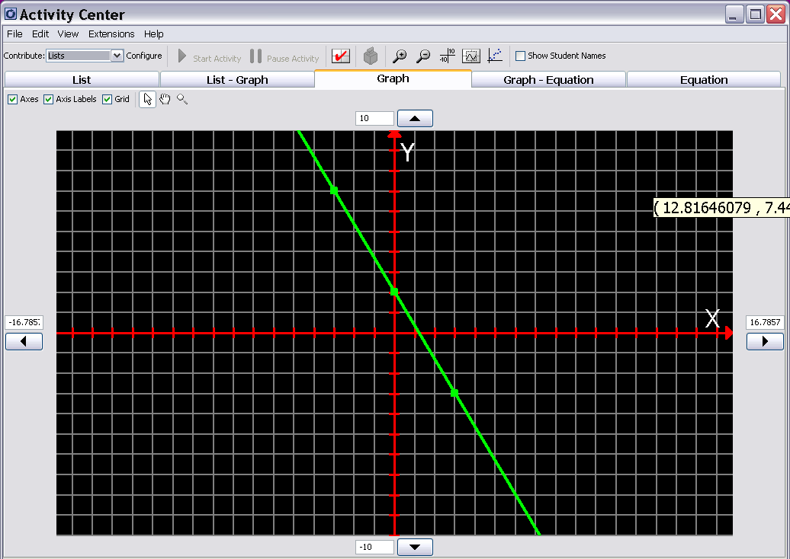

Placement of Lines 2 ()

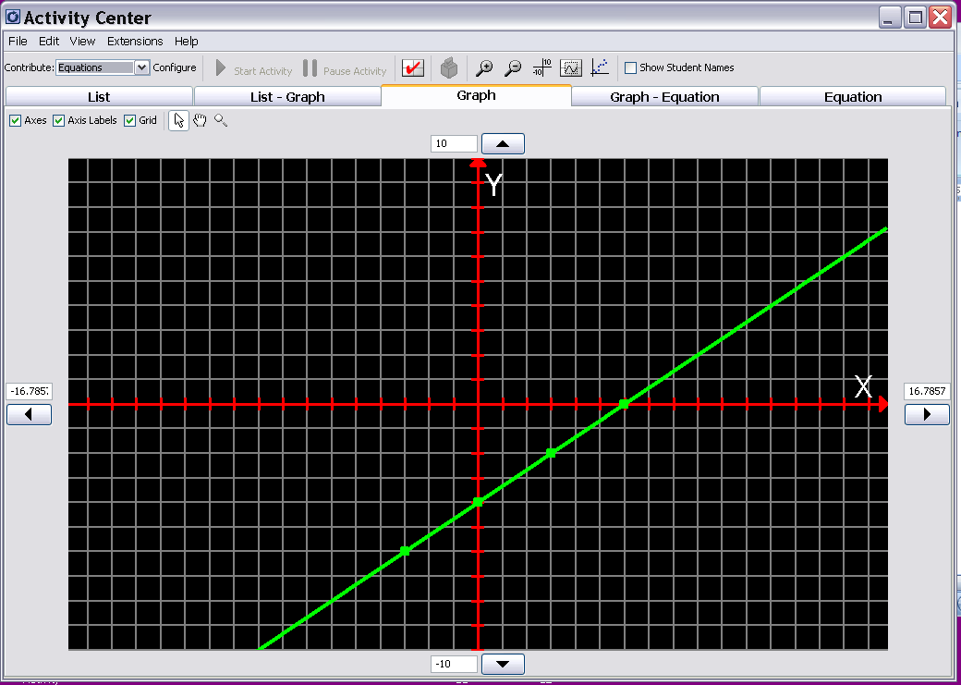

Placement of Lines 3 ()

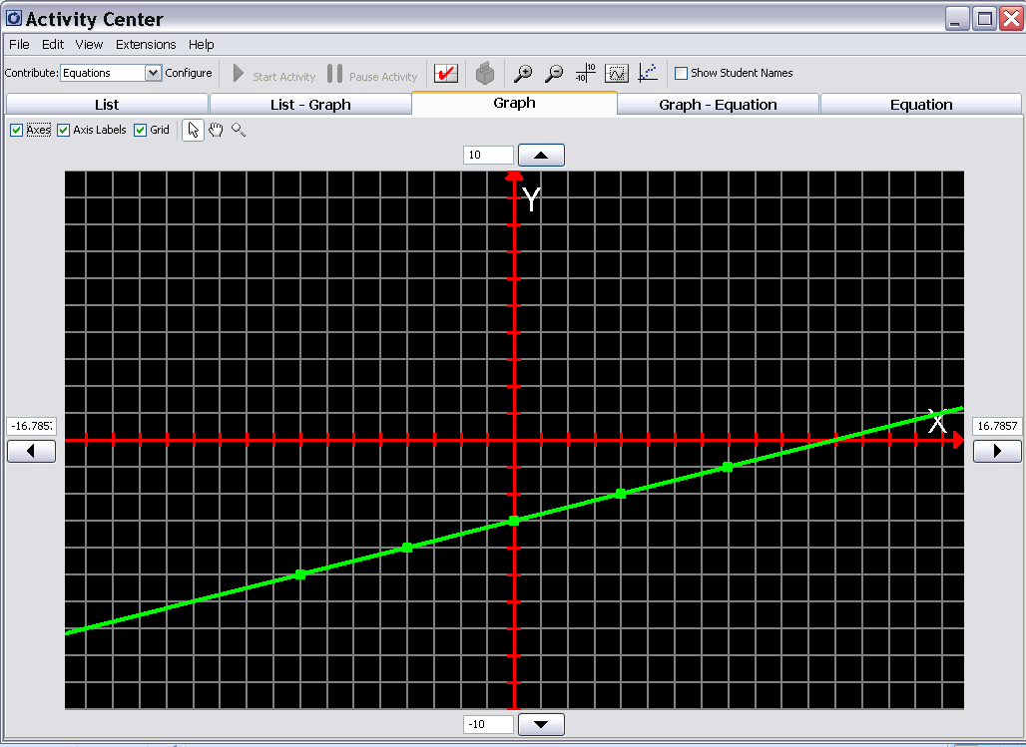

Placement of Lines 4 ()

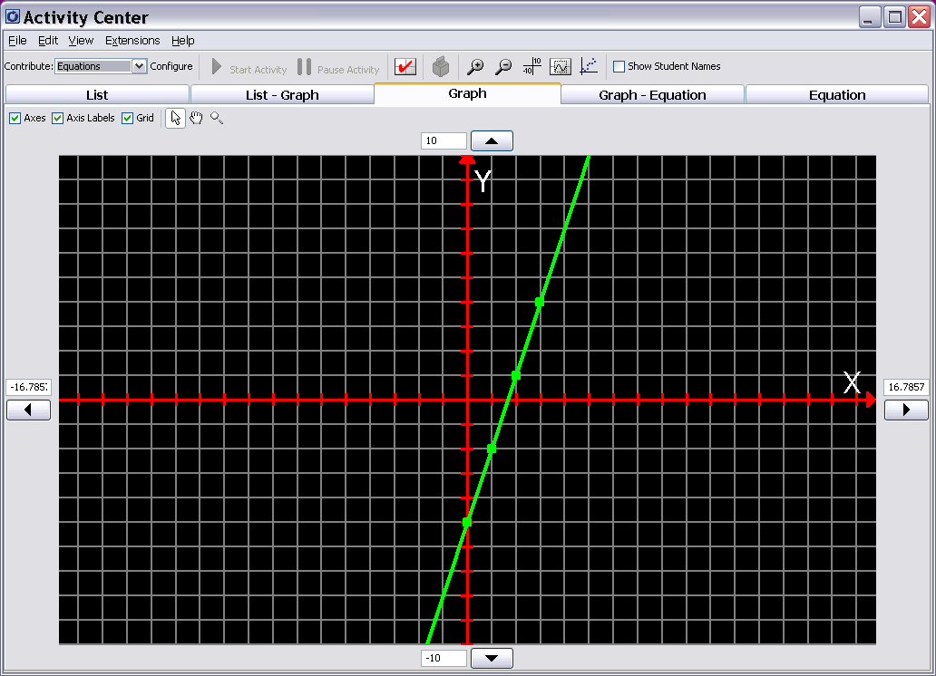

Placement of Lines 5 ()

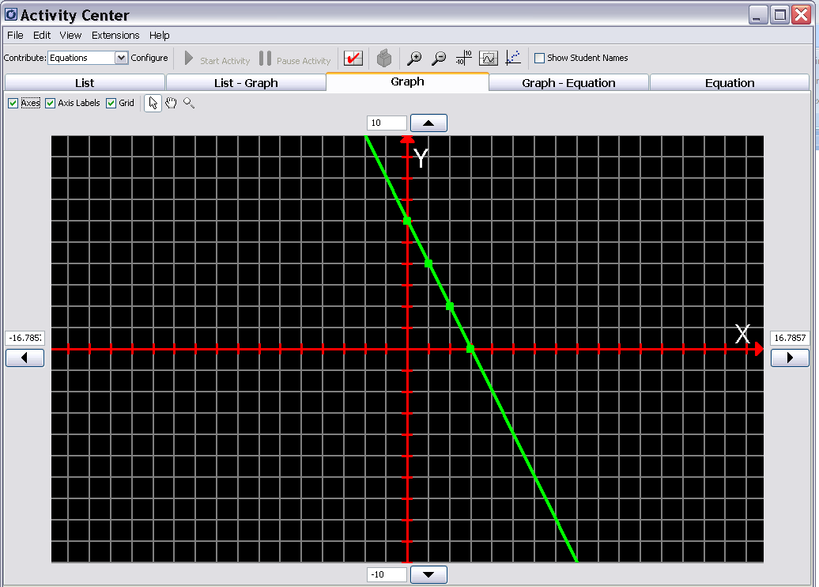

Placement of Lines 6 ()

