Introduction
When you measure the length of an object in centimeters is easy to see how many inches the length is since most rulers have one edge marked in centimeters and the other edge marked in inches. But what about temperature? If you listen to a weather forecast in Canada, the temperature might be reported as 24º on a day April. You might think that they were having unseasonably cold weather if you are thinking in degrees Fahrenheit. What is the relationship between degrees Fahrenheit and degrees Celsius?
Objectives
In this activity, you will:
- Make a scatterplot of temperatures measured in degrees Fahrenheit versus degrees Celsius (independent variable).
- Use the line of best fit to convert a Celsius temperature to degrees Fahrenheit.
- Calculate the percent error of the line of best fit.
Using the Vernier EasyTemp® and Vernier EasyData® App  Connect the handheld with the EasyTemp sensor, and EasyData will immediately open, and the temperature probe will begin collecting temperature data. In the EasyData app, the tabs at the bottom indicate the menus that can be accessed by pressing the actual calculator keys directly below the tab. | 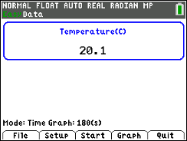
Collecting the Data
Working with a partner (or by yourself, but you will need to have two calculators, and two sensors) you will need to have the two EasyTemps® taped together, so the temperatures will be taken at approximately the same location in the beakers. | 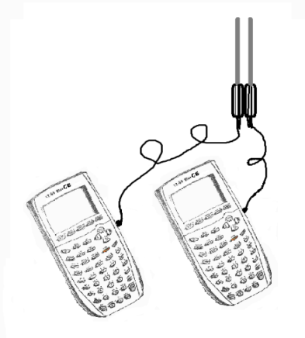
Now, change the units of one of the temperature probes to Fahrenheit.  To change from Celcius to Farhenheit, on one of the calculators, Go to and select Temp. Change the to Fahrenheit and select . | 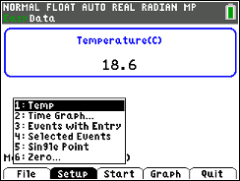  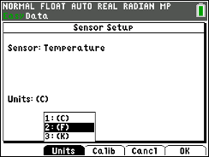
1. Hold the taped-together EasyTemps in the air to allow the probes to reach room temperature before starting the data collection.
2. Starting with the hot water bath, insert the EasyTemp sensors into the water, and simultaneously select Start on both calculators. Monitor the readings for about 30 to 45 seconds. When the readings level off, remove the EasyTemps. After allowing the probes to cool for about 15 to 30 seconds, insert the tips of the EasyTemps into the ice water. Try to keep both EasyTemps the same distance from an ice cube (or remove ice prior to starting). You may remove the EasyTemps when the readings level off if the experiment is still running. The goal is to get as large a range of temperatures as possible. The two graphs that are generated will be different from the examples shown here, but should be similar in shape. ( different values for the temperatures) | 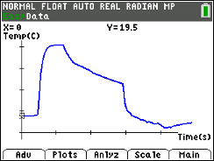  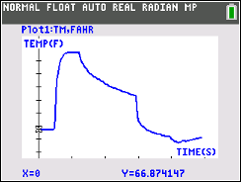
3. Quit the EasyData app by selecting and then selecting . The data will be in L1 and L2. Your teacher will give you instructions on how to insert two named lists and how to copy L1 and L2 into the named lists. Then the Celsius list needs to be linked to the calculator with the Fahrenheit list and vice versa to exchange data. | 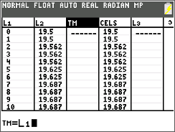
4. Once the exchange of data using calculator-to-calculator transfer is complete, everyone in your group should have three named lists. An example is shown. | 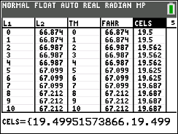
5. Look at the graph of the data. Set up Plot1 as a scatterplot with Celsius as the independent variable. | 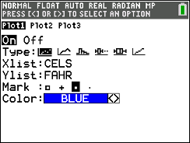
Looking at the Results
1. Make a sketch of the scatterplot on the axes to the right. Pay attention to the scales indicated. Describe the relationship between degrees Fahrenheit and degrees Celsius. | 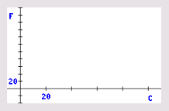
2. Find the equation of a line that you feel matches the data the best. Press … [CALC] and select [Manual-Fit Y=mX+b]. For the two points, choose a point in the lower (colder) part of the data and the other in the warmer part. Record your equation to the right using C in place of X and F in place of Y. | F = _______________
3. Using your line of prediction from Question 2, what temperature in degrees Fahrenheit would be the same as 47ºC and ‒15ºC. | 47ºC = _____________  Predicted value  ‒15ºC = _____________  Predicted value
4. What was the accepted value for the conversion of those temperatures to degrees Fahrenheit? Use the conversion equation: $F=\frac{9}{5}C+32$. | 47ºC = _____________  Accepted value  ‒15ºC = _____________  Accepted value
5. How good was your equation (the line of prediction from Question 2)? To answer this in a standard way, calculate the percent error of either conversion you did in Question 3.

$$Percent Error=\frac{Predicted Value-Accepted Value}{Accepted Value}×100\%$$
Show your work:

Comment about the accuracy of your line of prediction.
Going Further
1. Re-do the scatterplot as shown below with Fahrenheit as the independent variable. Sketch the graph paying attention to the scales on each axis.  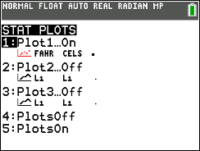 | Sketch the graph here:  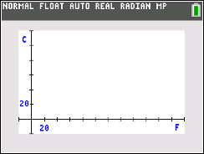
2. As before, find a line of best fit for the data. Press … [CALC] and select [Manual-Fit Y=mX+b]. Record your equation to the right using C for the Y and F for the X. | C = _______________
3. How does this compare with the line of best fit that you obtained in Looking at the Results-Question 2?
4. There is a “best” line of best fit that minimizes the sum of the vertical distances from each data point to the line of prediction. When the calculator computes a linear regression, it finds that line that keeps the errors to a minimum. Do a linear regression for FAHR and CELS with CELS as the independent variable. Press … and right arrow to the [CALC] menu. Select LinReg(ax+b). Compare that equation to the conversion formula from Celsius to Fahrenheit. Show your work and reasoning.
Linear Regression Equation = __________________
5. Find a temperature when the Fahrenheit reading is the same as the Celsius reading. Show your work.

