Introduction
When you heat a liquid and then remove the liquid from the heat, the liquid cools at a certain rate.
In this activity, a temperature sensor will be heated in a cup of hot water for approximately 30 seconds and then removed from the water. Temperature versus time data will be collected for three minutes after the sensor is removed from the hot water. A mathematical model will be determined to describe the temperature of the sensor as a function of time.
Before collecting data, predict how the graph of temperature as a function of time would look after the heated sensor is removed from the hot water. Sketch your prediction to the right. Be sure to label the axes.  Write a sentence to explain why you think the graph will look like your prediction. | 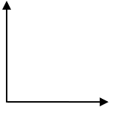
Setup
- This activity is best performed with at least two students: one to hold the temperature sensor and one to run the handheld.
- Open a new document on the TI-Nspire™ CX handheld. Connect the Vernier® EasyTemp sensor to the handheld. The Vernier DataQuest™ App will start with the Main Screen displayed.  Note: The default unit of measurement in the DataQuest App for the EasyTemp sensor is degrees Celsius. The ambient room temperature is displayed.  Note: The current Mode is Time Based, and the default data collection duration is 180 seconds.  - Before collecting data, record the ambient temperature of the room.  Ambient temperature: _______________  - Press Tab until the Start Collection button  is highlighted. Do not click on the button or press ·. | 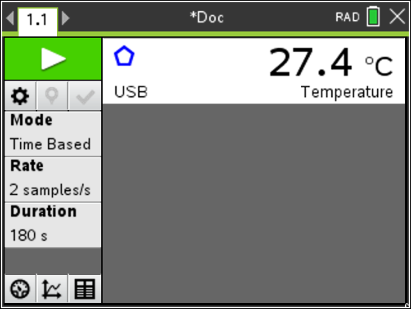
Data Collection
- Obtain a cup of hot water and place the EasyTemp sensor in the water. After it has heated for approximately 30 seconds, remove the sensor from the water and immediately click the Start Collection button or press ·.  Note: The EasyTemp sensor should be held still.  - After the data collection is complete, the temperature versus time graph is displayed. A graph of sample data is shown at the right.  Note: If it is necessary to repeat the data collection, press the Start Collection button again.) | 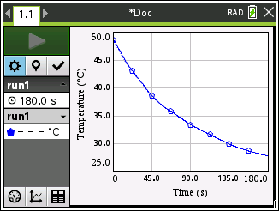
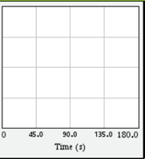
- Sketch a graph of your data on the grid at the right.
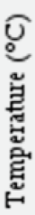
Note: Label the y-axis to fit your data.

How does the graph of your data compare to your prediction?

- Send the data to a Data & Statistics page by pressing Menu > Send To > Data & Statistics. | 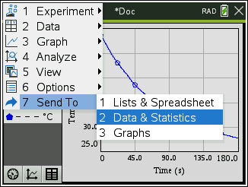  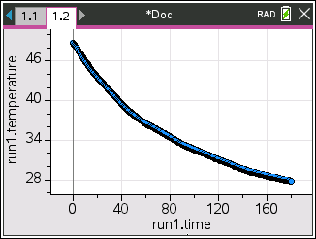
- Adjust the window to display a minimum temperature of 0 degrees Celsius.  - Press Menu > Window/Zoom > Window Settings.  - Tab to YMin, and enter 0.  - Press · or click OK. | 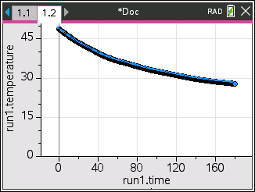
Data Analysis
- You will fit a model to your data.
- What type of function might be a good fit for your temperature versus time data?

- As the time increases, the graph of your data should level off and approach (but not necessarily reach) a certain temperature value. What temperature should the sensor be approaching?

- A horizontal asymptote is a horizontal line that a graph approaches. Record the equation of the horizontal asymptote for your graph.

- Graph your horizontal asymptote.
Tech Tip: To graph the line, select Menu > Analyze > Plot Function. Enter the function, and then press ·. To remove the graph of the line, select Menu > Analyze > Remove Plotted Function.

- A model for this cooling curve is an exponential function of the form f(x) = a(b)^{x} + c.

- How does the location of the horizontal asymptote relate to the value of c?

- Based on the graph of your data, what is the value of c? ___________ (Be sure to include units.)

- What does the value of c represent in the exponential function?

- Select Menu > Analyze > Graph Trace. Trace to the y-intercept of your temperature versus time graph. (Note: To exit Graph Trace, press d.)

- Use the x- and y-coordinates of the y-intercept and the value of c to determine the value of a in the function f(x) = a(b)^{x} + c?

- What is the value of a? _____________ (Be sure to include units.)

- What does the value of a represent?

- Based on the graph of your data, should the value of b in the function f(x) = a(b)^{x} + c be between 0 and 1 or greater than 1? Justify your answer.

- Estimate a value for b. _____________________

- What does this value of b represent?

- On the Data & Statistics page, select Menu > Analyze > Plot Function. Using the values you determined for a and c and your estimate for the value of b, enter the equation of your function in the form f(x) = a(b)^{x} + c. Press ·.

- If the graph of your function does not fit the data well, double-click on the equation, adjust the value of b, and regraph. (If necessary, also adjust the values of a and c.)

- What is the equation of the function that best fits the data? _________________________

- If you collected data for more than three minutes, would the graph of the data eventually cross your horizontal asymptote? Justify your answer.

