Pythagorean Proofs  ID: 11604 | Time Required  45 minutes

Activity Overview
In this activity, students will explore proofs of the Pythagorean Theorem. Students will explore the proof of the Pythagorean Theorem using area of squares, area of triangles and trapezoids, and by dissection. Students will then be asked to apply what they have learned about the Pythagorean Theorem.

Topic: Right Triangles & Trigonometric Ratios
- Pythagorean Theorem

Teacher Preparation and Notes
- This activity was written to be explored with the Cabri Jr. and the Learning Check app on the TI-84.
- Before beginning this activity, make sure that all students have the Cabri Jr. and Learning Check applications, and the Cabri Jr. file Trig.8xv and the Learning Check file Trig.edc loaded on their TI-84 calculators.

Associated Materials
- GeoWeek12_Pythagorean_Worksheet_TI84.doc
- Pythagor.8xv
- Pythago.8xv

Suggested Related Activities
To download any activity listed, go to education.ti.com/exchange and enter “11604” in the quick search box.
- The Pythagorean Theorem—and More (TI-Nspire technology) — 8287
- "Nspired" by Numb3rs Activity: Investigating the Pythagorean Theorem (TI-Nspire technology) — 11119
- The Pythagorean Theorem (TI-84 Plus) — 9532

Problem 1 – Proof of the Pythagorean Theorem
students will begin this activity In the file PYTHAGOR.8xv by looking at a right triangle and the square formed by each of the three sides of the right triangle. Students should see the connection between the squares of the sides and the Pythagorean theorem.  Students will collect data in the spreadsheet on their student worksheet. They will do this for four different positions of the point.  Students are asked several questions about the connection between the figure and the Pythagorean Theorem. | 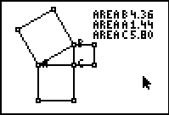
Problem 2 – Proof by Dissection of the Pythagorean Theorem
In this problem students are to “prove” the Pythagorean Theorem through a geometric proof. In PYTHAGO.8xv, students are given right triangle ABC and three squares representing a², b², and c². Students will move the four polygons that form to create c² to a² and b² to discover that the areas are the same.  Students are asked several questions that inquire as to why this proves the Pythagorean Theorem. | 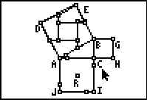
Problem 3 – President Garfield’s Proof of the Pythagorean Theorem
In this extension problem students will construct an algebraic proof of the Pythagorean Theorem using the area of a trapezoid and the sum of the area of three right triangles. | 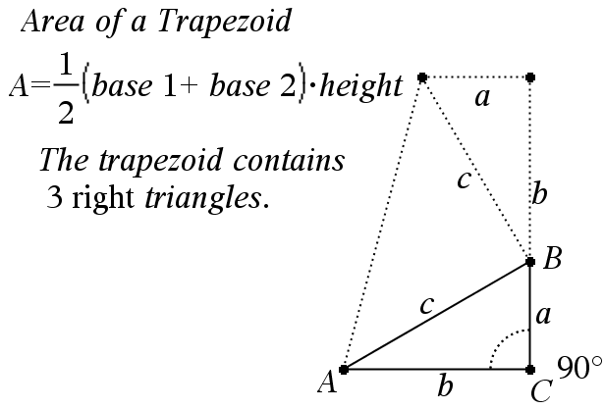
Problem 4 – Application of the Pythagorean Theorem
In Problem 4, students are asked to apply what they have learned about the Pythagorean Theorem to find the length of the third side of a right triangle given two sides of the triangle. |  | 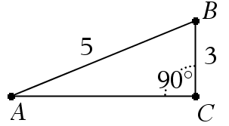
Student Solutions
1. Sample Answers
Position | Area A (a²) | Area B (b²) | Area C (c²) | a² + b²
1 | 1.44 | 4.36 | 5.80 | 5.80
2 | 1.44 | 5.71 | 7.15 | 7.15
3 | 2.22 | 3.24 | 5.46 | 5.46
4 | 2.22 | 0.64 | 2.86 | 2.86
2. They represent a², b², and c².
3. The sum of the area of the two smaller squares equals the area of the larger square.
4. They are equal.
5. a² + b² = c²
6. In a right triangle the sum of the square of the two legs is equal to the square of the hypotenuse.
7. Square ABED
8. Square ACIJ
9. Square BCHG
10. The area of c² and the areas of a² and b² are equal.
11. Area of c² = Area of (a² + b²)
12.
13. 4
14.
15. 5
16. 25

