Lesson 21: Why is there less precipitation further inland in the Pacific Northwest than further inland from the Gulf Coast?

Previous Lesson | We developed a representation for the temperature and movement of air masses but were still curious about whether their proximity to the ocean matters. We gathered additional information about the ocean by observing a visualization of ocean temperatures, through a reading about ocean currents, and through interpretation of precipitation data for coastal cities. We figured out that the ocean affects the humidity and temperature of air masses. We wondered why the moisture from the Atlantic Ocean and Gulf of Mexico travels so far inland compared to the moisture from the Pacific Ocean.
This Lesson  Investigation  2 days   | 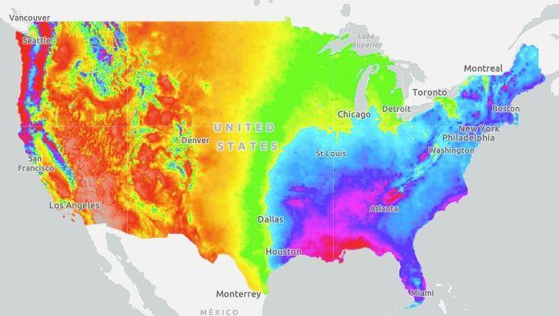Data Source: Prism Climate Group. Oregon State University. | We analyze precipitation, temperature, and elevation data at five locations along two different prevailing wind pathways to explore why there is less precipitation further inland in the Pacific Northwest than there is further inland from the Gulf Coast. We model what happens as an air mass moves from above the ocean to locations over tall mountains and relatively flat landforms. We develop a list of key ideas and data we would need to explain climate patterns in places outside of the United States.
Next Lesson | We will use our key ideas list from Lesson 21 to explain why the rainforests are located where they are and why they have different climates. We will revisit the Driving Question Board and discuss all of our questions that we have now answered.

BUILDING TOWARD NGSS  MS-PS1-4, MS-ESS2-4, MS-ESS2-5, MS-ESS2-6   | What students will do  21.A Analyze and interpret data to identify patterns in the data to provide evidence of the relationship between elevation (cause), air temperature, and precipitation (effect).  What students will figure out  - Changes in elevation affect the flow of air over the land.  - As elevation increases, the air flowing over the land is forced upward; as elevation decreases the air flowing over the land can fall back downward.  - Air that is forced upward cools as it rises and tends to lose much of the water vapor in it through condensation and precipitation.

Lesson 21 • Learning Plan Snapshot
Part | Duration | Summary | Slide | Materials
1 | 5 min | NAVIGATION  Revisit the lesson phenomenon (there is less precipitation further inland in the Pacific Northwest than further inland from the Gulf Coast, despite heavy precipitation along both coasts) and review students’ initial ideas to explain this phenomenon. | A
2 | 25 min | ANALYZE PACIFIC NORTHWEST AND GULF COAST DATA  Use the I² sensemaking strategy to analyze data at five locations along prevailing wind pathways in the Pacific Northwest and the Gulf Coast.  TI-Nspire Alternative to ANALYZE PACIFIC NORTHWEST AND GULF COAST DATA  Have students open the TI-Nspire file, “OSE 6.3_Lesson_21”. Students should follow the directions to run simulations involving a virtual drone that can fly between different locations in the Pacific Northwest and Gulf Coast and collect data (elevation, precipitation, and air temperature). The data is graphed on the following page | B-D | Maps and Data for the Pacific Northwest and Gulf Coast, tape
3 | 10 min | MODEL WHAT IS HAPPENING TO THE AIR AS IT MOVES ALONG THE PATHWAY  Develop a model to explain what is happening to air masses in the Pacific Northwest and in the Gulf Coast as they move inland over different landforms. | E | Profile Views: Pacific Northwest and Gulf Coast, tape
4 | 2 min | NAVIGATION  Tell students they will share their models and work on a class consensus model during the next class session. | F

End of day 1
5 | 5 min | NAVIGATION  Revisit the lesson question and review the models students developed in small groups during the previous session. | G | Profile Views: Pacific Northwest and Gulf Coast
6 | 13 min | BUILDING UNDERSTANDINGS DISCUSSION  Develop a shared understanding about what happens to air masses as they move inland from the coast based on the data analysis and modeling. | H-J | TI-Nspire file, “OSE 6.3_Lesson 21” – Data is collected as students interact with the drone simulations (for both Pacific and Gulf coasts). The data is in graphical form and can be analyzed.  Note – To learn how to obtain and use TI-Nspire CX Premium Teacher software go to www.ScienceNspired.com and click, “Let’s get started”, then click, “Get to know your software”.
7 | 7 min | UPDATE OUR PROGRESS TRACKERS  Update our Progress Trackers to explain why there is less inland precipitation in the Pacific Northwest than inland in the Gulf Coast. | K
8 | 17 min | DEVELOP A KEY IDEAS LIST  Develop a list of key ideas and data needed to prepare students to be able to explain climate patterns outside of the United States. | L | chart paper, marker

End of day 2

Lesson 21 • Materials List
 | per student | per group | per class
Lesson materials | - science notebook  - Maps and Data for the Pacific Northwest and Gulf Coast  - tape  - Profile Views: Pacific Northwest and Gulf Coast  For the TI-Nspire alternative investigation you will only need:  - TI-Nspire CX or CX II Handheld or Computer software  - TI-Nspire .tns file “OSE 6.3_Lesson 21” |  | - chart paper  - marker

Materials preparation (15 minutes)

Review teacher guide, slides, and teacher references or keys (if applicable).

Make copies of handouts and ensure sufficient copies of student references, readings, and procedures are available.

If you plan to use the TI-Nspire file, OSE 6.3_Lesson 21, be sure the student calculators have the file. To transfer a file from your TI-Nspire CX Teacher Premium software to TI-Nspire CX or CX II graphing calculators, you will need a usb computer to calculator cable or a TI-Nspire Docking Station.

Lesson 21 • Where We Are Going and NOT Going

Where We Are Going

In Lessons 18-20, students figured out that warm air masses from the equator and cooler air masses from the poles tend to collide in the middle of the United States and move from west to east due to prevailing winds. They figured out that ocean circulation and ocean temperatures play an important role in explaining whether an air mass is moist and explaining coastal precipitation patterns. In this lesson, students build on these ideas to consider how landforms, and specifically mountain ranges, can affect precipitation patterns.

Through investigation of the Pacific Northwest, students will develop ideas to explain why there is often substantial precipitation on the windward side of mountain ranges, but very little precipitation on the leeward side.

Through investigation of the Gulf Coast, students will develop the idea that when there are no large landforms, warm, wet air masses can move very far inland, causing precipitation throughout a region.

Where We Are NOT Going

The focus of this lesson is on explaining precipitation patterns along only coastal areas of the United States. In Lesson 22, students will apply the ideas from Lessons 18-21 to explain climate patterns in different parts of the world.

LEARNING PLAN for LESSON 21
1 · NAVIGATION | 5 min
MATERIALS: None
Review coastal precipitation patterns. Present slide A. Remind students that in the previous lesson, we observed heavy precipitation along coastal areas, including Seattle and New Orleans. However, further inland, Washington state has very little precipitation, whereas Mississippi and Alabama still have a lot of precipitation. Have students review the initial ideas they developed to explain this phenomenon.

Suggested prompt | Sample student response
What were our initial ideas about why there was less precipitation further inland in the Pacific Northwest than further inland from the Gulf Coast? | Maybe there are different things happening over the land.  Maybe the swamps in the Gulf Coast or the mountains in Washington play a role?

Focus on the direction of the prevailing winds. Share that we will investigate this phenomenon today. Record the related lesson question on the board: Why is there less precipitation further inland in the Pacific Northwest than further inland from the Gulf Coast? Then, tell students that we will consider where the air masses move from the coast to inland areas to help us think about how to answer our question.

Suggested prompt | Sample student response
If it’s raining in Seattle and New Orleans, where would those air masses move next? | The air mass over Seattle will move East.  The air mass over New Orleans will move Northeast.
How could investigating data about how the land compares along both of the pathways that these air masses move across help make progress answering our question? | The air mass moves in the direction of the prevailing winds. That’s the direction that weather travels.  Knowing about the land that one air mass travels over compared to another place might help us understand why there’s less precipitation further inland in Washington than in the Gulf Coast.

2 · ANALYZE PACIFIC NORTHWEST AND GULF COAST DATA | 25 min
MATERIALS: science notebook, Maps and Data for the Pacific Northwest and Gulf Coast, tape
Introduce datasets along two pathways of air mass movement. Present slide B. Introduce students to two datasets that may help us understand what is happening as we move from the coast inland. Point out the locations of the two different pathways, one in the Pacific Northwest from Seattle to Spokane, WA and other in the Gulf Coast region from New Orleans, LA to Chattanooga, TN. Explain that each pathway has five different locations along it with data we can analyze. These pathways follow the direction of the prevailing winds, which is the direction that one air mass would travel.  Introduce and prepare to analyze data using the I² sensemaking strategy. Present slide C.  Remind students how to use the I² strategy to analyze data. Divide students into groups of 4-5. Within each group, have students divide again into pairs or groups of three. Have each group decide whether they want to analyze data for Pathway 1 (Pacific Northwest) or Pathway 2 (Gulf Coast). Hand out a copy of Maps and Data for the Pacific Northwest and Gulf Coast to each student. Students can tape this in their science notebooks. Maps and Data for the Pacific Northwest and Gulf Coast has the same information in color, located in the student edition.  Make and interpret observations of the data. Prompt students to write “What I see” (WIS) statements in their small groups. Remind students to write directly on the graphs, drawing arrows to their observations. Have students write “What it means” (WIM) statements next to each of their “What I see” statements.✱  Share and compare observations and interpretations of Pathways 1 and 2. Present slide D. Give groups 6-7 minutes to share their observations and interpretations with each other. Have students compare patterns and interpretations between the Pacific Northwest and Gulf Coast pathways. Then have a few groups share out their observations and interpretations with the class. Listen for:  - Pathway 1 Patterns  - Stampede Pass has the highest elevation, coldest temperature, and most precipitation. There is much less precipitation east of the mountains.  - Pathway 2 Patterns  - Precipitation slowly decreases, temperature decreases, and elevation slowly increases.  - Interpretations:  - The mountains play an important role. As the air moves higher up and gets cold, water condenses and it rains.  - There are no mountains in Pathway 2, so the wet air mass can go a long distance and rain everywhere.  - The rain emptied out from the clouds over the mountains so there was not much left after the mountains.  - The air can pick up some moisture as it moves over the land (e.g., It’s rainier in Spokane than Wenatchee).  - A slow and small change in elevation doesn’t seem to make a huge difference (e.g., New Orleans to Chattanooga). | ✱ SUPPORTING STUDENTS IN ENGAGING IN ANALYZING AND INTERPRETING DATA  Students will use the Identify and Interpret (I²) sensemaking strategy to analyze the data table. Consider modeling one observation (WIS) and one interpretation (WIM) with your students before they begin small-group work. This strategy helps students break down information-rich graphs into smaller pieces to interpret, which will allow them to identify patterns that provide evidence for a phenomenon.  ✱ SUPPORTING STUDENTS IN DEVELOPING AND USING PATTERNS  WIS statements from the Pacific Northwest pathway will help students identify patterns in the data about the relationship between elevation, precipitation, and air temperature. WIM statements are students’ initial explanations about what they think is happening to cause the observations and patterns.  ✱ ATTENDING TO EQUITY  Universal Design for Learning. Asking students to annotate the graphs with symbols can help students manage information so that they can express their understanding. Students may need additional support in obtaining information from the provided graph. Consider including any of the following options to support students:  - Have students work with a partner as they read and annotate their graph.  - Allow for a competent aide, partner, or “intervener” to interpret the patterns they notice from the graph aloud.
  ADDITIONAL GUIDANCE | Emphasize that we have data along these two specific pathways because these locations follow the direction of the prevailing winds in each area. This will help us consider what happens as the same air mass moves over a larger area. If necessary, revisit regional prevailing wind ideas from Lesson 19.
    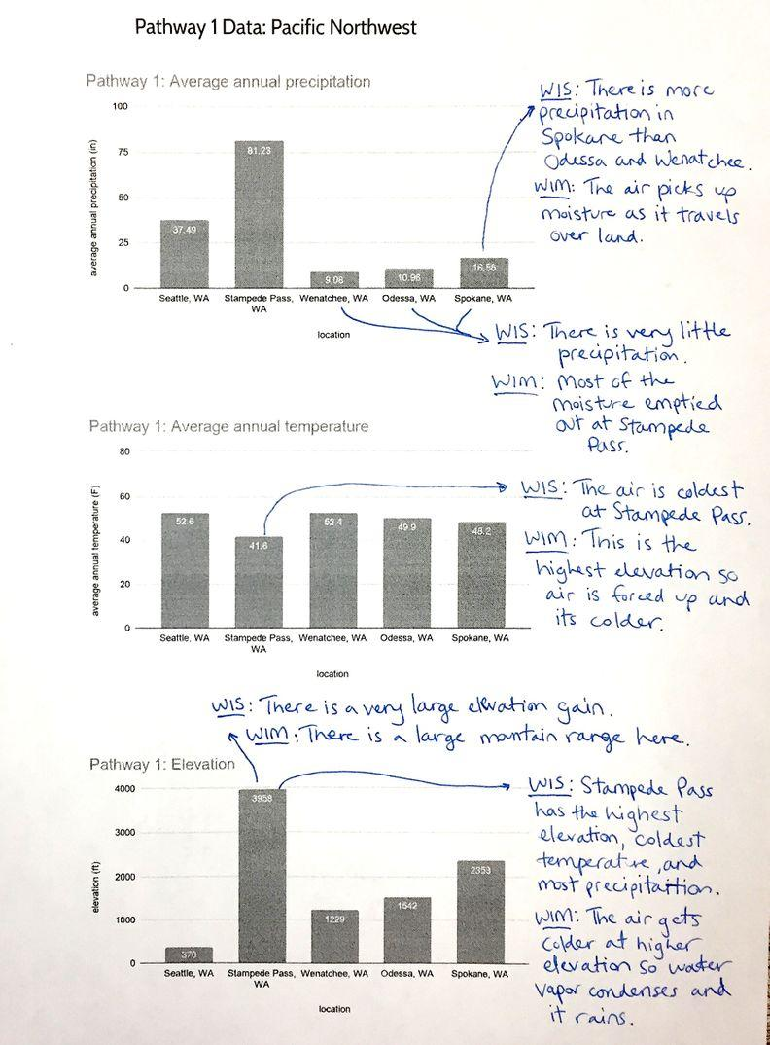
    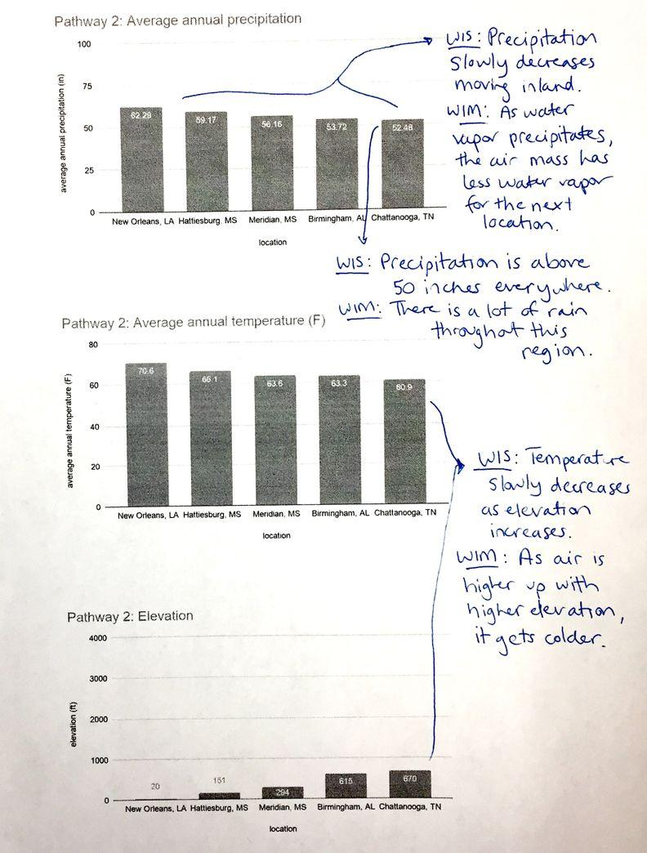
  ADDITIONAL GUIDANCE | As students annotate Maps and Data for the Pacific Northwest and Gulf Coast, circulate and use the following prompts to ensure that they notice key aspects of the graphs.  - What do you notice about how precipitation changes as the air mass moves further inland?  - Where do you see the largest changes in precipitation? What else is changing in those locations? What do you think that means?  - Why would mountains cause precipitation to form in the air that flows towards them?  - Why would mountains change precipitation patterns?
  ADDITIONAL GUIDANCE | The elevation increase and precipitation decrease in Pathway 2 may be counterintuitive to the patterns students observed in Pathway 1. Focus students on careful analysis and comparison between the differences in the two pathways. The profile map on Maps and Data for the Pacific Northwest and Gulf Coast may be particularly useful to help students compare and visualize these differences:  - How large is the elevation gain? Emphasize that it’s relatively small in Pathway 2 compared to Pathway 1.  - How long is the distance between points? Emphasize that it’s a much larger distance in Pathway 2 than Pathway 1.  - Why would a sudden large increase in elevation cause a large increase in precipitation, but a slow and small increase in elevation wouldn’t?

3 · MODEL WHAT IS HAPPENING TO THE AIR AS IT MOVES ALONG THE PATHWAY | 10 min
MATERIALS: science notebook, Profile Views: Pacific Northwest and Gulf Coast, tape
Summarize what we’ve figured out so far about the role of elevation. Say, It seems like the mountains in Washington might help us explain why there is less precipitation further inland in Washington than in Mississippi or Alabama. Let’s use what we already know about air, temperature, and precipitation to model what we think is happening in the locations along both pathways.

Model air mass movement across the prevailing wind pathways. Present slide E. Pass out Profile Views: Pacific Northwest and Gulf Coast to each student, which contains the profile views of both pathways, and have students tape these into their science notebooks. Have students work in small groups to model what is happening with air and water at each point along the pathways, including over the ocean. An example model follows.

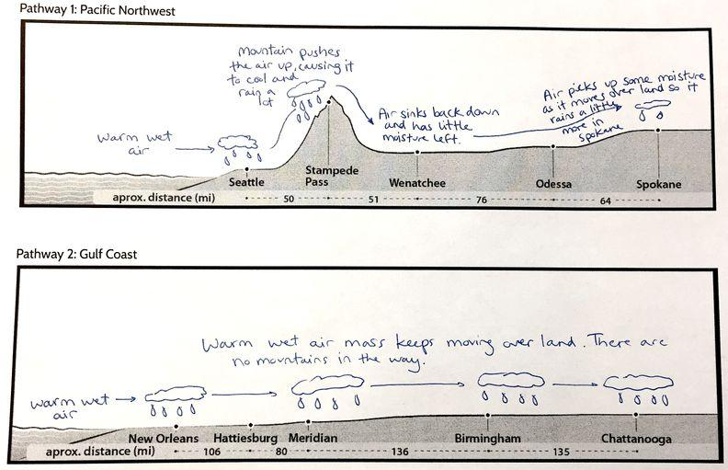

4 · NAVIGATION | 2 min
MATERIALS: None
Look forward to the next class session. Present slide F. Say, Next time, we’ll share our models about what we think is happening and develop a consensus model.


Have students leave their science notebooks so you can review their data analyses and models to assess their current thinking and anticipate how to best facilitate the building understandings discussion during the next class session.

ASSESSMENT OPPORTUNITY | Building toward: 21.A.1 Analyze and interpret data to identify patterns in the data to provide evidence of the relationship between elevation (cause), air temperature, and precipitation (effect).  What to look for/listen for: Look for these observed patterns:  - Pacific Northwest: Stampede Pass has the highest elevation, coldest temperature, and most precipitation. There is much less precipitation east of the mountains and further inland where it is warmer and lower in elevation.  - Gulf Coast: Precipitation slowly decreases, temperature decreases, and elevation slowly increases moving inland from the Gulf of Mexico.  Look for these ideas in students’ WIM statements and group models:  - As air passes over tall mountains (e.g., Stampede Pass), it gets pushed upward and cools down, causing water vapor to condense and form precipitation. Once the air passes over the mountains, there is little water vapor left in the air mass, causing less precipitation. The air can fall back downward along the mountains as elevation decreases.  - As a warm, wet air mass passes over a relatively flat landform (e.g., New Orleans to Chattanooga), it can move a long distance, so there can be a lot of precipitation over the entire pathway.  - Air can pick up some moisture as it moves over land (e.g., Wenatchee to Spokane).  What to do: If students have difficulty identifying key patterns from the data, project the profile view as a class and use visual representations to illustrate patterns of precipitation and air temperature (e.g., draw lots of rain and an image of it being very cold over Stampede Pass). If students’ ideas are not accurate at the end of Day 1, have students compare their models with other groups prior to the whole-group Scientists Circle discussion on Day 2. This will allow them to get new ideas from their peers. Pay attention to students’ ideas during the Scientists Circle. If students’ explanations are still incomplete, project an example of a group model that is complete. Encourage students to try to use this example model to explain what is happening.

End of day 1
5 · NAVIGATION | 5 min
MATERIALS: Profile Views: Pacific Northwest and Gulf Coast
Revisit the lesson question. Present slide G. Remind students that we’ve been trying to explain why there is less precipitation further inland in the Pacific Northwest than further inland from the Gulf Coast. Have students briefly review their models with their small groups to explain precipitation patterns in the Pacific Northwest and the Gulf Coast.

6 · BUILDING UNDERSTANDINGS DISCUSSION | 13 min
MATERIALS: science notebook, Maps and Data for the Pacific Northwest and Gulf Coast, Profile Views: Pacific Northwest and Gulf Coast
Gather in a Scientists Circle to explain patterns of inland precipitation. Facilitate a Building Understandings Discussion in which students share their interpretations and make claims about what is happening inland from the coast in Washington state and how it differs from what is happening inland from the Gulf Coast. Have students bring their science notebooks to the discussion. Maps and Data for the Pacific Northwest and Gulf Coast and Profile Views: Pacific Northwest and Gulf Coast should be taped into their notebooks for reference.✱  Use slide H to focus first on the Pacific Northwest. Have students share their ideas about what is happening to the air mass as it moves from over the ocean to Spokane.  Present slide I. Have students compare the model explaining the Pacific Northwest precipitation patterns to the frontal storm model they developed in Lessons 16-18.  Use slide J to focus next on the Gulf Coast. Have students share their ideas about what is happening to the air mass as it moves from over the Gulf of Mexico to Chattanooga. | ✱ ATTENDING TO EQUITY  Universal Design for Learning: Be sure to reinforce norms throughout the discussion which helps create an accepting and supportive classroom culture for taking risks and sharing ideas and also will help to minimize threats or distractions for students.
  KEY IDEAS | Purpose of this discussion: to help students make claims about how elevation affects precipitation patterns in the Pacific Northwest and Gulf Coast.  Listen for these ideas:  Pacific Northwest  - Pattern:  - There is a large and fast increase in precipitation that coincides with an elevation increase and drop in temperature.  - After the mountains, there is less precipitation.  - Explanation:  - A warm, moist air mass forms over the ocean. Prevailing winds push that air mass east over the land.  - When that air mass moves over land, the increase in elevation forces the moving air mass upward. The decrease in elevation allows the air mass to fall downward.  - Air that is forced upward cools as it rises. Because there is moisture in the air, it condenses as it cools, causing precipitation to fall.  - This is similar to what happens on a frontal boundary.  - As the air mass moves over the mountains, it has much less water vapor, leading to very little precipitation east of the mountains.  Gulf Coast  - Pattern:  - There is steady precipitation along the prevailing wind pathway that slowly decreases further inland. The temperature drops slightly and elevation increases slightly.  - Explanation  - A warm, moist air mass forms over the Gulf. Prevailing winds push that air mass northeast over the land.  - The air mass moves over land unobstructed by large mountains. It can stay warm and wet for a long distance. There is slightly less precipitation inland because some of the moisture condenses and precipitates, but there are not major changes.
  Suggested prompts | Sample student responses | Follow-up questions
  What happens with the air mass as it moves from over the ocean to the land? | The ocean water hitting Seattle is warm, so warm, moist air evaporates. | Where does the air go next and why?
  What is happening with the air mass as it moves over land to Stampede Pass? | The air mass is pushed up because of the mountains. | What happens when air rises higher up in the atmosphere?  Why does the air mass moving up in the atmosphere cause precipitation?  What happens after the air passes over the mountains?
  Why is there so little precipitation in Wenatchee? | All of the moisture fell out at the mountains. There’s very little water vapor left in the air mass.
  Why is there more precipitation in Spokane than Wenatchee? | Spokane is at a higher elevation and cooler, so maybe more water condenses.
  Where does the new moisture come from? | As the air mass passes over more land, more water evaporates into the air mass.
  Suggested prompt | Sample student response
  How is our model to explain precipitation patterns in the Pacific Northwest similar to our frontal storm model? | In both models, a cool air mass gets pushed up in the atmosphere. That causes air to get cooler, condense, and cause heavy rain.
  How is it different? | The mountains push the air up in our Pacific Northwest model.  The warm air mass pushes the air up in the frontal storm model.
  Suggested prompt | Sample student response
  What happens with the air mass over the Gulf? | Warm, moist air evaporates over the warm Gulf water.
  What is happening with the air mass in New Orleans and Hattiesburg? | The air mass loses some moisture as precipitation, but it just keeps moving.
  Why is there still so much precipitation in Birmingham and Chattanooga? | The air mass doesn’t hit any landforms with major elevation so it can just keep going and dumping out moisture.
  Why is there less precipitation in Birmingham and Chattanooga compared to New Orleans? | As there is rain, there’s slightly less moisture in the air by the time the air mass gets to Birmingham and New Orleans.
  What would happen to precipitation patterns if there was a large mountain range in between Meridian and Birmingham? | There would be a spike in precipitation in Meridian and then less precipitation in Birmingham and Chattanooga.

7 · UPDATE OUR PROGRESS TRACKERS | 7 min
MATERIALS: science notebook
Update individual Progress Trackers. Present slide K. Have students create another entry in their 2-column chart and record the lesson question and what the class figured out using words and/or pictures.

ASSESSMENT OPPORTUNITY | Building toward: 21.A.2 Analyze and interpret data to identify patterns in the data to provide evidence of the relationship between elevation (cause), air temperature, and precipitation (effect).  What to look/listen for: This is the second opportunity to look for these observed patterns:  - Pacific Northwest: Stampede Pass has the highest elevation, coldest temperature, and most precipitation. There is much less precipitation east of the mountains and further inland where it is warmer and lower in elevation.  - Gulf Coast: Precipitation slowly decreases, temperature decreases, and elevation slowly increases moving inland from the Gulf of Mexico.  Look for these ideas in students’ WIM statements and group models:  - As air passes over tall mountains (e.g., Stampede Pass), it gets pushed upward and cools down, causing water vapor to condense and form precipitation. Once the air passes over the mountains, there is little water vapor left in the air mass, causing less precipitation. The air can fall back downward along the mountains as elevation decreases.  - As a warm, wet air mass passes over a relatively flat landform (e.g., New Orleans to Chattanooga), it can move a long distance, so there can be a lot of precipitation over the entire pathway.  - Air can pick up some moisture as it moves over land (e.g., Wenatchee to Spokane).  What to do: This is a good formative assessment opportunity. To check to see if students have made progress in their thinking, review students’ Progress Trackers at the end of Day 2. Compare students’ responses here to student models from Day 1. This will provide you an opportunity to assess student growth in understanding over Day 2.

8 · DEVELOP A KEY IDEAS LIST | 17 min
MATERIALS: chart paper, marker
Consider precipitation patterns outside of the United States. Say, We’ve now explained the precipitations along the coastal areas of the country. Earlier in the unit, we explained precipitation patterns in the central United States. Now that we’ve developed ideas to explain what we see happening in our country, let’s try to extend them to predict and explain what we expect to see in climate patterns in other parts of the world besides the United States. This would be a good way to test the ability of our ideas to explain the widest possible set of phenomena we know of, which is what scientists are always trying to do with the models they develop. And it would also be a good summative assessment of the understanding each of you have individually here at the end of the unit.

Make a list of key ideas and data needed that explain regional climate differences. Present slide L. Ask students to brainstorm the data they would need to predict or explain such differences in precipitation. Have students work in small groups to generate these two lists.

Share key ideas and data needed as a whole class. As students share suggestions for key ideas, ask if other groups had similar ideas. Generate a class list on chart paper. For each key idea, have students share the kind of data they would need to determine whether or not the key idea in question might help explain regional climate differences.

Key ideas | Data needed
Prevailing wind patterns describe the direction that air moves over a region. | Air circulation map
The source of moisture is where water comes from before it evaporates into an air mass. | Map showing oceans, lakes, rivers, and land areas
Ocean temperature influences the temperature and humidity of air moving over it. | Ocean temperature map  Air temperature data
Sunlight warms water causing evaporation and increasing humidity. This causes the average surface temperature of the land and the air above it to change. | Solar radiation data  Land temperature data  Air temperature data
Increases in elevation force air moving over land to rise and cool, causing condensation and precipitation. | Elevation data or profile of the land in the direction of prevailing winds

Navigate to the next session. Tell students that in the next lesson, we’ll use these key ideas and data needed lists to explain climate patterns elsewhere in the world.

