Topic 3: Geometry and Trigonometry | Angles of Depression and Elevation
The diagram below shows a trapeze artist at point T, 60 ft. vertically above the ground. Point C is the point on the ground directly below the trapeze artist.  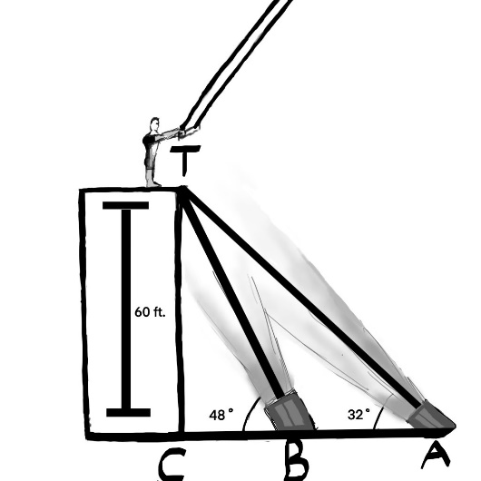 * Diagram not to scale  - Find the size of the angle of depression from T to A and label it on the diagram above.  (b) Find the distance from C to A  (c) Cameron walks closer to point C and stops at point B and looks upward at an angle of 48°. Find the distance from A to B. |  | (1 mark)  (2 marks)  (3 marks)
Mark scheme:  (a) $33°$  Diagram: [1 mark]  (b) CA = $\frac{60}{\tan{33°}}$ OR CA = $\sqrt{{\left(\frac{60}{\sin{33°}}\right)}^{2}- {60}^{2}}$ OR $\frac{60}{\sin{33°}}= \frac{CA}{\sin{57°}}$ (M1)  CA = $92.4 (ft.)$ (92.39189…) A1  (c) Method 1  Attempt to find BC  BC = $\frac{60}{\tan{49°}}$  $=52.2 (ft.)$ (52.15720…) (A1)  AB = 92.39189… - 52.15720…  = $40.2 m$ (40.23469…) |  | (A1)  (A1)  (M1)(A1)  2 marks  (M1)  (A1)  A1

