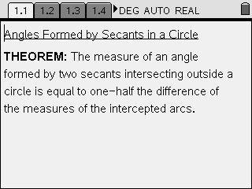
In this lesson you will investigate the relationship among the angles formed by 2 secants drawn from a common external point, outside a circle.

Open secants.tns on your TI-Nspire handheld and follow along with your teacher, using this worksheet as a reference throughout the lesson.

On page 1.2, you will find circle O with secants ABC & ADE, forming arc BD, arc CE, and •A, each labeled with their measures in degrees. As you drag either of the endpoints of the 2 secants, or angle A, notice how “c – b” changes to reflect the difference of the measures of the 2 arcs. More importantly, take note of the measure of angle A relative to the value of this difference. The constant 2:1 ratio indicates that the measure of the angle is truly one-half the difference of the intercepted arcs.

Applying the Theorem
Now, use the theorem, and the diagrams below, to answer the questions on pages 1.3 to 1.6.
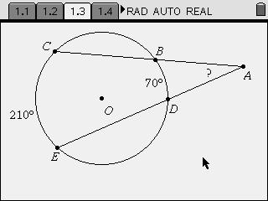
#1.3
1.4
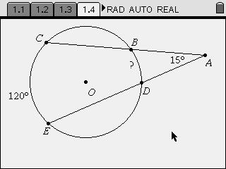

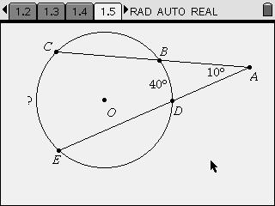
1.5

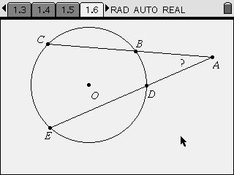
1.6
Geometric Proof
On page 1.8, you are presented with a 2-column proof of the theorem. Complete the theorem by filling in the missing items in both the Statements and Reasons columns.
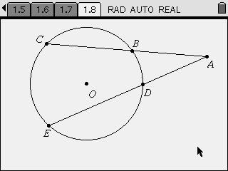

STATEMENTS | REASONS
1. Circle O with secants ABC and ADE, drawn  from a common external point, A. | 1. Given
2. m •BCD = ½ m arc BD and  m •CDE = ½ m arc CE | 2.
3. m •CDE = m •BCD + m •A | 3.
4. m •A = | 4. Subtraction
5. m •A = ½ m arc CE – ½ m arc BD | 5.
6. m •A = ½ (m arc CE – m arc BD) | 6. Greatest common factor.

