Activity Overview

In this activity, students will observe a simulation of a record breaking bungee jump, consider a mathematical model of the height as a function of time, and take the derivative to determine points of interest like the minimum height, maximum velocity, acceleration, and maximum jerk. Students will algebraically, numerically, graphically and verbally investigate higher order derivatives.

Topic: Higher order derivatives
- Interpret the derivative in context of velocity, speed, and acceleration
- Corresponding characteristics of the graph of f, f ′, f ″

Teacher Preparation and Notes
- Students will write their responses directly into the TI-Nspire handheld and/or on the accompanying handout. On self-check questions, students can then press b and select Check Answer (or / + ).
- Students will need to know that the derivative of position is velocity, and the derivative of velocity is acceleration. For multiple-choice questions at the end, students are expected to be familiar with the concept of the definite integral. The Product Rule using exponential and trigonometric functions is also utilized.
- The data for the helicopter bungee jump problem is from Bungee Consultants International (http://www.bungeeconsultants.com/stuntengineering-stuntcredits.htm).
- After finishing this activity students should be better equipped for AP* exam questions like 2002 AB/BC #4 and multiple-choice questions like 2003AB25,28.

Associated Materials
- HelicopterBungeeJump.tns
- HelicopterBungeeJump_Student.doc

*AP, College Board, and SAT are registered trademarks of the College Board, which was not involved in the production of and does not endorse this product.

Part 1 – Bungee Jump
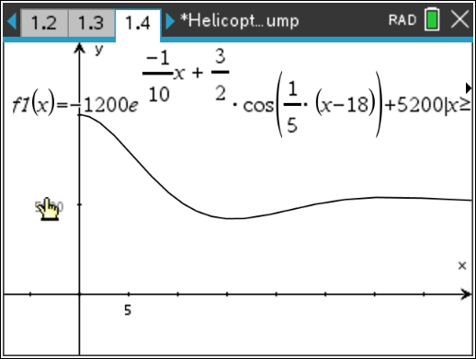
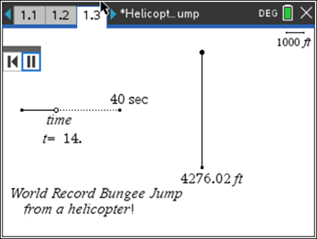
This activity begins by describing the record breaking bungee jump. Students see a “parametric” graph of the situation on page 1.3. The equation modeling the situation and the position graph are given on page 1.4. On the student worksheet, students use the Product Rule to take the first and second derivatives. The derivatives can be verified using a Calculator screen, but it is such a long function that it wouldn’t fit on the screen well. To begin, some students may find it helpful for organizational purposes to use CAS to solve for y′(t) = 0, y″(t) = 0, y′′′(t) = 0, and yIV(t) = 0. In this document, y(t) is defined to be equivalent to f1(t), but using y(t) in the Solve command gives decimal answers without the need of pressing / + · to approximate.
The questions are designed to develop student’s proficiency with TI-Nspire CAS technology and deepen understanding of the connection between y, y′, y″, y′′′.

For Questions 6 and 7 the Data & Statistics page is explored. Students should click the variable on the vertical axis to change between a position-time graph, a velocity-time graph, and an acceleration-time graph. Many compare and contrast discoveries can be made. Question 7 points out the limitations of a mathematical model. When the jumper is in freefall for first 4 seconds or so, the only acceleration should be gravity = 32 ft/s².

Student Solutions
- It is expected that students will say “v = 0” or “y = max/min”. Solving when the first derivative equals zero for a position-time graph gives the time when the velocity is zero. This will give the maximum or minimum position.
- y″(t) = acceleration
- y″(t) = 0 when t =5.5 s, 21.2 s, and 36.9 s
- yIV(t) = 0 for t > 15.7 s when t =16.6 s
- y″(t) = 0 when t = 5.5 s. The speed is 619.98 ft/s. (Speed is scalar and should not be negative.)
- When the height y is a minimum, the velocity graph is zero. The velocity in ft/s graph is identical to the velocity in mph except for the scale. The y, v, a, and j graphs all have a similar damped shape.
- Maximum acceleration is about 2.5 g (80 ft/s² / 32ft/s² = 2.5)
- Point of infection of y(x) is (21.218, 4684.477).

Part 2 – Graphically Examine Another Situation
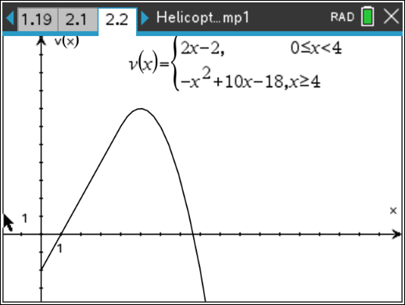
To test for understanding of calculus concepts, questions relating a graph of the derivative to the original function are effective. Students do not need to know the Power Rule for integration to do the first question. They do need to understand the concept of the integral and its notation. If students know how to find the area of a triangle, they can find this integral.
The only question in this series that uses the function is Question 12—using calculus to find when v is a maximum.
For further thought and discussion
- Verify that v(x) is continuous.
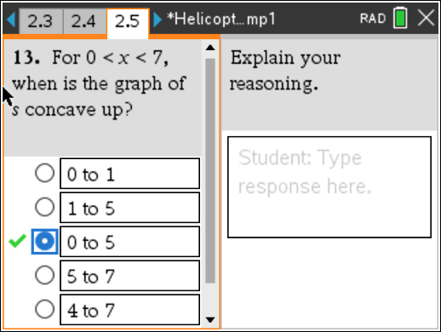
- Prove that v(x) is differentiable.
Students will relate concavity with the graphs in Question 13. Remind students that they are finding when the graph of s is concave up, not v as shown in the graph on page 2.2. Explaining answers “using calculus” is important to stress. Often, students justify that a function is increasing by saying “it is going up.” They should avoid the use of “it.” For example, “the derivative is positive, so the function is increasing.”
Question 14 asks when is the function s decreasing and to explain. This occurs when s′ < 0. Since s′ = v and v is negative between 0 and 1, that is the solution.
For further thought and discussion
- When is s increasing?
- When is s concave up?
- When is s′ concave down?

Student Solutions
- s(1) = 1 (1)(–2) = –1
2
- s′(1) = v(1) = 0
- s″(1) = v′(1) = slope = 2
- Max v occurs when v′ = 0. Max v occurs when v′ = –2x + 10 = 0. So x = 5.
- s″ > 0 when v′ > 0, i.e., when the slope of the graph is positive or when 0 < x < 5.
- s′ = v < 0, when 0 < x < 1

