Activity Overview
In this activity, students will split rational functions into sums of partial fractions. Graphing is utilized to verify accuracy of results and to support the understanding of functions being represented in multiple ways.

Topic: Rational Functions & Equations
- Least common denominator
- Sum of partial fractions
- Equivalent functions

Teacher Preparation and Notes
- This activity was designed for use with TI-Nspire technology, both CAS and non-CAS versions.
- Problems 1-3 in the .tns file should be done in class as guided practice or small group work. Several problems are provided on the student worksheet for additional practice.
- As an extension, the teacher could include a discussion of the placement of vertical asymptotes.
- Notes for using the TI-Nspire™ Navigator™ System are included throughout the activity. The use of the Navigator System is not necessary for completion of this activity.

Time Required = 45 minutes

Associated Materials
- BreakingUp_Student.doc
- BreakingUp.tns

Problem 1 – Introduction
This part of the activity involves an exploration of equivalent ways to express a rational function.  Students will generate function graphs from which they will learn that a rational function can be represented as the sum of individual fractions, known as partial fractions.  To make it clear to students that the graphs of f1 and f2 are identical, show students how to toggle between f1(x) and f2(x) by clicking up or down in the function entry line.  Students will answer questions regarding their observations of the graphs of the given equations. They are also asked to observe the denominators of the two functions. | 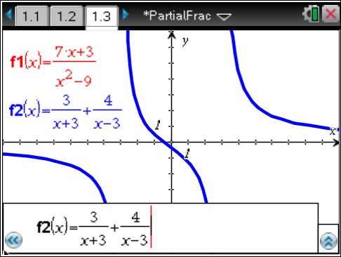  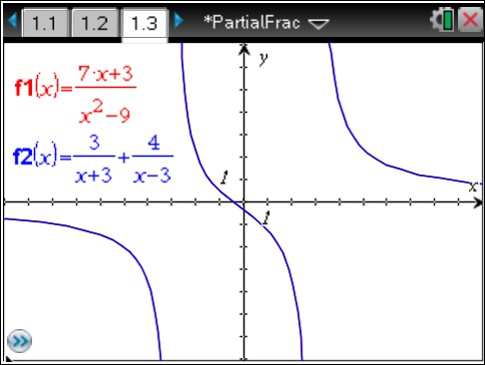
The denominators of the fractions in f2 are the factors of the denominator in f1.  Since the graphic results show that the two functions are equivalent, they are set equal to each other and a framework is established for finding the numerators of the partial fractions of a rational function. Directions are provided to help students through the process. | 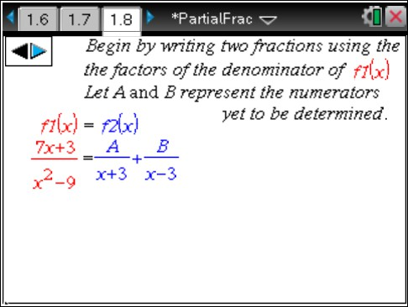
Students proceed to solve for A and B by substituting in values for x that will simplify the work to be done. For example, substituting –3 for x will eliminate the B term and simplify the process of solving for A. Similarly, substituting 3 for x will simplify solving for B.  Discuss with students why it might be helpful to decompose a rational expression into a sum of partial fractions. Students may note that the partial fractions, being less complex, will be easier to  work with for certain mathematical applications. | 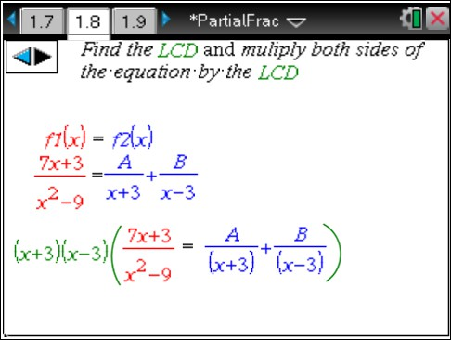

Problem 2 – Practice
Students apply what was learned in Problem 1 to find a sum of partial fractions equivalent to a given rational function.  Once the algebraic work is completed, students can verify the equivalence of their solution to the original function via graphing the two functions. Remind students to use the show/hide feature to the left in the function entry bar of the graph page to be certain that the graphs of the two functions are identical.  CAS TI-Nspire users may wish to take advantage of some of the special algebra tools (factor) available on Calculator pages. | 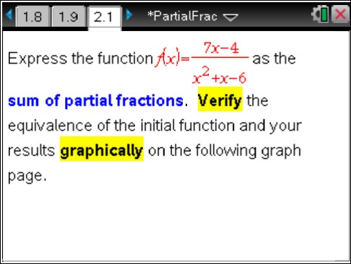
TI-Nspire Navigator Opportunity: Quick Poll and Screen Capture
See Note 1 at the end of this lesson.
Problem 3 – The Next Level
Students again apply what has been learned, but the challenge level increases.  In this situation, the denominator has a constant factor in addition to two binomial factors. A hint is given to prompt students to use the algebraic binomial factors as denominators for the partial fractions to be determined.  When students solve for A and B, they will find that the values for both A and B are fractions, which will result in a need for simplification of the partial fractions obtained. | 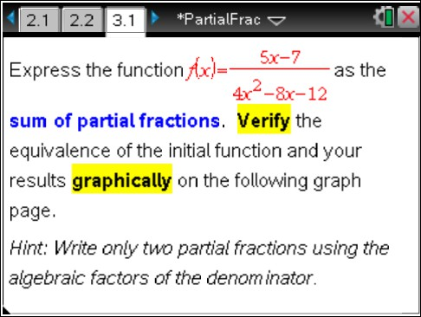
TI-Nspire Navigator Opportunity: Quick Poll and Screen Capture
See Note 2 at the end of this lesson.

Solutions – student worksheet
- The graphs are the same.
- The functions appear to be equal.
- The denominators of f2 are factors of the denominator of f1.
- x²–9 or (x–3)(x+3)
- 7x+3 = A(x–3) + B(x+3)
- 3
- 4
- 7x + 3 = 3 + 4
x2 − 9 x + 3 x − 3
- The results verify algebraically that the two functions are equivalent.
- 7x − 4 = 2 + 5
x2 + x − 6 x − 2 x + 3
- Yes; Same graph result verifies equivalent algebraic result.
- 5x − 7 = 1 + 3
4x2 − 8x − 12 2x − 6 4x + 4
- Yes; Same graph result verifies equivalent algebraic result.
- −7x − 11 = −2 − 5
x2 + 4x + 3 x + 1 x + 3
- 2x + 42 = 5 − 3
x2 + 2x − 24 x − 4 x + 6
- x = 2 + 1
x2 + 2x − 8 3x + 12 3x − 6

TI-Nspire Navigator Opportunities Note 1
Problem 1, Quick Poll, Screen Capture
Consider sending multiple Quick Polls for this problem requesting the information for each step. Asking questions like:
- What is the common denominator for the partial fraction?
- When is the result after multiplying through by the common denominator?
- What is the value for A? For B?
- What is the complete partial fraction?
Monitor student progress through the problem, especially if they are using CAS capabilities.

Note 2
Problem 1, Quick Poll, Live Presenter
Consider sending multiple Quick Polls for this problem requesting the information for each step. Asking questions like:
- What is the common denominator for the partial fraction?
- When is the result after multiplying through by the common denominator?
- What is the value for A? For B?
- What is the complete partial fraction?
Monitor student progress through the problem, especially if they are using CAS capabilities.

