Box-and-Whisker Plot Comparison

In this Activity, you will explore:
- making box-and-whisker plots on the TI-Nspire,
- comparing dot plots and box-and-whisker plots, and
- comparing box-and-whisker plots.

Open the file Box_Plots.tns on your handheld and follow the directions on the calculator and the worksheet. Use this document to answer questions and record results.

Comparing Dot Plots and Box-and-Whisker Plots

First, you will create a dot plot and box-and-whisker plot for the mean monthly temperatures for Washington, D.C. The data, which is listed below (and includes two other cities we will examine later), is also on page 1.6 of the file, entered for your use.
Mean Monthly Temperatures
Month Washington, DC Tampa, FL Caribou, ME
January 37 60 9
February 38 62 12
March 45 67 25
April 56 71 38
May 66 77 51
June 74 81 61
July 78 82 66
August 77 82 63
September 70 81 54
October 59 75 43
November 48 68 31
December 38 62 15

Starting on page 1.3, select the top half of the page and move your cursor using the ¡ , ¢, £, and ¤ keys to highlight the horizontal ‘Click to add variable’ box at the bottom of the top part of the split screen. Once you are inside the box area, you will see a list of the three cities available for analysis, dc for Washington, D.C., caribou for Caribou, Maine, and tampa for Tampa, Florida, as well as the variable for month. Select the variable dc (by placing the cursor over it or using the arrow key) and the dot plot will appear.  Next, move to the bottom split by clicking within it and move to ‘Click to add variable’ and again select dc. At this point, you should have two dot plots for Washington, D.C. | 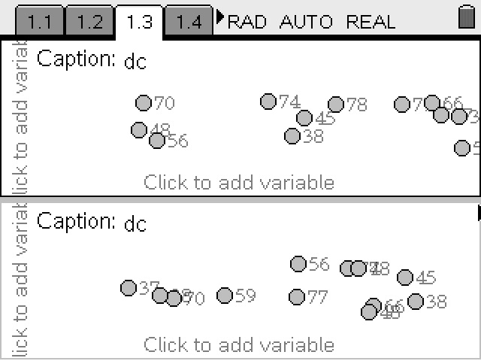

Now that you have two dot plots, select the b key (make sure that you are in the highlighted bottom half of the split – use your cursor to move if necessary). Once you are in the menu, select Plot Type and Box Plot. You should now have a dot plot on top of a box-and-whisker plot, both representing the data set of mean monthly temperatures for Washington, D.C.

What comparisons can you make between the dot plot and the box plot?

How many dots are in each quartile of the box-and-whisker plot? What does this tell you?

What can you state about the spread of the data based on the box-and-whisker plot?

Now, compare the mean monthly temperatures for Caribou, Maine with the mean monthly temperatures for Washington, D.C.

Move to page 1.4, ‘Click to add variable’ and select the variable caribou for the top split and dc for the bottom. Using the b key, select Plot Type and Box Plot for each split.

Is it fair to compare the mean monthly temperatures for the two cities? Why or why not?

So, in order to correctly make meaningful comparisons using box-and-whisker plots, they need to have the same scale. So, select b, Window/Zoom and Window/Settings. Set both of the two box-and-whisker plots to the same scale (being sure to include the minimum and maximum values for both cities).

Compare the box-and-whisker plots for Caribou, Maine and Washington, D.C. What observations can you make?

What do these observations imply about the climate differences between the two cities?

Now, compare the mean monthly temperatures for Tampa, Florida with the mean monthly temperatures for Washington, D.C.

Now go to on page 1.5, ‘Click to add variable’ and select the variable tampa for the top split and dc for the bottom. Using the b key, select Plot Type and Box Plot for each split.

Again, in order to make a fair comparison, set the scales to be the same.

Compare the box-and-whisker plots for Tampa, Florida and Washington, D.C. What observations can you make?

What do these observations imply about the climate differences between the two cities?

Analysis/Extension

What have you learned about comparing box-and-whisker plots?

