# STAAR-EOC-Parallel Lines with Cabri Jr.

This lesson will show the relationships that exist with angles formed by parallel lines and transversals. Use the Cabri Jr. for the TI-84.

Follow the instructions given in the steps below and answer the questions based on your exploration.

**1**. Open the **Drawing Tools Menu (F2)**, and then highlight **Line**. Press e.

***Note:*** *The tool icon at the top left of the screen indicates that the* **Line** *tool is active.*

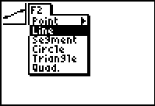

**2.** Move the cursor to the middle of the screen and press e to anchor the line. Move the cursor and press e again to anchor another point on the line.

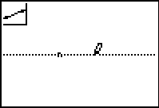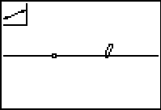

**3**. Open the **Drawing Tools Menu (F2)**, and then highlight **Point**. Move the cursor to a point not on the line. Press e.

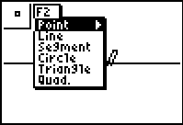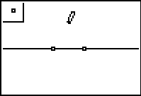

**4.** Open the **Construction Tools Menu (F3)** and highlight **Parallel**. Press e.Move the cursor to the point not on the line. The point blinks when the cursor is close enough to the point to select it. Press e to select this point. The point will continue to blink. Move the cursor to the line….it will blink when it can be selected. Press e**.**

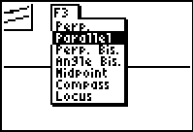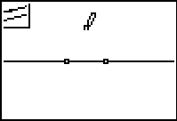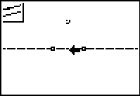

This should produce a picture similar to the one below. Press C to stop this construction.

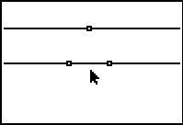

**5**. Open the **Drawing Tools Menu (F2)**, and then highlight **Line**. Press e. Move the Draw Tool a point on the original line and press e to anchor one endpoint of a new line. Move the cursor to the point on the parallel line. Make sure that the point is blinking and press e to anchor the other point of the new line.

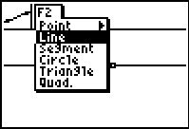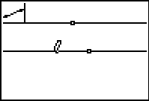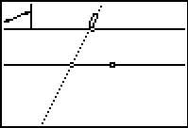

This should produce a picture similar to the one below. Press C to stop this construction.

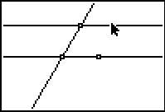

**6.** Open the **Drawing Tools Menu**, and then highlight **Point**. Move the cursor to a point on the line. Press e.

**7.** Repeat the process to include all the points shown below.

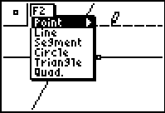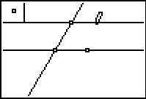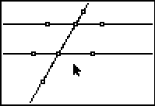

**8.** Open the **Display Tools Menu**, and then highlight **Measure**. Press > and e toselect angle. To measure an angle, highlight each of the three points that define the angle with the vertex in the middle of the group. Press e. When the measurement appears on the screen, the “hand” indicates you can relocate the measurement to a convenient place. Press e when you are satisfied with the location.

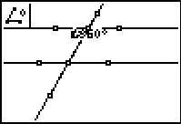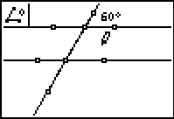

Repeat the measurement process to measure other angles of interest on the drawing.

**9.** Sketch your drawing from your screen and label the measurements and name the points.



When two parallel lines are cut by a transversal (a line that crosses the two lines), special angles are formed. Look at your drawing above and, using your measurements, give the measurements for the angles described in the following statements:

Angles that are on the same side of the transversal and in the same position relative to the parallel lines are called ***corresponding angles***. Name the measures of two pairs of corresponding angles from your drawing above.

_________________________ __________________________

Angles that are on the interior of the two parallel lines and alternating sides of the transversal are called ***alternate interior angles***. Name the measures of two pairs of alternate interior angles from your drawing above.

_________________________ __________________________

Angles formed by two intersecting lines are called ***vertical angles***. Name the measures of two pairs of vertical angles from your drawing above.

_________________________ __________________________

Angles that are on the exterior of the parallel lines and alternate sides of the transversal are called ***alternate*** ***exterior angles***. Name the measures of two pairs of alternate exterior angles from your drawing above.

_________________________ __________________________

Angles that are on the exterior of the parallel lines and same-sides of the transversal are called

***same-side interior angles***. Name the measures of two pairs of same-side interior angles from your drawing above.

_________________________ __________________________

**10**. Move the cursor to one of the points used to construct the parallel lines. When the point is blinking, press a key to “grab” the point. Use the > or < key to move the point.

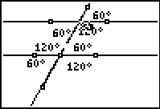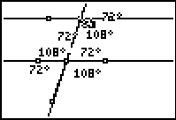

**Watch what happens to the measurements of the angles. Use what you notice about the measurements as the line moves to answer the questions below.**

**Questions**

**1.** Explain the relationships between the pairs of angles when the transversal is moved.

____________________________________________________________________________________________________________________________________________________________________________________________________________

**2.** Explain the relationship between the pairs of angles when one of the parallel lines is moved.

________________________________________________________________________________________________________________________________________

____________________________________________________________________

**Complete the following statements.**

**3**. If two parallel lines are cut by a transversal, alternate interior angles are ___________________________________________________________________.

**4**. If two parallel lines are cut by a transversal, corresponding angles are _______________________________________________________.

**5**. If two parallel lines are cut by a transversal, alternate exterior angles are ______________________________________________.

**6**. If two parallel lines are cut by a transversal, same-side interior angles are ______________________________________________.

Use the information you have gathered in the activity above to answer the following question.

49. Line **t** intersects parallel lines ***l***1 and ***l***2, as shown below.

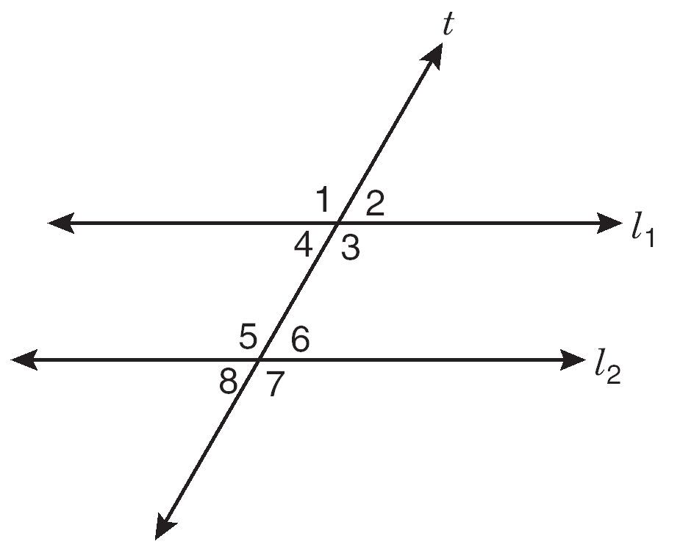

According to the information provided, which of the following pairs of angles are not always congruent?

A Same-side interior angles 4 and 5

B Alternate interior angles 3 and 5

C Corresponding angles 2 and 6

D Vertical angles 5 and 7