Cobweb Plots: Investigating Chaos  ID: 9974 | Name ____________________________
Cobweb Plots: Investigating Chaos  ID: 9974 | Class ____________________________

In this activity, we investigate population growth using a variety of representations, leading to some observations about stable and unstable populations as an introduction to chaos theory.  Open the file ActXX_Web_Plots2_EN.tns on your handheld and follow along with your teacher to work through the activity. Use this document as a reference and to record your answers. | 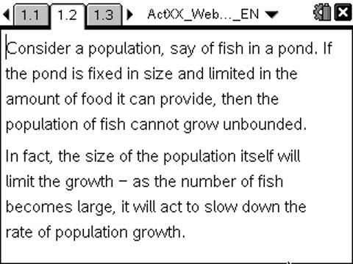
The Problem: Consider a population, say of fish in a pond. If the pond is fixed in size and limited in the amount of food it can provide, then the population of fish cannot grow unbounded. In fact, the size of the population itself will limit the growth - as the number of fish becomes large, it will act to slow down the rate of population growth.  A simple model of such a situation over time is given by the relationship $F(x)=R∗x∗(1−x)$  In this model, the value of "x" (the population of fish) may vary between 0 and 1, and "R" is the "growth rate" of the population. Such a "logistic equation" proves useful in studying real world populations.  Note that as x approaches its upper value of 1, this will cause the population to decrease. The points where the graph of this function meets the identity function (I(x) = x) are called equilibrium points and indicate zero population growth in a year. | 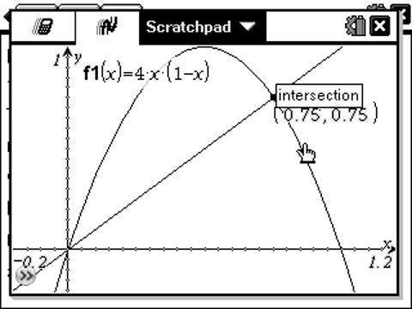  In the example shown, with R = 4, we see that there are two equilibrium points, at x = 0 and x = 0.75. These are the solutions to the equation 4*x*(1 - x) = x.  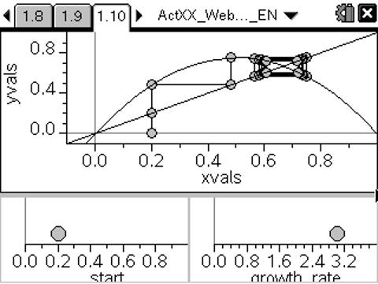
EXERCISES
- Can you explain why such equilibrium points indicate zero population growth?  More interesting is to consider the behavior (or orbit) of a point which is NOT an equilibrium point. For varying values of R, the behavior of such orbits is quite different.  Use the spreadsheet and graphs provided to explore the effects of varying the initial population, (start) and the growth rate (R). | 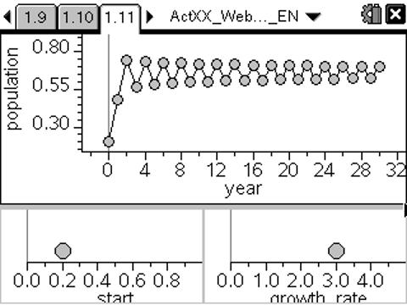
- Carefully describe the effects upon the population growth of changes to the start value.
- Carefully describe the effect of changing values of the growth rate upon the population growth.
One of the characteristics of chaotic behavior in complex systems appears to be a feature known as period doubling. When R = 3, you should observe that the population oscillates between two stable values - this is an example of a period 2 cycle. By the time R = 3.5, however, there is clearly a change - in fact, we have moved to a period 4 cycle (hence the term "period doubling"!)
- Try to find the values of R at which these period changes occur, from 2 to 4, from 4 to 8...
By around 3.83... all cycles of the form 2^n appear to have been exhausted, and 3-cycles take over. These occur even more rapidly and by the time R = 4 the system has reached a chaotic state.
CAS Extension: If you have access to a computer algebra system, you may explore these elements of chaos further. Use the program webplot(function, start, iterations) to study other functions in this way. e.g. try 2x and even sin(π*x).
- Can you find other functions that lead to equilibrium or to chaos?
These are the elements of chaos, a field at the cutting edge of mathematics and human knowledge. There is much yet to be learned about its properties and applications, and yet it is accessible through such simple models as those studied here. Be patient and systematic and you may discover something new and unexpected!

SUGGESTED SOLUTIONS
- If the initial population is x, then the population after one year is F(x). After two years, F(F(x)), and so on. If F(x) = x, then F(F(X)) = x and so on.
- Apart from the two equilibrium points for the function, the start value has little impact upon the population growth in the medium to long term.
- The value of R has great impact upon the population growth. For small values of R (< 3) the population quickly settles to equilibrium. Between 3 and 4, the growth moves from stability to instability - in fact, to chaos.
- It appears that for values of R between 3 and 3.43... the cycle has period 2. For 3.43... < R < 3.53... the cycle is of period 4.

