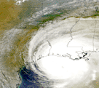
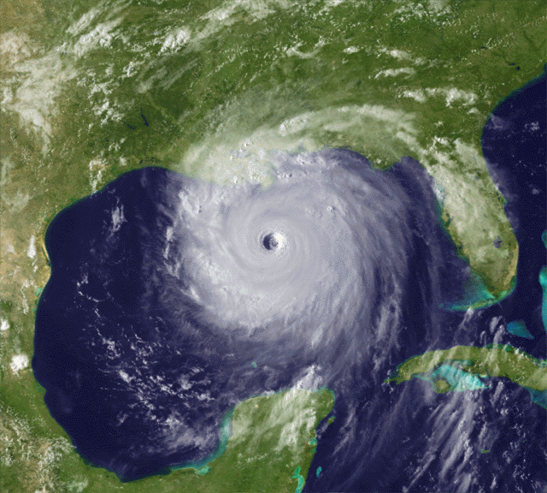
Tracking Katrina and Rita

Hurricane Katrina 8/29/05 Hurricane Rita 9/24/05

Within 3 weeks Louisiana was hit by two very strong hurricanes. Hurricanes Katrina and Rita have changed the “face” of coastal Louisiana and Mississippi forever. Hurricane Katrina evacuees are currently living in almost every state in the United States.

Hurricane Season runs from June 1 – November 30 in the Atlantic, Caribbean and the Gulf of Mexico.

During the 2005 hurricane season including Epsilon and Zeta, there were 27 named storms, surpassing the record of 21 set in 1933. Thirteen of the storms were hurricanes, edging by one the previous record set in 1969. Seven of the hurricanes were in 2005 were considered major. Three of the hurricanes in the 2005 season reached Category 5 status, meaning they had wind speeds greater than 155 mph at some point during the arc of the storm.

Hurricane Camille hit Biloxi, Mississippi August 17, 1969 with winds of 190 mph. 255 people were killed. This had been the deadliest hurricane to hit the gulf coast region until Katrina.

From Louisiana Advisory Board ( December 19, 2005)

(http://lra.louisiana.gov/assets/12212005.ppt#556,1,Slide 1)

$37 Billion is the estimated cost (19 times per capita cost of 9/11 World Trade Center disaster)

$40 Billion in insured losses for Katrina and $5 Billion for Rita (Katrina 7 times greater than average for top 10 hurricanes)

275,000 homes destroyed by Katrina (10 times those destroyed by next most destructive Hurricane Andrew)

650,000 people displaced from their home by Katrina. (6 times more than any other state impacted.)

Increase of 240,000 unemployed people (5 times more than in Mississippi)

At least 1,071 killed (5 times any other state) not including pending deaths from more than 6,000 missing.

217,000 homes destroyed (3 times more than any other state)

875 schools damaged and 40 schools destroyed

10 hospitals closed

18,750 businesses destroyed (10 times more any other state)

NCTM Standards:

Understand patterns and functions

Use mathematical models to represent and understand quantitative relationships

Formulate questions that can be addressed with data and collect, organize, and display relevant data to answer them

Select and use appropriate statistical methods to analyze data

Develop and evaluate inferences and predictions that are based on data

Connections Standards:
- Recognize and apply mathematics in contexts outside of mathematics
Below are some Cities along the Gulf Coast. Listed are their longitudes and latitudes.
City | Longitudes | Latitudes
New Orleans, Louisiana | 90.0W | 30.0N
Biloxi, Mississippi | 89.0W | 30.5N
Mobile, Alabama | 88.0W | 30.6N
Pensacola, Florida | 87.1W | 30.2N
Panama City, Florida | 85.6W | 30.2N
Baton Rouge, Louisiana | 91.1W | 30.5N
Houma, Louisiana | 91.2W | 29.6N
Lake Charles, Louisiana | 93.13W | 30.7N
Houston, Texas | 95.21W | 29.58N

- Student Prompt: For the cities to graph either the longitude or the latitude should be negative. Which should be negative and why? Explain.

__________________________________________________________________________________________

Tracking Hurricane Katrina
- Clear the list :  Edit  to darken L1 repeat for and 

- Enter the latitude and longitude for the gulf coast cities in and  . Put your x list in  and your y list in 
Student Prompt: Should latitude or longitude be in the x list? Explain.  

- Use plot 1, a scatter plot and the square to graph the cities.
□ (Turn on plot 1) or 1  Type:  Xlist:  Ylist:  and Mark: 

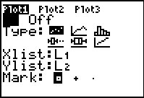

Tracking info for Hurricane Katrina
Time Latitude Longitude Wind(mph) Pressure Storm type
21 GMT 08/23/05 23.2N 75.5W 35 1007 Tropical Depression
03 GMT 08/24/05 23.4N 76.0W 35 1007 Tropical Depression
09 GMT 08/24/05 24.0N 76.4W 35 1006 Tropical Depression
15 GMT 08/24/05 24.7N 76.7W 40 1006 Tropical Storm
21 GMT 08/24/05 25.6N 77.2W 45 1002 Tropical Storm
03 GMT 08/25/05 26.0N 78.0W 50 1001 Tropical Storm
09 GMT 08/25/05 26.2N 78.7W 50 1000 Tropical Storm
15 GMT 08/25/05 26.2N 79.3W 60 997 Tropical Storm
21 GMT 08/25/05 26.1N 79.9W 75 985 Category 1 Hurricane
03 GMT 08/26/05 25.5N 80.7W 75 984 Category 1 Hurricane
09 GMT 08/26/05 25.3N 81.5W 75 987 Category 1 Hurricane
15 GMT 08/26/05 25.1N 82.2W 75 981 Category 1 Hurricane
15 GMT 08/26/05 25.1N 82.2W 80 981 Category 1 Hurricane
15 GMT 08/26/05 25.1N 82.2W 100 971 Category 2 Hurricane
21 GMT 08/26/05 24.8N 82.9W 100 965 Category 2 Hurricane
03 GMT 08/27/05 24.6N 83.6W 105 965 Category 2 Hurricane
09 GMT 08/27/05 24.4N 84.4W 115 945 Category 3 Hurricane
15 GMT 08/27/05 24.5N 85.0W 115 940 Category 3 Hurricane
21 GMT 08/27/05 24.6N 85.6W 115 945 Category 3 Hurricane
03 GMT 08/28/05 25.0N 86.2W 115 939 Category 3 Hurricane
06 GMT 08/28/05 25.1N 86.8W 145 935 Category 4 Hurricane
09 GMT 08/28/05 25.4N 87.4W 145 935 Category 4 Hurricane
12 GMT 08/28/05 25.7N 87.7W 160 908 Category 5 Hurricane
15 GMT 08/28/05 26.0N 88.1W 175 907 Category 5 Hurricane
21 GMT 08/28/05 26.9N 89.0W 165 902 Category 5 Hurricane
03 GMT 08/29/05 27.6N 89.4W 160 904 Category 5 Hurricane
09 GMT 08/29/05 28.8N 89.6W 150 915 Category 4 Hurricane
15 GMT 08/29/05 30.2N 89.6W 125 927 Category 3 Hurricane
21 GMT 08/29/05 31.9N 89.6W 75 960 Category 1 Hurricane
03 GMT 08/30/05 33.5N 88.5W 60 973 Tropical Storm
09 GMT 08/30/05 34.7N 88.4W 50 981 Tropical Storm

http://www.wunderground.com/hurricane/at200512.asp

- Use  and  to enter the longitude and latitude of Katrina into the calculator. Put the x list in  and the y list in .
- Use Plot 2 to graph this data.
□ (Turn on plot 2) 2 Type:  Xlist: Ylist: and Mark: +
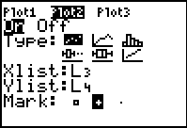

- Graph the path of Hurricane Katrina. Two ways

- Look at the domain and range for both plots. Set the x min, x max, xscl, ymin, ymax and yscl in the window. When my students first start to do graphing I have them set the window. After I know they understand the domain and range mathematically I show them how to. Even if they use  they show me their window and explain why the calculator set that window.

-  9 (ZoomStat) will set the window to graph the path of the hurricane 

 
- Look at the path of Hurricane Katrina.
Student Prompt: What mathematical function do you think would model Katrina’s path? Explain.

- To find regression to model the path of Hurricane Katrina
 6 (Cubic Regression),, Y-VARS1(Function) Y1
This will find the cubic regression.

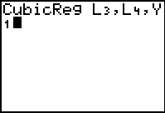

Student Prompt: What does the R² tell you about the cubic function and the entire path of Hurricane Katrina?
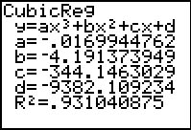

Student Prompt: Why was the original prediction for landfall of this hurricane the panhandle of Florida? Explain.

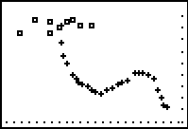

Tracking Hurricane Rita
- Turn off plot 2 in □ (Leave Plot 1 turned on because these are your cities.)
- Enter coordinates of Hurricane Rita in and 
Time Latitude Longitude Wind(mph) Pressure Storm type
03 GMT 09/18/05 22.0N 69.7W 30 1009 Tropical Depression
09 GMT 09/18/05 21.7N 71.2W 30 1008 Tropical Depression
15 GMT 09/18/05 22.0N 72.2W 35 1008 Tropical Depression
21 GMT 09/18/05 22.2N 72.7W 40 1006 Tropical Storm
03 GMT 09/19/05 22.9N 73.3W 50 1002 Tropical Storm
09 GMT 09/19/05 22.7N 74.3W 60 998 Tropical Storm
15 GMT 09/19/05 23.0N 75.2W 65 994 Tropical Storm
21 GMT 09/19/05 23.3N 76.5W 70 995 Tropical Storm
03 GMT 09/20/05 23.3N 77.8W 70 990 Tropical Storm
09 GMT 09/20/05 23.7N 79.5W 70 988 Tropical Storm
15 GMT 09/20/05 23.8N 81.0W 85 982 Category 1 Hurricane
18 GMT 09/20/05 23.9N 81.7W 100 978 Category 2 Hurricane
21 GMT 09/20/05 24.0N 82.2W 100 973 Category 2 Hurricane
03 GMT 09/21/05 24.1N 83.2W 110 965 Category 2 Hurricane
09 GMT 09/21/05 24.3N 84.6W 120 956 Category 3 Hurricane
15 GMT 09/21/05 24.3N 85.9W 140 944 Category 4 Hurricane
21 GMT 09/21/05 24.4N 86.8W 165 914 Category 5 Hurricane
03 GMT 09/22/05 24.6N 87.2W 175 897 Category 5 Hurricane
09 GMT 09/22/05 24.9N 88.0W 175 897 Category 5 Hurricane
15 GMT 09/22/05 25.4N 88.7W 165 907 Category 5 Hurricane
21 GMT 09/22/05 25.8N 89.5W 145 913 Category 4 Hurricane
03 GMT 09/23/05 26.2N 90.3W 140 917 Category 4 Hurricane
09 GMT 09/23/05 26.8N 91.0W 140 927 Category 4 Hurricane
15 GMT 09/23/05 27.4N 91.9W 135 929 Category 4 Hurricane
21 GMT 09/23/05 28.2N 92.6W 125 930 Category 3 Hurricane
03 GMT 09/24/05 29.1N 93.2W 120 931 Category 3 Hurricane
09 GMT 09/24/05 29.9N 93.9W 120 937 Category 3 Hurricane
15 GMT 09/24/05 31.0N 94.3W 75 960 Category 1 Hurricane
21 GMT 09/24/05 32.1N 94.0W 50 980 Tropical Storm
03 GMT 09/25/05 33.0N 93.9W 35 985 Tropical Depression

Tracking info for Hurricane Rita

http://www.wunderground.com/hurricane/at200518.asp?imgfeature=image&textfeature=track

- Turn on Plot 3 to graph hurricane Rita.
□ (Turn on plot 3) 3 Type:  Xlist: Ylist: and Mark: ·

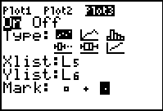
- Graph by setting  or  9.

- Look at the path of Hurricane Rita.
Student Prompt: What mathematical function models the path of hurricane Rita? Is it the same function as the path of hurricane Katrina? Explain.

- Try QuadReg (5) and and QuartReg (7). Remember the x-list is and the y-list is .
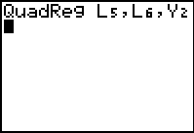
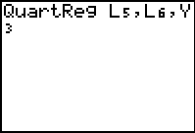

Student Prompt: Which function regression is the best fit? Defend your answer.

Comparing Katrina and Rita.
- Turn on Plot 2
- Graph both hurricanes  9 or 
- Student Prompt: Compare and contrast the paths of these two hurricanes.
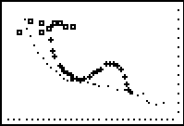
_________________________________________________________________________________
Extension: Run program KATPRWI. This will put the pressure and wind speed of Hurricane Katrina.
Student Prompt: What relationship do you observe between the pressure in the eye of the hurricane and the wind speed in the eye wall of the hurricane? What function would model this relationship?
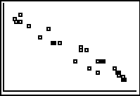
How to write a program to save data: (To store data typed in list in a program to recall at a later time.)
New Name (name program so you will know what data you have saved)
:(Recall)(or whatever list you want to recall)(or whatever list you want the program to re-enter the data) 
:(Recall) (or whatever list you want to recall) (or whatever list you want the program to re-enter the data) 
Repeat for each list you want to save to re-enter by running the program.
 to get out of program

How to run program
- EXEC and then run whatever program you have developed to save your lists. When the screen says DONE then your lists will be back in the  Edit lists.

Resources

National Hurricane Center
http://www.nhc.noaa.gov/

Kids page for weather in the classroom
http://www.weatherwizkids.com/trackingcharts.htm

Hurricane Tracking charts to print
http://www.nhc.noaa.gov/AT_Track_chart.pdf

(This map will give you coordinates for any active hurricane by placing the mouse over the coordinate. You can get information on time, wind speed, etc.)
http://www.hurricanetrack.com/Java/westatl.html

At this web site you can find information on any hurricane up to 2004
http://www.nhc.noaa.gov/pastall.shtml

Find the latitudes and longitudes of any city in the world at this web site.
http://www.jgiesen.de/astro/astroJS/rsTable/cities.htm

http://www.lat-long.com/?utm_source=google&utm_medium=ppc&utm_campaign=coordinates

Cross Curriculum lesson plans on weather
http://faldo.atmos.uiuc.edu/w_unit/weather.html

K – 12 lesson plans on weather
http://school.discovery.com/lessonplans/weather.html

A big thanks from the people of Louisiana for the donations of clothes, supplies, food, money and prayers after the hurricanes.

