Gettin’ the Swing  ID: 11691 | Time Required  40–45 minutes

Activity Overview
In this activity, students will investigate sinusoidal functions, collect data from a swinging pendulum, model the data with a cosine function, and take the derivative to find the velocity and acceleration.

Topic: Model Sinusoidal Data
- Write an equation for a sinusoidal function.
- First and second derivative to determine velocity and acceleration

Teacher Preparation and Notes
- Students will need to know that the derivative of position is velocity, and the derivative of velocity is acceleration. Students are also expected to know the derivative of trigonometric functions.
- The activity is designed to be a student-centered discovery/review involving data collection. If a motion sensor is not available, then use the data from the lists provided.
- In order to collect data using the Calculator-Based Ranger 2™, use the Ranger program. To download the Ranger program, go to education.ti.com/exchange and enter “ranger program” in the search box.
- To download the calculator lists (.tns files) and student worksheet, go to education.ti.com/exchange and enter “11691” in the quick search box.

Associated Materials
- CalcWeek14_GettinTheSwing_Worksheet_TI89.doc
- time.89l
- distance.89l
- velocity.89l
- Calculator-Based Ranger 2™ or Vernier Go!™ Motion
- pendulum (smooth ball hanging from a string)
- meter stick
- stop watch

Suggested Related Activities
- Derivatives of Trigonometric Functions (TI-Nspire CAS technology) — 9290
- Graphs of Sine and Cosine (TI-Nspire technology) — 9431
- Vertical and Phase Shifts (TI-84 Plus) — 9608

Part 1 – Warm-up
Students begin the activity by answering questions to help them visualize and review characteristics of sinusoidal functions.  Next, students will translate the cosine function to explore the effects of varying the parameters of the general sinusoidal functions. Students will use a split screen to view the equation and graph of the function at the same time. Students should see that as B increases the period decreases. Students should also see that this relationship involves 2π. | 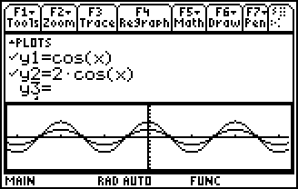
Further Discussion
- Ask students what the derivative of y = cos(x) is. When the A = 1, B = 1, C = 0, and the D is set at π/2, the graph looks likes y = –sin(x).
Student Solutions
1. range is from –1 to 1
2. amplitude A = 1
3. period T = 2π
4. A makes the amplitude bigger
5. C produces a vertical shift
6. B changes the frequency
7. ; The inverse function graphed on 3.2 confirms this.
8. y = A ∙ cos(B ∙ (x – D)) + C

Part 2 – Collect & Analyze Data
This part of the activity begins with students plugging in the CBR 2™ or Go!™ Motion with an I/O cable. (Note: the mini USB cables will not work with this program.) Students should start the Ranger program. The experiment should be set up to match the settings shown on the student worksheet. When  is pressed, data is collected. If there is a wall, chair, person or some other object that “distracts” the motion detector, the data may not look as good as depicted on the right. Students can repeat the experiment by pressing  and select 3:Repeat Sample. Have student repeat the data collection until they are pleased with the shape of the graph. | 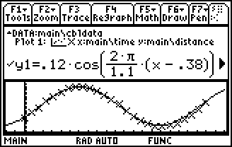
Be sure to use a smooth ball so that the sonic pulse is reflected off the surface well. | 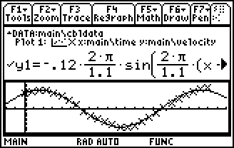
Students can see the connection to real life more clearly if meter sticks and stop watches are available. Students can measure the period with the stop watch. With the meter stick they can see how far the pendulum is from the motion detector when the ball is at rest. This will be their C. Also they can measure how far they pull the pendulum. This is the amplitude. The phase shift is related to when they pressed start to collect the data.
Student Solutions
The graphs and equations for the experiment will vary. The following equations correlate to the data in the given lists.

