Activity Overview
In this activity, students will use the capabilities of their handhelds to find limits and compare two series to determine if the alternating series converges or diverges. Then students will approximate the sum of an alternating series by using a table to find partial sums and using the Alternating Series Remainder theorem.

Topic: Rational Functions & Equations
- Prove and apply the alternating series test for convergence.

Teacher Preparation and Notes
- Students should be familiar with setting up spreadsheets and using the calculator prior to beginning this activity.
- Review p-series, the sum of a geometric series as well as the definition of a harmonic series before doing this worksheet.
- Notes for using the TI-Nspire™ Navigator™ System are included throughout the activity. The use of the Navigator System is not necessary for completion of this activity.

Time Required = 45 minutes

Associated Materials
- AlternatingSeries_Student.doc
- AlternatingSeries.tns
- AlternatingSeries_Soln.tns

Problem 1 – Introduction to an Alternating Series
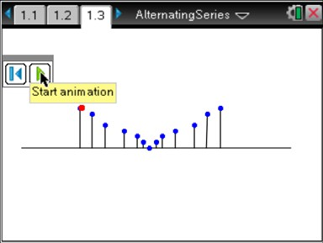
Instruct students to go to page 1.3. A large dot touches the top of each vertical line segments. Students should see that the dot goes back and forth until it goes to the middle of the figure; the process repeats.
Discuss the illustration with students and have them answer the questions on their worksheet.
When the terms of an infinite series alternate in sign for every term (+, –, +, –, +…) or (–, +, –, +, –
…), then the series is called an alternating series.
TI-Nspire Navigator Opportunity: Live Presenter
See Note 1 at the end of this lesson.

Problem 2 – Alternating Series Test
The Alternating Series Test emphasizes that certain conditions must be met for an alternating series to be convergent.
∞ ∞
If an alternating series ∑ (−1)na or ∑ (−1)n +1a converges, then these conditions must hold.

- lim a = 0
n
x →∞
n = 1
n n
n = 1

- an + 1 ≤ an for all n
Students are to use pages 2.3 to 6.1 to test both of these conditions.
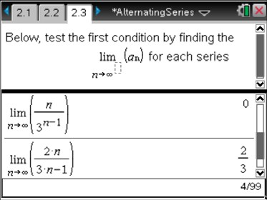
They will first use the Calculator page to find the limit for each a_{n}

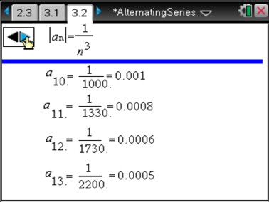
Students will use pages 3.2 to 6.1 to check each value. Students will click on the arrows to create each new a_{n} term in the sequence.
Discuss which of the four series converges and why.
The first 3 series converges because they satisfy both conditions. The last series diverges because the limit is not equal to zero.

TI-Nspire Navigator Opportunity: Quick Poll and Live Presenter
See Note 2 at the end of this lesson.

Problem 3 – Alternating Series Estimation
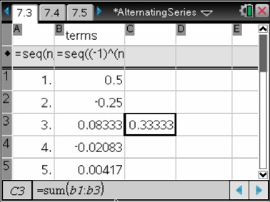
A convergent alternating series, has a partial sum, S_{n}. It can be used to find the approximation for the total sum S of the series.

If lim a = 0
n
x →∞
and an + 1 ≤ an
hold true then the absolute

value of the remainder (R_{n}) is less than or equal to the first neglected term.
That is S − Sn = Rn ≤ an + 1 . R_{n} can also be
referred to as the error.

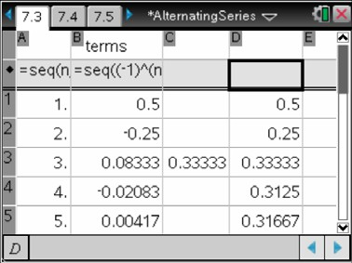
Students will use the spreadsheet on page 7.3 to observe the partial sums of an alternating series.

∞
∑
n =1
(−1)n −1 2n !

In cell C3, students are to use the formula =sum(b1:b3) to find the sum of the first 3 terms. Then, in cell C6, they use =sum(b1:b6) to find the sum of the first 6 terms.

a1 (−1)n −1

To see the partial sums of the first 50 terms students are to enter the formula ∑
n =1
in
2n !

cell d1. Then they can use the Fill Down command to complete the rest of the sums for the Column D. So Column A contains the number of the term, Column B the term, and Column D the partial sum to that point.
TI-Nspire Navigator Opportunity: Live Presenter
See Note 3 at the end of this lesson.

Student Worksheet Solutions
- The white dot goes back and forth.
- The dot goes from negative to positive and continues this pattern OR signs alternate.
- The series is alternating and its values approach 0.
- converges
- converges

- converges
- diverges

- i)
S ≈ 0.33333 and a = 1 ≈ 0.02083

3 4 48
Therefore 0.33333 − 0.02083 ≤ S ≤ 0.33333 + 0.02083
0.31250 ≤ S ≤ 0.35416

ii)
S ≈ .31597 and a = 1 ≈ 0.0001

6 7 10080
Therefore .31597 − 0.0001 ≤ S ≤ 31597 + 0.0001
0.31587 ≤ S ≤ 0.31607
- The change becomes smaller.
- The interval where the actual sum lies will become more precise and a better approximation can be made.

TI-Nspire Navigator Opportunities

Note 1
Problem 1, Live Presenter
This is an excellent place to use Live Presenter to have the animation on page 1.3 on the screen while having the class discussion for Questions 1–3.

Note 2
Problem 2, Quick Poll and Live Presenter
Send a Quick Poll for Questions 4–7. Use Live Presenter to help clear-up any misconceptions the Quick Polls identify.

Note 3
Problem 3, Live Presenter
It may be necessary to use Live Presenter to help students with the Lists & Spreadsheet page.

