Introduction
When one quantity changes at a constant rate with respect to another, we say these quantities are linearly related. Mathematically, we describe this relationship by defining a linear equation. In real-world applications, many quantities are linearly related and can be represented using a straight- line plot.

Objectives  In this activity you will:  - Create constant-speed motion plots.  - Develop linear equations to describe these plots mathematically.  You'll Need  - TI 84 Plus CE, with Vernier EasyData™ App  - CBR 2™ motion sensor unit with mini-USB connecting cable | 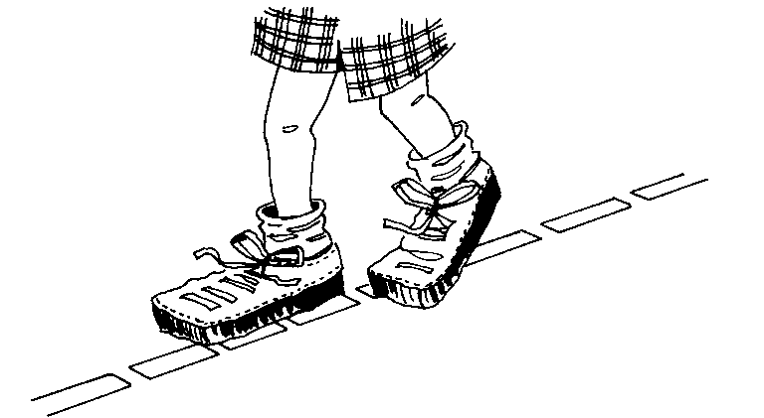
Using the CBR 2™ motion sensor and Vernier EasyData™ App  Connect the handheld with the CBR 2 using the USB cable. EasyData will immediately open, and the CBR 2 will begin collecting distance data every time it clicks. In the EasyData app, the tabs at the bottom of the screen indicate the menus that can be accessed by pressing the actual calculator keys directly below the tabs. |  | 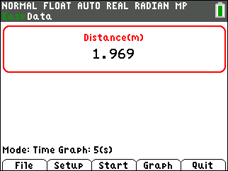
Collecting the Data  You will be walking at a constant speed to make a distance time plot. Depending on your teacher’s instructions, start your walk so that the CBR 2 will measure about 0.15 meters (6 inches). Prepare to walk directly away from the CBR 2 or from the target at a slow but steady speed. Once data collection begins, move in this manner for approximately 5 seconds. |  | 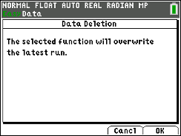
After the plot is displayed, if you are not satisfied with your graph, press s to go back to . When you select , you will get a warning message. Be ready because as soon as you select , the CBR 2 will immediately start collecting data. To find how far you were at the end, use the right arrow key ~ to move along the plot. The coordinates appear at the top.  Sketch your plot to the right. Indicate the scale on the axes. |  | 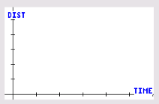
Looking at the Results

The slope-intercept form of a linear equation is

Y = mX + b

where m is the slope or steepness of the line and b is the intercept or starting value. In this activity, the independent variable, X, represents time and the dependent variable, Y, represents distance.

1. Use the arrow keys on the calculator to move the cursor along the Distance-Time plot. Identify the starting value (the Y-value when X = 0) and record this below as the y-intercept, b.

b = __________________
2. Exit EasyData by selecting and then selecting . The message will tell you that the time is in L1. Distance will be in L6. Select . You should be on the Home screen.
3. Enter the y-intercept value from question1, then press ¿ ƒ [B]Í to store this value to the variable B on your calculator.  4. Press o and enter the expression M*X+B. Press y5 to go back to the home screen.  We want to find the equation of the line that you walked by using a guess-and-check method in order to find the slope (m) of your walk. |  | 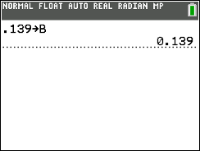  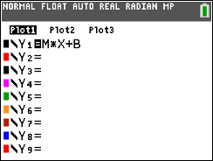
5. On the home screen, store an initial guess for m by storing 1 to the variable M on the calculator. Press [1] ¿ ƒ [M] Í.  6. Press o to see how well the equation fits the data. If the line doesn’t fit the data well, press y5 to go to the home screen and store a different value to M using the method above.  7. For each new value of M that you test, press o to see your adjusted equation. Experiment until you find a value for M that provides a good fit for the data. |  | 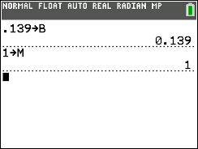
8. Using the value for M that fits best and the B from question 1, complete the slope -intercept form of the equation and record it below.

9. Before going back to the data, press o and clear out the equation in Y1. Press s. Use the arrow keys to move along the data and identify two points (x₁, y₁) and (x₂, y₂). Record the values below. Pick two points that are not close together.

X₁ | Y₁ | X₂ | Y₂

When the coordinates of two points of your walk are known, the slope of the line can be computed by finding the difference in the y-values divided by the difference in the x-values:
Slope = $\frac{y_{2}-y_{1}}{x_{2}-x_{1}}$ Use this formula to compute the slope for your data and record the value here. Slope = _____________

How does this value compare to the value of M you found by the guess-and-check method in question 8?

10. The values you found for M and B can be tested using a built-in feature of your calculator that allows it to compute the best-fit line through a set of data. The procedure is called linear regression.
- Press …~ to select the CALC menu. Select LinReg(ax+b) and enter the information shown at the right. To enter Y1, press ½~ to select the Y-Vars menu. Select Function, then Y1 and press Í. |  | 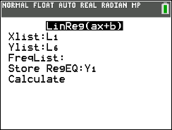
- Copy the values that appear on your calculator screen into the matching table to the right.
How do the values of a and b in the regression model compare to the values of M and B you found earlier?

11. Remember, slope is defined as change in y-values divided by change in x-values. Complete the following statement about slope for the linear data set you collected.

For this activity, slope represents a change in divided

by a change in .

Based on this statement, what are the units of measurement for slope in this activity?

12. As mentioned earlier, the intercept value, B, can be interpreted as the starting position or the starting distance from the CBR 2. What does the value of M represent physically?
Hint: Think about the units of measurement for slope you described in question 11.

Going Further
1. Repeat the activity, this time walking away from the CBR 2 at a slower rate than before. Find the linear equation associated with this data set. How does the slope of this equation compare with the slope of your original equation? How do you think the slope would compare if you walked away from the CBR 2 at a much faster pace? Generally, how is the slope (steepness) of a linear plot related to the speed of the walker?

2. Repeat the activity again, this time starting several meters from the CBR 2 and walking toward it at a slow and steady pace. Find the linear equation associated with this data set. How does the slope of this equation compare with the slope of your original equation? Generally, how is the sign (positive or negative) of the slope related to the direction in which you are moving?

