Concepts:
Circle, radius.

Materials:
- TI-83+/TI-84
- Cabri Jr.
- Document Camera (though you could use Smartview. However, Cabri Jr. sometimes responds has a lag in Smartview. If that occurs use a calculator under the document camera.)

Overview:
- This activity is designed to remind students of the definition of a circle being the set of all points equidistant from the center. The activity also introduces them to the equation of a circle.

1. Use TI-Connect computer Software to transfer the Circle.8xv file to your TI-83+/84 calculator.

2. Transfer the document called Circle.8xv to the student calculators.

- Ask for a student calculator to demo the process under the document camera.
- Connect the calculators using a cable.
- Push 2nd, link on the receiving calculator.
- Right arrow over to RECEIVE and push enter
- Push 2nd, link on your calculator
- Arrow down to AppVars and push enter
- Arrow down to circle and push enter. A small square should appear next to Circle.
- Now arrow to the right and hightlight TRANSMIT and push enter. The program will be sent.

- When the calculators both say done, detach the calculators.
- Give the student back the calculator, ask for another calculator and ask the student to follow along with you and send the file to another student’s calculator.
- Repeat this process until all students have the file.
- Alternate method is to use Navigator. Much easier for those willing to try. ☺

3. Have students open Cabri Jr.

4. Have them open the file Circles (Fig. 1)

5. Have them Move the cursor down to the point at the bottom of the screen until the point blinks. Have them press ALPHA to “grab” the point. (Fig. 2)

6. Have them move the hand back and forth and observe what happens. What figure would be created by the path of the moving point? Why would it create a circle?

7. Have them push WINDOW and choose Circle. They should now draw a circle by moving the “pencil” to each endpoint of the segment until just the endpoint (not the segment) blinks and pushing enter on each endpoint. (Fig. 3)

8. Have them press clear so the cursor becomes an arrow again.

9. Have them once again go down to the point at the bottom, press ALPHA and drag the point back and forth. Ask if they were correct about the rotation forming a circle.

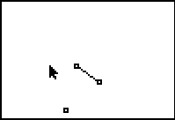

Fig. 1

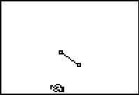

Fig. 2

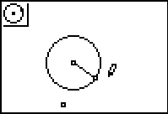

Fig. 3

10. Now, have them get the equation of the circle, by pressing GRAPH, then choosing Coord. & Eq. This time they must highlight the circle so it looks like a bunch of ants walking around the circle and then press enter. The equation appears. Drag the equation so that x² is just to the right of the (x,y) box in the top left part of the screen. (Fig. 4) and push enter to put the equation down.

11. Ask what the 1.6 means? If nobody has an idea, ask what measurements a circle has to lead them. (radius/diameter)

12. Have them check the length of the radius by pressing GRAPH and choosing Measure. They then must press the
right arrow followed by selecting D & Length and pressing enter. Then they highlight the radius and press enter. The length of the radius will appear. Have them drag the number off to the right side and push enter to drop it.(Fig. 5) What do they notice about the radius as compared to the number in the equation?

13. Now have them press GRAPH, choose Hide/Show, press the right arrow and choose axes before pressing enter. The x and y axis will appear. (Fig. 6)

14. Have them press clear so the cursor becomes an arrow, then highlight the center of the circle and press ALPHA. (Fig. 7) Have them move the center of the circle around and note the changes to the radius and the equation. Discuss the patterns. What happens when you move the center to the right? To the left? Up? Down? When the radius changes what happens to the equation?

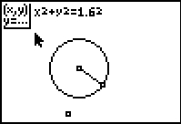

Fig. 4

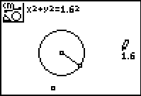

Fig. 5
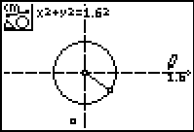

Fig. 6
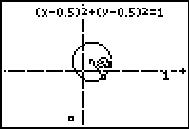

Fig. 7

