Snowboarding Activity
TI-Navigator and Sinusoidal Regression

Concepts
• Use TI-Navigator to collect data points and perform a sinusoidal regression to represent the trail formed by a snowboarder going down a mountain slope.
• Describe the sinusoidal equation in the form in terms of amplitude, period, phase shift and displacement.

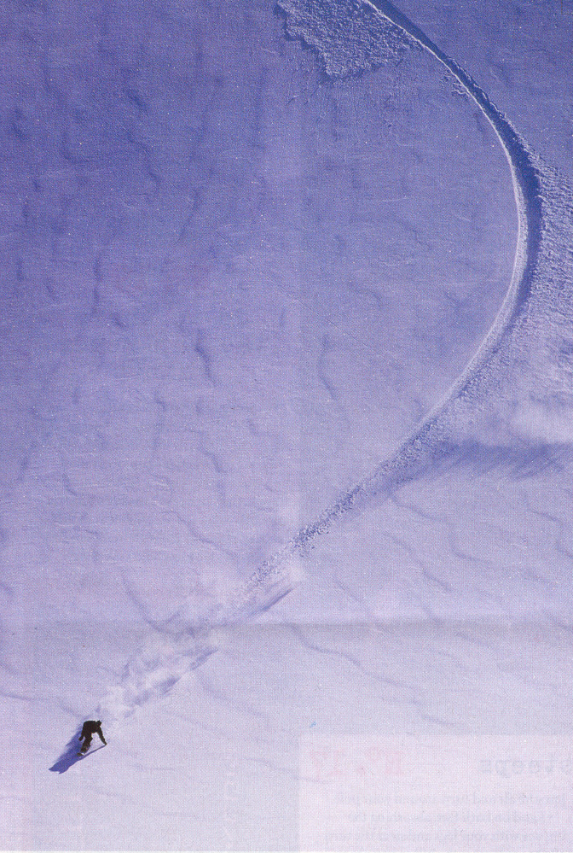
1. As a snowboarder travels down a slope of a mountain, he carves a path in the fresh snow resembling a sinusoidal curve. A partial picture is shown. The graph will be rotated 90º and a sinusoidal equation will be created to describe the path.
Begin a class with Navigator and open the Activity Center.

2. Load the picture of the snowboarder trail as a background image. Notice that the image has been rotated 90º in order to resemble a sinusoidal function.

3. Collect the coordinates for points along the curve from students.
Change the Activity Centre settings for the students to Contribute Points. Configure the number of points per student to be 2, X List to L₁, Y List to L₂, and step size to 0.1. Start the activity and allow students to contribute two points. Stop the activity when all points have been submitted.

4. Send all coordinates of points to all students.
Change the Activity Centre settings to Contribute Lists. Configure for students to start with existing activity lists. Start the Activity to send the lists to students. Stop the Activity after all students have received L₁ and L₂.

5. Exit NavNet and sort the data set in ascending order according to L₁.
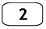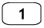

6. Graph the data on the calculator by turning on StatPlots and plotting L₁ and L₂. ZoomStat will set up the window settings according to the given data.

7. Perform a sinusoidal regression of the data stored in L₁ and L₂. The regression equation should be stored in Y₁.


6. Students must reenter NavNet and choose the Activity Centre.

7. Verify the regression equations found by students fit the data set.
Change the Activity Centre settings to Contribute Equations. Configure the number of equations per student to be one. Students start with equations from calculator. Start the Activity. Students must send the sinusoidal regression equation that was stored in Y1. The result on Activity Centre should be one sinusoidal equation passing through the points on the background image.

8. Notice that the form of the sinusoidal equation from the calculator is given in the form .

a) Students should rewrite the sinusoidal regression equation in the form .

b) Give the values of a, b, c, and d.

a = b = c = d =

c) Use these values to describe value of the following characteristics of the sinusoidal equation:

amplitude = period = phase shift = displacement=

