Activity Overview

In this activity, students will move a quadratic function in the coordinate plane to specific points to observe how the vertex form of the equation changes.

Topic: Quadratic Functions
- Vertex Form

Teacher Preparation and Notes
- This activity is meant to be explored on the TI-Nspire.
- Students need to be able grab and move a quadratic function.

Associated Materials
- AroundVertex_Student.doc
- AroundVertex.tns

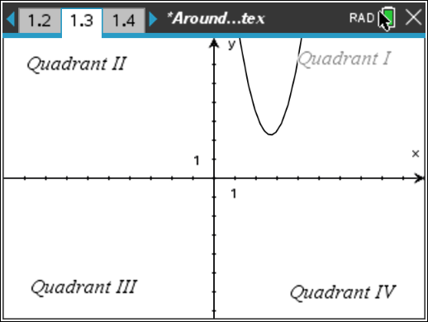
Problem 1 – Exploring Vertex Form
In this problem, students will move the parabola into each quadrant and record four different equations. Students will determine the pattern of the signs of h and k in each quadrant and answer questions about what they observe.
Discussion Questions:
- What happens to the equation when the vertex is on the x- or y-axis?
- When is the h-value positive? Negative?
- When is the k-value positive? Negative?
- What happens to the signs of h and k if the parabola opens downward?

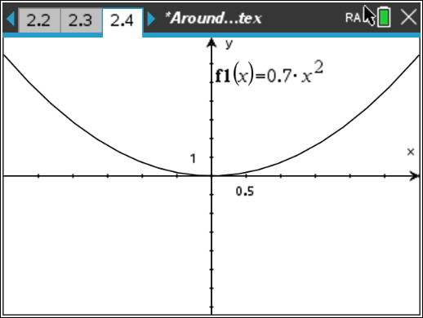
Problem 2 – Happy and Sad Parabolas
In this problem, students will make a parabola wider and narrower and observe the changes in the equation. Students will also make the parabola “sad” (or open down). Students will record four equations for parabolas that open up and four for parabolas that open down. Students will determine patterns in the equations.
Discussion Questions:
- How does making the parabola wider or narrower change the equation?
- What happens if we make the a = 0?
- Which parabola is “wider” a = 2 or a = –3?

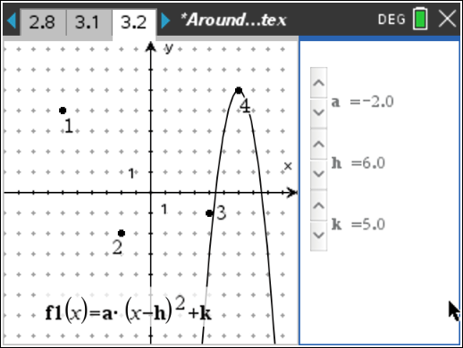
Extension – Parabola Hunt
In the extension, student must write equations for parabolas that open up and down at four given points representing the vertices of the parabolas. Students can use sliders to check their equations given the constraints of integer values for a, h, and k.

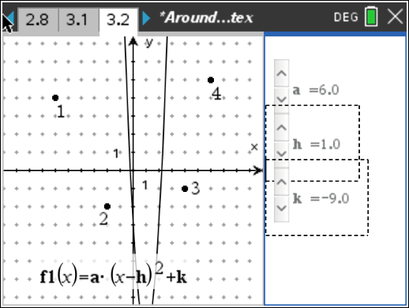
Note: For the bonus question the students will need to access more values for a. When the curser is over the slider, press / + b and select Settings. Then change the Step Size to 0.1 and press OK. Students can then use the slider to get non-integer values of a.
Discussion Questions:
- Have students compare their equations with a partner. Discuss whose parabola is wider/narrower.
- Is it possible to find a parabola that goes through more than one of the labeled points?

Student Solutions
- Quadrant I & II
- Quadrant I & IV
- The coefficient of squared term changes.
- “Happy” parabolas have values of a such that a > 0. “Sad” parabolas have values of a
such that a < 0.
- It is a “happy” parabola because the coefficient of the squared term is positive.
- a(x) opens up b(x) opens up c(x) opens down d(x) opens up
Bonus: Sample answer through (–2, –2) and (4, –1) is y = .025(x – 2)² – 2

