Topic 3: Geometry and Trigonometry | Trigonometric Ratios
- The angle of elevation to the top of a building in New York City is found to be $60°$ from the ground at a distance of 1200 ft from the base of the building. Using this information, find the height of the building.  - If you move toward the building, the new angle of elevation is $60°$. Find your distance from the base of the building. |  | (2 marks)  (2 marks)
Mark scheme:  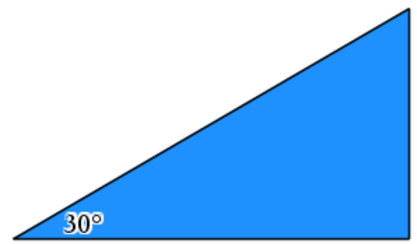  $h$  1200 ft  $$\tan{30°}=\frac{h}{1200}$$  $$h=1200*\tan{30°}$$  $$h=400\sqrt{3}$$  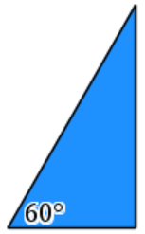  - $h$  $x$  $$\tan{60°}=\frac{400\sqrt{3}}{x} \\ x=\frac{400\sqrt{3}}{\tan{60°}}x=400$$ft. |  | (M1)  (A1)  (M1)  (A1)

