Car Stopping Distances

You are out for a lovely Sunday drive and a deer jumps out on the road in front of you. Will you have time to stop without hitting the deer or are you going to have to call Mom to tell her you wrecked the car?

Part A
Two factors at least are involved in your stopping distance: reaction time and braking distance. How long do you think it will take you to react once the deer has jumped onto the road? ___ seconds

Now create a table that shows speed in miles/hour versus reaction distance in feet assuming a reaction time of 1 second.

Speed (mi/hr) | Reaction Distance (ft)
0
10
20
30
40
50
60
70
If you need help with the chart follow the example below:

$$\frac{\text{10} \text{miles}}{\text{1 hour}}×\frac{\text{5280} \text{feet}}{\text{1 mile}}×\frac{1 \text{hour}}{\text{60} \text{minutes}}×\frac{1 \text{minute}}{\text{60 seconds}}×1\text{ second}=\text{14}\text{.}\text{67 feet}$$

Now put the above information in the table into list 1 and list 2 in your TI calculator:

Then EDIT (hit enter)
If there are numbers is L1, L2, L3, or L4 please clear them by going up to the list name, hit the ❻ key, then push the down arrow . Please put the speeds in L1 and the reaction distances in L2.

Now let us look at the data points. Press  (to do this press  and then □).
You should see the following screen:
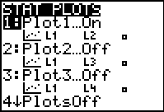
Press  and make sure your calculator matches:
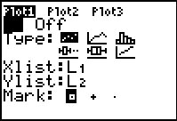

To change any item, place the cursor on the item and hit  or to change to L1 or L2, hit  and the number 1 or 2 key (note the L1 or L2 above the number 1 or 2 key).

Next, hit the □ key and clear out any old graphs. Finally, go to the  key and set an appropriate window.
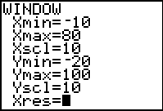

Finally, hit the  key and you should see the following graph.
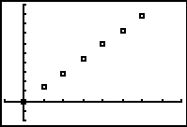

Now find an equation that represents this data. Go to the ❶ key and go to the application called Transfrm. Press enter twice. It does not look like anything happened, but when you now go back to the □ menu, notice the symbols in front of the Y1= .
Type AX+B in the Y1= space.
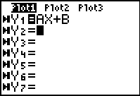

Go to  again and note the new word at the top right “SETTINGS”.
Arrow up and over to SETTINGS and set A= 0 and B=0 with a step of 0.1. Hit  and with the cursor on the A=, use your left and right arrow keys to change A.

By changing A, what is affected in your graph? __________
Try changing B. What does changing B do to your graph? ____________

When you think you are close, type in numbers for A= or B= to make it more accurate. Write your equation you came up with here: _____________________
What does A represent in this equation (including units)? ________________
What does B represent? _______________

Part B
Now for the approximate braking distance once you have reacted to seeing the deer. The following is a table of approximate braking distances if on dry pavement (if on wet pavement the distances double!).

Speed  (mi/hr) | Approximate Braking Distance (ft)
0 | 0
10 | 5
20 | 20
30 | 45
40 | 80
50 | 125
60 | 180
70 | 245
List three factors that could affect the braking distance?
1.
2.
3.

Now put the approximate braking distances in L3 (see above to remember how to get to your lists).

Turn on STAT PLOT 2 and change your window to represent your new data (you may want to turn STAT PLOT 1 off and clear Y1=).

What do you notice about the braking distances? For example, if you double your speed, what happens to the braking distance? _____________________

What type of an equation do you think best represents this data? _________________

Go to □ and type in ${\text{AX}}^{2}+\text{BX}+C$.
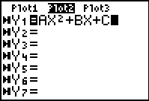

Go to  and change your settings:
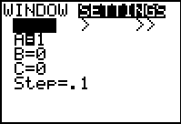

Hit  and adjust A= until you have a curve going through your data points (either type in numbers for A or change the step).

Write your equation you came up with here: _____________________

Part C
Now find the graph and equation for the overall stopping distance. Go back to  and hit ENTER to get back to your lists. Go up and over to L4. The overall braking distance is the sum of the reaction distance and the braking distance. So with the cursor on L4, type in L2+L3.
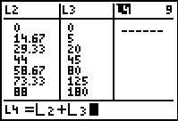

Then hit . Did it add the reaction distance to the braking distance to get the overall distance?

Next, turn on Plot 3 (you may want to turn off Plot 2) and adjust your window for your new data.

Now change A= and B= until you have an equation that fits this data well.
Write your equation you came up with here: _____________________

How does this equation relate to the first two equations you discovered?

So, did you hit the deer? If you were driving 55 miles/hour, what would your overall stopping distance be according to your model? ___________

If a semi-truck is approximately 75 feet in length, how many semi-truck lengths should you stay away from the car in front of you if driving 55 miles/hour? _________

Remember, this activity dealt with dry pavement, something we have very little of around here. How far back should you be if the pavement is wet? _______________
What about icy pavement? _____________

When you have completed this activity, go back to ❶ and down to Transfrm. Hit . Hit  again to turn the application back off (it does not unintstall it – it will just turn it off). To see that this turned it off, hit □ and notice the diagonal line in front of Y1= instead .

❶❻

  

