Open the TI-Nspire document No_Bones_About_It.tns  Have you ever noticed that people in the same family often look very much alike? In fact, sometimes a child will look nearly identical to his or her great-grandparent. However, sometimes people from different families will also look very similar to one another. Also, many different types of animals share many of the same physical properties. For example, eagles, penguins, and bumblebees all have wings. In this activity, you will explore some of the factors that can cause different organisms to share the same physical properties. |  |  | 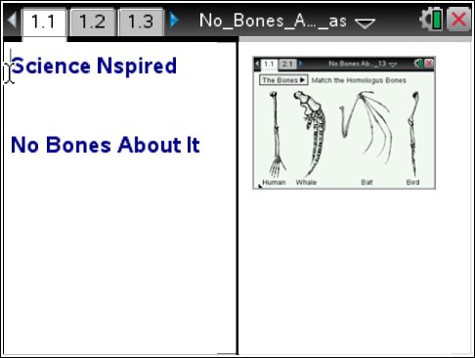
Move to page 1.2 and read the background information for this activity.
Similarities and differences in the structure of organisms throughout history can give us insight into their evolutionary relationships. Many organisms share similar physical characteristics, but they may share these characteristics for different reasons. For example, sharks and dolphins both have fins on their backs. However, they do not share a common ancestor. The fins both share a similar function, but their bone structure is very different since they have evolved from different ancestors. When different organisms share similar characteristics but not common ancestors, we say that their characteristics are analogous structures. The fins of sharks and dolphins are analogous structures. Now, consider the wings of butterflies and dragonflies. These organisms both evolved from a common ancestor, an ancient flying insect. The wings both share similar structural features. When organisms share similar characteristics along with a common ancestor, we say that their characteristics are homologous structures. The wings of butterflies and dragonflies are homologous structures.

Move to page 1.3.
 | Read the directions for the simulation.  1. Use the drop-down menu to select a group of bones to investigate. When a bone type is selected from the drop-down menu, the corresponding bone will be highlighted in a specific color on the human arm example.  2. Identify and select the similar bones in the other organisms. If you select the correct bone on another organism, the bone will be highlighted the same color as the human bone. If you incorrectly select the bones for a group, select the group again from the drop-down menu and the group will reset.  3. Continue this process for each group of bones from the drop-down menu. When all bone groups have been correctly identified, all groups will have check marks within the drop-down menu.  . | 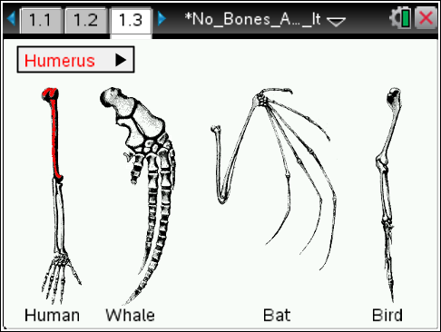
Tech Tip: To access the Directions again, select > No Bones About It > Directions.
Tech Tip: To access the Directions again, select b or Document Tools () > No Bones About It > Directions.

 | Move to pages 1.4 – 1.9. Answer questions below and/or on your device.
Q1. The bones in this simulation show similar structural traits between organisms. This is an example of

A. analogous structures
B. homologous structures
C. analogous and homologous structures

Q2. What do these structures suggest about the relationship of the organisms in this simulation?

Q3. The wings of a bird and a bat are an example of

A. homologous structures
B. analogous structures

Q4. Bees and birds do not share a common ancestor. The wings of a bee and a bird are an example of

A. homologous structures
B. analogous structures

Q5. The necks of a giraffe and a human have a very similar bone structure. This is an example of

A. homologous structures
B. analogous structures

Q6. The bodies of a shark and a dolphin are both long and aerodynamic, but the bone structure of each is very different. This is an example of

A. homologous structures
B. analogous structures

