TI-Nspire Activity: Paint Can Dimensions
By: Patsy Fagan and Angela Halsted

Activity Overview
Problem 1 explores the relationship between height and volume of a right cylinder, the height and surface area, and the surface area and volume with a set radius measure. Problem 2 explores the relationship between the radius and volume, radius and surface area, and surface area and volume when the height is kept stable. Questions are posed that encourage integration between geometric formulas and algebraic modeling. Compare and explore these measures through the interactive functionality of numerical and graphical representations.

Scenario:
Your company can make paint cans that vary in radius from 1 - 10 inches and in height from 2 - 20 inches. You want to make cans that hold different amounts of paint (volume) but consider the costs of the labels to cover the cans (surface area).

In Problem 1 you are to determine the relationship between height and volume, height and surface area, and surface area and volume when the radius is fixed at 2 units. On page 1.4, a modified view of a right cylinder is given with an open point on the top of the cylinder that adjusts the height. The volume formula, and the surface area formula, , are given and their values calculated for each height measure. On pages 1.5-1.6, a spreadsheet and scatter plot of the captured data will be seen. Respond to questions that connect the geometry of a right cylinder to the algebra of the relationship between the measures.

Open the file, PaintCan.tns, on your TI-Nspire handheld.

Problem 1
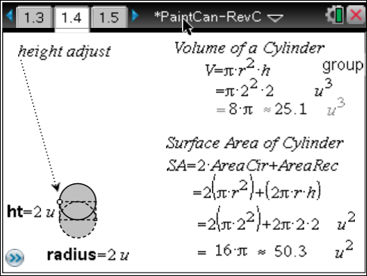
1. On page 1.4, grab the open circle (hold a for a few seconds to change ÷ to {) that adjusts the height of the can and practice moving it to different height measures. The radius measure is set at 2 units.

2. Move to a height of 2 units then press /^. The volume of the cylinder is 25.1 units³ and the surface area is 50.3 units².

Repeat step 2 to move the height to each measure in the table. Be sure to press / ^ after each move. Record each outcome in Table 1.

Height (units) | Radius (units) | Volume (units³) | Surface Area (units²)
2 | 2 | 25.133 | 50.265
4 | 2
6 | 2
8 | 2
10 | 2
12 | 2
14 | 2
16 | 2
18 | 2
20 | 2
Table 1

4. From the numerical view of the data, make a conjecture of the relationship between the height and volume, height and surface area, and volume and surface area. Which ones do you think are linear? Are any of them non-linear? Explain your reasoning.

5. Move to page 1.5 (press / ¢) to check your table entries.

The data were captured each time / ^ were pressed.

6. On page 1.6, set up a scatter plot for each relationship by following the steps:  a. Select scatter plot by pressing b – Graph Type – Scatter plot ·.  b. Change the labels of the axes. Hover the cursor over the label of the horizontal axis then press · twice to open the text box of the label. Delete the existing text using . then change the label on the input (horizontal) axis to “Input”. Do the same to change the label on the output (vertical) axis to “Output”.  The use of “Input” and “Output” instead of “x” and “y” are used for accurate interpretation of the graphs when all three plots are placed on the same coordinate plane.  What are actual names for the variables?  Input: __________________________________  Output: _________________________________ | 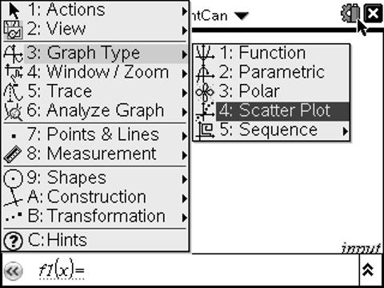  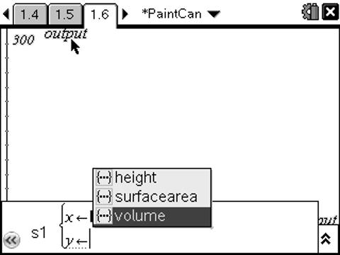
c. Select the data for the first scatter plot. In s1, press h to open the pull down menu for “x” and select “height”, press e, then open the pull down menu for “y” and select “volume”. Press · to see the data.

d. Manually change the window settings to view all of the data.  What are the lowest and the highest input values needed to see the data?  What are the lowest and the highest output values needed to see the data?  What are the algebraic names used to refer to these settings? | 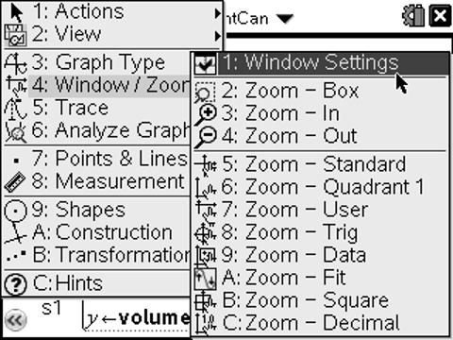
e. Describe the pattern and relationship you observe in the scatter plot. Is the pattern linear or non-linear?

f. Repeat steps (a)-(e) to create scatter plots for height and surface area and for surface area and volume. Describe the pattern and relationship you observe in the scatter plots.

7. Enter regression models for the following relationships on page 1.6:
a. Using the formula , write an equation for volume in terms of height. Enter your equation into f1(x) as an approximation of the data pattern for height and volume. Explain the significance of in this function.

b. Using the formula , write an equation for surface area in terms of height. Then, on page 1.6, enter your equation into f2(x) as an approximation of the data pattern for height and surface area. Explain the significance of in this function.

c. Rewrite the formula for volume in terms of surface area. Then, on page 2.4, enter your equation into f3(x) as an approximation of the data pattern for surface area and volume. Explain the significance of in this function.

Problem 2
This is similar to Problem 1 with the exception that you are asked to vary the radius with a fixed height of 10 inches.

8. On page 2.1, grab the circle that adjusts the radius of the paint can and practice moving it to different radius measures. The height measure is locked at 10 units.  9. Move to a radius of 1 unit then press / ^.  The volume of the cylinder is 31.4 units³ and the surface area is 16.3 units².  10. Repeat step 9 to move the radius to each measure in the table. Be sure to press / ^ after each move. Record each outcome in Table 2. |  |  | 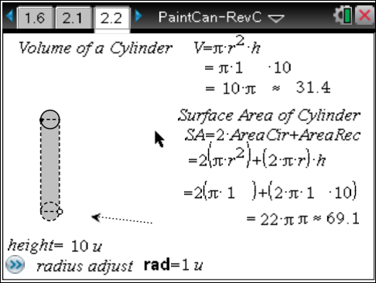
Height (units) | Radius (units) | Volume (units³) |  | Surface Area (units²)
10 | 1 | 31.416 |  | 69.115
10 | 2
10 | 3
10 | 4
10 | 5
10 | 6
10 | 7
10 | 8
10 | 9
10 | 10
Table 2

11. From the numerical view of the data, make a conjecture of the relationship between the radius and volume, radius and surface area, and volume and surface area.
a. Which ones do you think are linear? Are any of them non-linear? Explain your reasoning.

b. Which measure affects the volume more – height or radius? Is this the same for surface area? Give a plausible explanation.

13. On page 2.3, create scatter plots for each relationship.
a. Select scatter plot.

b. Open the text box of the label then delete the existing text. Change the labels on the input (horizontal) axis to “Input” and the label on the output (vertical) axis to “Output”.

c. Select the data for the first scatter plot. In s1 select “radius” for “x” and “volume” for “y”.

d. Manually change the window settings to view all of the data.
What are the lowest and the highest input values needed to see the data?

What are the lowest and the highest output values needed to see the data?

What are the algebraic names used to refer to these settings?

e. Describe the pattern and relationship you observe in the scatter plot. Is the pattern linear or non-linear?

f. Repeat steps (a)-(e) to create scatter plots for radius and surface area and for surface area and volume. Describe the pattern and relationship you observe in the scatter plots.

14. Enter regression models for the following relationships on page 2.3:
a. Using the formula, , write an equation for volume in terms of radius. Enter your equation into f1(x) as an approximation of the data pattern for radius and volume. Explain the significance of in this function.

b. Using the formula, , write an equation for surface area in terms of radius. Enter your equation into f2(x) as an approximation of the data pattern for radius and surface area. Explain the significance of and in this function.

c. Challenge: Rewrite the formula for volume in terms of surface area. Enter your equation into f3(x) as an approximation of the data pattern for surface area and volume. Change the window settings to view the scatter plot and function.

Conclusion
Your company can make paint cans that vary in radius from 1 - 10 inches and in height from 2 - 20 inches. You want to make cans that hold different amounts of paint (volume) but consider the costs of the labels to cover the cans (surface area).

Which measure, height or radius, changes the volume and surface area the most? Why? Explain your reasoning.

