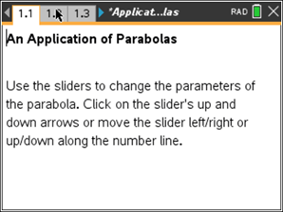
Math Objectives
- Interpret an equation with a real-world application.
- Determine the vertex of a parabola.
- Apply the characteristics of a parabola to a real-world problem.

Vocabulary
- equation
- parabola
- parameter

About the Lesson
- This lesson is a follow-up lesson to the Algebra 2 activity
Families of Functions.
- Students will begin by changing the sliders for a, b, and c on page 1.3 and observing the effects each has on the graph of the parabola. They will apply the effects to the real-world problem.
- Students will complete the activity by finding an equation for a parabola with desired characteristics.

Lesson Materials:
Student Activity Application_of_Parabolas
_Student.pdf
Application_of_Parabolas
_Student.doc
TI-Nspire document
Application_of_Parabolas.tns

Discussion Points and Possible Answers
Tech Tip: If students experience difficulty changing the slider for a, check to make sure that they have moved the cursor (arrow) until the triangles become shaded. If they have difficulty moving the sliders for b and c, check
to make sure that they have moved the cursor (arrow) until it becomes a hand (÷) getting ready to grab the pentagon on the slider number line. Press /x to grab the pentagon to close the hand ({). When finished
moving any slider, press d to release.

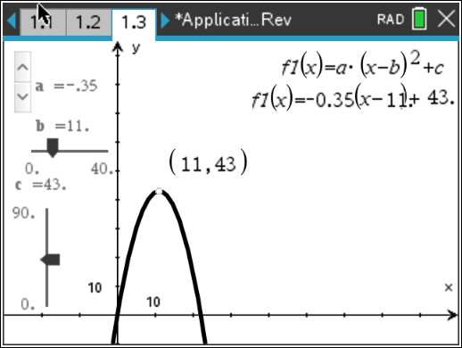
Move to page 1.2.

- What do you think the value of y represents?

Answer: The vertical distance of the ball.

- The vertex form of a parabola is y = a(x – b)² + c. In the equation y = –0.35(x – 11)² + 43, what is the value of b and what does it represent? What is the value of c and what does it represent? Use the point on the graph to test your conclusion.

Answer: The value of b is 11. It represents the horizontal distance where the maximum height occurs. The value of c is 43. It represents the maximum height of the ball.
Tech Tip: Students can move the point on the curve until the word
“maximum” appears. This should help students to understand what the values of b and c represent.

- Use the slider to change the value of a.
  - How does it affect the graph?

Answer: The value of a flattens or shrinks the curve.

  - How does this relate to the problem?

Answer: The value of a can change the horizontal distance the ball travels, the starting height of the ball, and how quickly the ball increases/decreases its vertical distance.

  - Why does the value of a need to be negative?

Answer: The value of a needs to be negative due to the pull of gravity. (What goes up must come down.)

- Use the sliders to change the values of b and c. What effect do they have on the graph that the value of a does not?

Answer: The values of b and c affect the point at which the maximum height occurs.
Teacher Tip Students should understand that this is the vertex of the parabola.

- What is the equation of the path of the ball?

Sample Answer: y = –0.05(x – 40)² + 80
Teacher Tip Equations for the parabola will vary but the curve should go through or near the point (0, 0), because the ball is on the ground when it is
hit by the club.

- For the new equation, did you need to change all of the values of a, b, and c, or just one or two? Explain.

Answer: All of the variables were changed. If you change any one of the variables, it changes the starting point. At a minimum, only two of the variables had to be changed.

Wrap Up:
Upon completion of the discussion, the teacher should ensure that students are able to:
- Interpret the graph of a parabola for a given real-world problem.
- Understand how the parameters of the equation of a parabola affect the curve and how this effect relates to the real-world problem.
- Manipulate the parameters of one equation to produce a desired new parabola.

