Part 1 – Introduction & Limits
1. Before taking calculus, what had you heard about the subject?

Calculus comes from a Latin word for a stone used for counting. Calculus deals with counting infinitesimals (something really small).
Simply put, this highly applicable discipline of mathematics is about slope and area. The concept of limit defines these two major calculus topics of the derivative and integral.
2. View the graph to the right. As x approaches c, what is the value the function is approaching? In other words, as x gets closer to c, but not equal to c, the value of f(x) gets closer to what one value? | 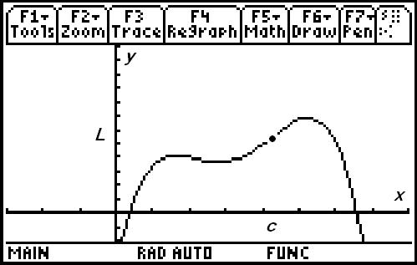
Part 2 – Derivatives & Optimization
Extrema points are the maxima and minima points on a curve. These extreme values could just be highest and lowest points in a neighborhood, or local region.
Run the program whatcalc by typing whatcalc() on the Home screen and pressing . When prompted, select 1:Graph 1.
3. For the 4th degree polynomial shown, how many extrema does this function have?

4. What is the slope of the tangent at these local maximum and minimum points?

The derivative, or slope of the tangent line, is the limit of the slope of secant lines. Now select 2:Graph 2 from the program drop down menu.
The derivative is useful to solve all sorts of problems involving rates of change in medicine, economics, science, and engineering. Calculus can help a manufacturer find the optimal shape to minimize cost. Optimization of functions is extremely beneficial for real-world problems.
For example, a manufacturer may want to maximize the volume of a box given a certain sized piece of cardboard. The box can be formed by folding or cutting the corners. Optimizing the volume would help determine the dimension of the box with the largest volume. The next graph you will view represents the volume of the box. Setting the derivative of the function equal to zero would give the exact answer.
Select 3:Graph 3 from the program drop down menu.
5. a. Trace the graph to approximate maximum volume. What is the maximum and when does it occur?

b. Using calculus, how could the exact maximum value of the volume function be found?

Part 3 – Integrals and History
Adding rectangles will come up in the study of calculus.  6. What is the area of the rectangle shown to the right? | 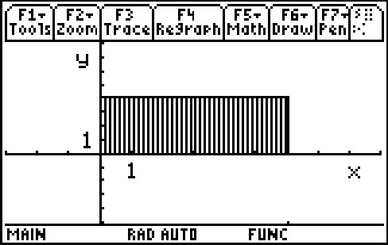
Select 4:Graph 4 from the program menu. The volume can be found by adding cylinders of width dx.  7. What line is this function rotated about? | 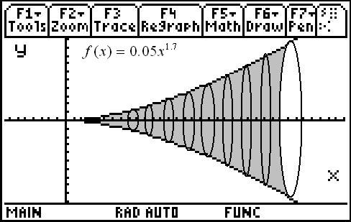
Calculus was independently co−discovered by Sir Isaac Newton (in England) and Gottfried Wilhelm Leibniz (in Germany). Newton actually was the first to discover the inverse relationship between slope and area—the derivative and integral—but Leibniz published first. This relationship is called the Fundamental Theorem of Calculus.
Newton made use of calculus in his book Principia, the greatest scientific work of all time and the work which marks the beginning of the Scientific Revolution.
The creation of nearly all technology today could be traced back to the Fundamental Theorem of Calculus.

8. Who were the co-discoverers of calculus (even though they did not work together)?

9. What did you learn from this activity? Especially explain your current understanding of the three main calculus concepts.

