Example of a Geometric Sequence
The height that a ball rebounds to after repeated bounces is an example of a geometric sequence. The top of the ball appears to be about 4.0, 2.8, 2.0, and 1.4 units.  1. Find the ratio for each of the consecutive terms.  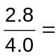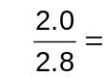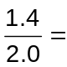 | 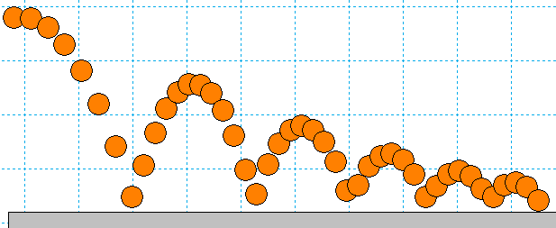
If the ratios of consecutive terms of a sequence are the same, then it is a geometric sequence.

Changing the Initial Value and the Common Ratio
Open IntrotoGeometricSequences.tns. On page 1.2, use the sliders to change the values of a₁ and r, the common ratio, of the series a_{n} = a₁ · r^{n–1}. Start by using the slider to change the value for r while leaving a₁ unchanged. Explore what happens when the common ratio changes.  2. What did you observe happens when you change the common ratio from positive to negative? Explain why this happens. |  | 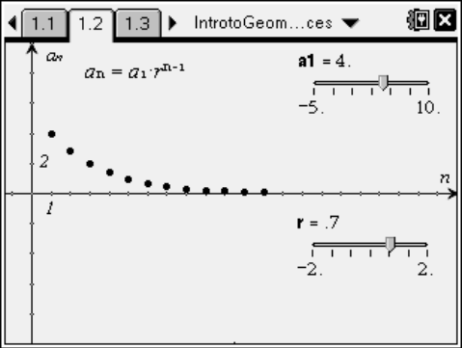
3. When the common ratio is larger than 1, explain what happens to the graph and values of a_{n}.

4. What r-values could model the heights of a ball bounce? Explain your reasoning.

Now click and drag the slider to explore what happens as a₁ and the common ratio r are changed. To make numerical observations, look at the spreadsheet on page 1.3.
5. Explain your observations of what happens when a₁ changes. What is a₁ also known as?

6. If the common ratio is less than –1, describe what occurs to the terms of the sequence.

Sum of a Finite Geometric Sequence
The sum of a finite geometric sequence can be useful for calculating funds in your bank account, the depreciation of a car, or the population growth of a city.
S₆ = 4 + 8 + 16 + 32 + 64 + 128
In this example the common ratio (r) is 2, the first term (a₁) is 4, and there are 6 terms (n = 6).
This sum can be found using the formula: 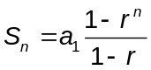, where a₁ is the first term, r is the common ratio, and n is the number of terms.

7. Use the formula to find the sum of the example given on page 2.1.
S₆ = 4 + 8 + 16 + 32 + 64 + 128. Show your work.

There are several ways to verify your answer to Question 7. First, use the table on page 4.1 to find the sum. Enter the numbers in the sequence in column B and the sum is calculated in cell C1.
Find the sum using the sum() function on page 4.2.
Type sum({4,8,16,32,64,128}) ·.

Now use the sigma notation found with the templates t. Once the sigma appears use e to move to the next box. It should appear as 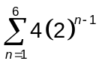.

Extension: Apply What Was Learned
Use the formula to find the sum of the following finite geometric series AND use at least one other method to confirm your answer. Show work using the formula and write the summation notation. To find the approximate, decimal equivalent, answer, immediately press / · ·after using the sum() function.

8. 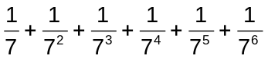 =

9. 64 – 32 + 16 – 8 + 4 – 2 + 1 –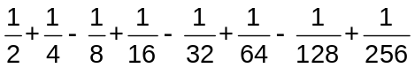 =

10. Find S₂₅ for a_{n} = 2(1.01)^{n – 1}.

