Open the TI-Nspire document Matter_Conservation.tns.  A fundamental principle of physics is that matter cannot be created nor destroyed in a closed system. In this investigation, you will explore a reaction in an open and closed system and compare the mass of the systems before and after the reactions. |  | 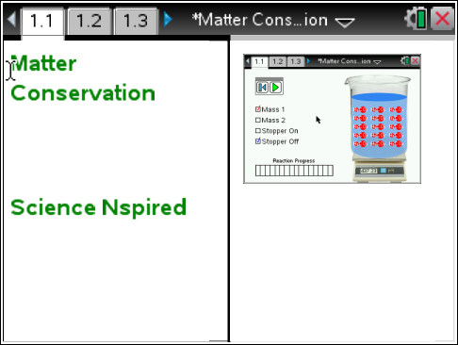
 | Move to page 1.2.
 | Read the instructions for the simulation.  1. In this simulation you will explore the chemical reaction between two different amounts of carbonic Acid (H₂CO₃) and water (H₂O). In addition, you can have the system open (Stopper Off) or closed (Stopper On). To begin, select Mass 1 with the Stopper off. Record the initial mass of the system with the stopper off in the table below.  2. Once you have recorded the initial mass, select the Play button to run the simulation. Wait until the reaction is fully completed. Then, record the final mass of the system with the stopper off in the table.  3. Select the Reset Button and then select Mass 2. Repeat steps 1 and 2 for the new mass. Record the initial and final masses in the table. | 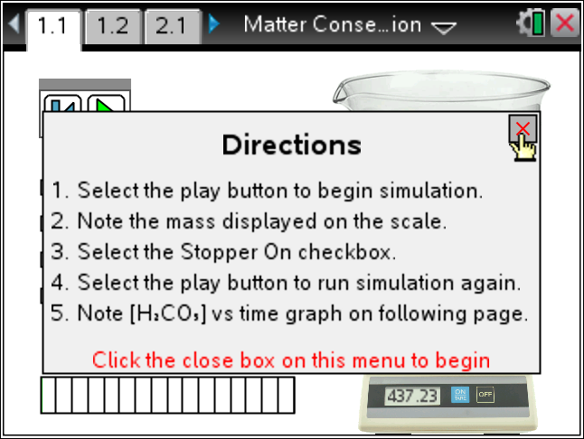  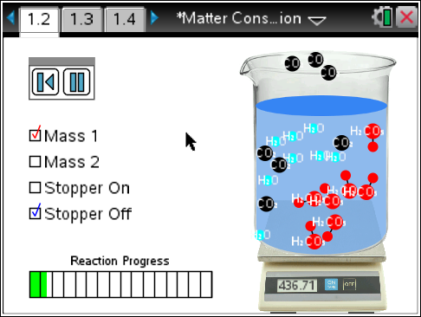
 | Tech Tip: To access the Directions again, select b or Document Tools () > Matter Conservation > Directions.
 | Tech Tip: To access the Directions again, select > Matter Conservation > Directions.
Amount of H₂CO₃ | Initial Mass, Stopper Off | Final Mass, Stopper Off | Initial Mass, Stopper On | Final Mass, Stopper On
Mass 1
Mass 2

Move to Pages 1.3 - 1.4.
Observe the graph on page 1.3. This graph shows the rate at which the concentration of H₂CO₃ in the water changes during the course of the chemical reaction. Essentially, it tells you how quickly the chemical reaction takes place. Then, answer questions 1 and 2 below and/or in your .tns file.

Q1. What happens to the total mass of the system when the stopper is off of the beaker during the chemical reaction?
A. The mass increases.
B. The mass decreases.
C. The mass stays the same.

Q2. How does the concentration of H₂CO₃ in the water change during the course of the chemical reaction?

Move back to Page 1.2.
4. Select the Reset Button and then select Stopper On. Repeat steps 1 and 2 with the Stopper On. Be sure to record the initial and final masses of the system in the table. (Note that the stopper adds some mass to the system.)

Move to Page 1.3 and observe the graph. Then, move to pages 1.5 - 1.8.
Answer the questions 3 - 6 below and/or in your .tns file.

Q3. What happens to the total mass of the system when the stopper is on the beaker during the chemical reaction?
A. The mass increases.
B. The mass decreases.
C. The mass stays the same.

Q4. Recall the graph of the concentration of H₂CO₃ with the stopper off. Now, compare it with the graph of H₂CO₃ with the stopper on. Did the rate at which the reaction takes place depend on whether or not the stopper was on the beaker?

A. yes
B. no

 | Q5. In which scenario does the total mass of the system decrease? Can you explain why this happens?
 | Q6. How does this simulation demonstrate the law of conservation of matter?
 | Move to Page 2.1.  5. Now, consider a new chemical reaction. If we combine two atoms of sodium (2Na) with a molecule of chlorine gas (Cl₂), we obtain common table salt. Use the Periodic Table to determine how many total protons, neutrons, and electrons are involved in each of these reactants. (Note that Cl₂ has two atoms of chlorine and 2Na has two atoms of sodium.) Fill in the table below.  You may use the following rules to fill in the table:  - The number of protons in an atom is equal to the atomic number.  - The number of electrons in a neutral atom is equal to the number of protons.  - The number of neutrons in an atom is equal to atomic mass – atomic number. | 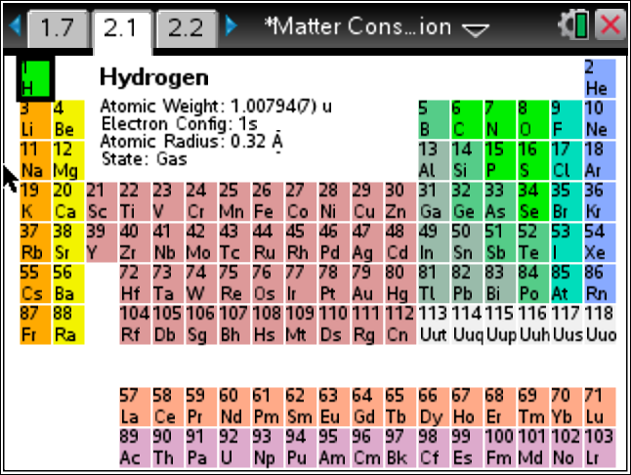  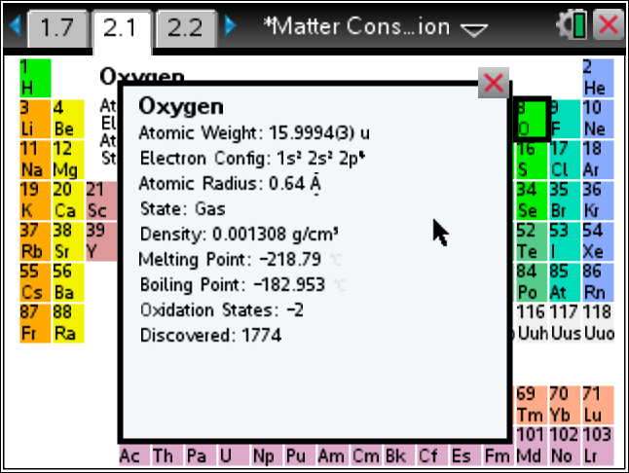
Reactant | Protons | Neutrons | Electrons
2Na
Cl₂
Total
Move to Pages 2.2 - 2.3.
Answer questions 7-8 below and/or in your .tns file.

Q7. NaCl is the empirical formula for common table salt. One NaCl compound has 28 protons, 28 electrons, and 30 neutrons. The chemical reaction between sodium and chloride is given by: 2Na + Cl₂ 2NaCl. Calculate the total number of protons, electrons, and neutrons in the product of the reaction (2NaCl).

Q8. Is the total amount of matter conserved in this reaction? Use your calculations to defend your answer. (Hint: Compare the total amount of protons, neutrons, and electrons of the products in your table with the amounts calculated in question 7.)

