Old MacDonald has 40 meters of fencing to make a rectangular pen for his pigs. If he wants to give the little pigs as much room as possible, what dimensions should he make the pen? To figure this out, he drew a few sample rectangles with different dimensions. Mark the sides of the following rectangles with the lengths that will make the perimeter of each rectangle 40 meters. Work with a partner and fill in the table on the next page. In the columns for perimeter and area in the table, show the calculations you make to determine each of the values.

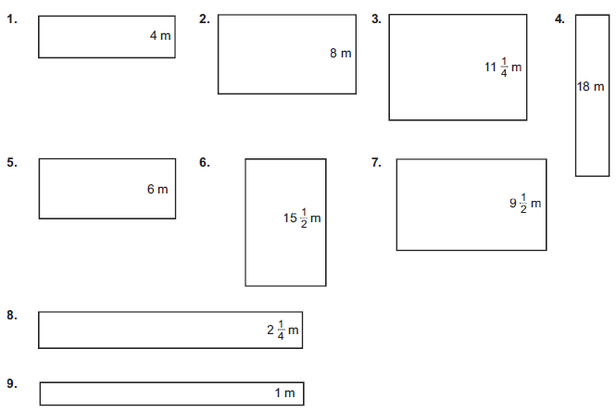
pigpen | width (m) | length (m) | perimeter (m) | area (m²)
1. | 4
2. | 8
3.
4. | 18
5. | 6
6.
7.
8.
9. | 1
10. | x

11. The table shows that the area of the rectangular pigpen is a function of the length of the four sides. Use x to denote the width and write an equation that relates the area to x. Recall the formula for area.
A(x) =
12. What kind of equation is this? Describe the shape of the graph. This will be easier to do if you plot the data.

Use lists on your TI-84 to confirm your arithmetic. Plot the lists and explore regressions to see what equations might fit the data. Discover how your algebra confirms the results given from technology.
13. When plotting an equation it is important to decide what variable goes on which axes.
a. What variable will be plotted on the horizontal axes? What is the domain for this variable? Explain how the domain relates to the rectangular pigpen.

b. What variable is to be plotted on the vertical axes, the y-axis?

14. Using the graph, explain how you can find the maximum area of the pigpen. What is the maximum area?

