Math Objectives  - Students will determine the type of function modeled by the height of a capsule on the London Ey observation wheel.  - Students will determine the amplitude, angular frequency, period, and midline of a sinusoidal function when given information in verbal and graphical form.  - Students will model the height of the capsule on the London Eye by writing an equation in the form $y= -a cos\left(b\left(x\right)\right)+d$.  - Students will model with mathematics (CCSS Mathematical Practice).  Vocabulary  - angular frequency • amplitude • period  - periodic function • midline • parameters of a function  About the Lesson  - This lesson involves creating an appropriate equation to model the height of a capsule on the wheel.  - As a result, students will:  - Use s slider to animate the function modeled by the height of a capsule on the London Eye observation wheel.  - Discover the concepts of amplitude, angular frequency, period, and midline.  - Determine the amplitude, angular frequency, period, and midline of the “observation wheel” function.  TI-Nspire™ Navigator™  - Transfer a File.  - Use Class Capture to examine patterns that emerge.  - Use Live Presenter to demonstrate.  - Use Teacher Edition computer software to review student documents.  - Use Quick Poll to assess students’ understanding  Activity Materials  Compatible TI Technologies: TI-Nspire™ CX Handhelds,   TI-Nspire™ Apps for iPad®,  TI-Nspire™ Software | 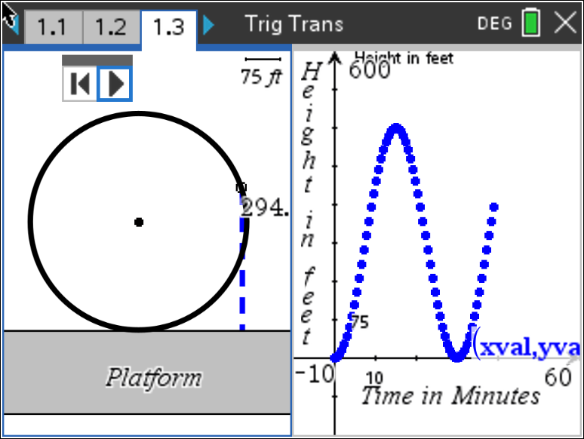  Tech Tips:  - This activity includes screen captures taken from the TI-Nspire CX II handheld. It is also appropriate for use with the TI-Nspire family of products including TI-Nspire software and TI-Nspire App. Slight variations to these directions may be required if using other technologies besides the handheld.  - Watch for additional Tech Tips throughout the activity for the specific technology you are using.  - Access free tutorials at http://education.ti.com/calculators/pd/US/Online-Learning/Tutorials  Lesson Files:  Student Activity  Trigonometric_Transformations_Nspire_Student.pdf  Trigonometric_Transformations_Nspire_Student.doc  Trigonometric_Transformations.tns

Open the TI-Nspire document Trigonometric_Transformations.tns.  In this activity, you will use an observation wheel to apply transformations to periodic functions and write an equation for a trigonometric function. | 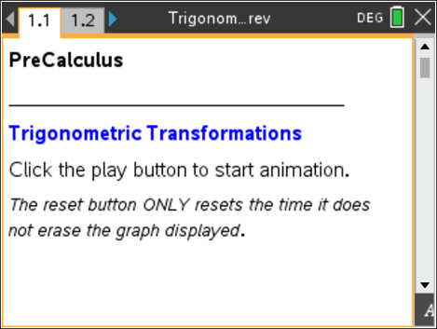
____________________________________________________________________________________

Tech Tip: Press esc to hide the entry line if the students accidently press tab.

Problem 1 – Creating a Trigonometric Model for the London Eye

Move to page 1.2.

The London Eye is an observation wheel in London that can carry 800 passengers in 32 capsules. It turns continuously, completing a single rotation once every 30 minutes.

1. On the screen, you see a model of the London Eye on the left side and a graph on the right. Click on the play button to start the animation. Click the button again to stop it. What type of function was created as a result of the animation?
Possible Solutions: A sinusoidal function. A cosine function. A periodic function. A
cyclical function.

TI-Nspire Navigator Opportunity: Class Capture or Live Presenter
See Note 1 at the end of this lesson.

2. What does the changing measurement on the left screen represent as the capsule (represented by the open circle) moves around the observation wheel?

Solution: The measurement shows the height of the capsule from the platform.

Teacher Tip: Students should recognize the shape of the graph. Some students might recognize the transformations, while others will not. Some extra discussion might be necessary.

3. What are the units of the x- and y-axes on the right?

Solution: The x-axis represents time in minutes. The y-axis represents height in feet.

4. a. What is the maximum height a capsule reaches from the platform?

Solution: 450 feet

TI-Nspire Navigator Opportunity: Class Capture or Live Presenter
See Note 2 at the end of this lesson.

b. The horizontal line halfway between the maximum and minimum of the function is called the midline of the graph. What is the equation of the midline? Explain your reasoning.

Solution: The equation of the midline is $y=225$. The maximum height is 450 feet and the
minimum is 0 feet, resulting in a midpoint of 225.

5. The function y = –A · cos(Bx) + D can be used to model the capsule’s height above the platform at time x. This is a transformation of a basic cosine curve.
a. Use your knowledge of transformations to explain why there is a negative sign in front of the variable A.

Solution: The basic cosine function starts at its maximum. This function starts at its
minimum. The negative represents the reflection about the midline.

b. The variable A represents the amplitude, which is the vertical distance between the midline and the maximum or the minimum. What is the amplitude of the “observation wheel” function, and how did you find the value?

Solution: The amplitude is 225. This distance from the maximum of 450 to the
value of the midline is 225.

c. Which variable of the equations represents the midline of the function? Explain your reasoning.

Solution: The midline is the variable D, which is 225 in this function. In a basic cosine curve,
the maximum is 1, the minimum is –1, and the midline is y = 0. In this function, the
maximum is 450, the minimum is 0, and the midline is 225. Vertical shifts are
represented as an addition or subtraction from the basic function.

d. The period of a function is the time it takes to complete one cycle of a periodic function. What is the period of the “observation wheel” function, and how is it visible in the graph?

Solution: The period is 30. Looking at the graph, it takes 60 minutes to complete two cycles.
Thus, it takes 30 minutes to complete one cycle of the periodic function.

6. What characteristic of the observation wheel does the amplitude represent? Explain your reasoning.

Solution: The amplitude represents the radius of the observation wheel.

7. The variable B represents angular frequency. Angular frequency is the measure of the arc (in radians) traveled by the capsule divided by the time traveled (in minutes).

a. What is the measure of the arc traveled by the capsule in one complete revolution?

Solution: The measure of the arc is $2π$.

Teacher Tip: You might have to remind students that the measure of the arc is the measure of the central angle, and the length of the arc is the distance traveled. Frequency in this example is angular velocity.

b. How long does it take for a capsule to complete one revolution?

Solution: It takes 30 minutes.

c. What is the frequency for the “observation wheel” function?

Solution: Frequency is $\frac{2π}{30}= \frac{π}{15}$.

8. Using y = –A · cos(Bx) + D and the variable information found in Question 5, write the equation representing the height of a London Eye capsule at time x. Verify your answer by graphing the function.

Solution: The equation is $y= -225\cos\left(\frac{π}{15}x\right)+225$.
9. Imagine the boarding platform for the observation wheel stands 10 feet above the ground. If your function takes this height into consideration, what parameters of the equation would change? What parameters would stay the same?

Solution: The equation is $y= -225\cos\left(\frac{π}{15}x\right)+235$. The only parameter that changes is D, the
vertical shift. The amplitude and frequency are based on the observation wheel not
where it exists in space, therefore they do not change.

TI-Nspire Navigator Opportunity: Quick Poll
See Note 3 at the end of this lesson.

Problem 2 – Creating a Trigonometric Model for an Electric Train

The following diagram shows the electric train set that Timmy received for his birthday. Once it is put together, it will travel in an almost perfect circle. Timmy found a space in his playroom right next to a wall to build the set.

P

Train Track
wall

After Timmy puts the train set together, he notices some patterns about the train’s movement. If Timmy starts the train at the wall, t = 0 seconds, it takes the train 12 seconds to travel from the wall to the farthest point from the wall, point P. The distance the train travels from the wall increases and decreases periodically. He measures that point P is ten feet from the wall.

The sinusoidal function $g$ models the distance, in feet, the train is from the wall as a function of time $t$ in seconds.

Teacher Tip: This is an AP Precalculus style question that uses all the information gained from problem 1 in this activity. There will need to be some discussion on how the diagram translates into a sinusoidal graph like the one below. There will need to be some discussion on the five labeled points on the graph below, where the graph is located (above or below the x-axis that is not indicated), where the train starts in relation to its distances as it travels around the circular track, and finally, the amount of time that is passing as it travels around the track. When your students get to question 11, there should be discussion about whether they can use sine or cosine (yes, they can!), and how this is possible. This could be a great place to introduce or review a phase shift (x + C) that has not been discussed in this activity. In questions 12 and 13, the function and the rate of change of the function are discussed. Feel free to adjust these questions if necessary and talk about the period, midline, frequency instead.

- The graph of $g$ and its dashed midline for two full cycles is shown below. Five points, F, H, J,
K, P, are labeled on the graph. No scale is indicated, and no axes are presented. Determine
possible coordinates $\left(t, g(t)\right)$ for the five points shown.

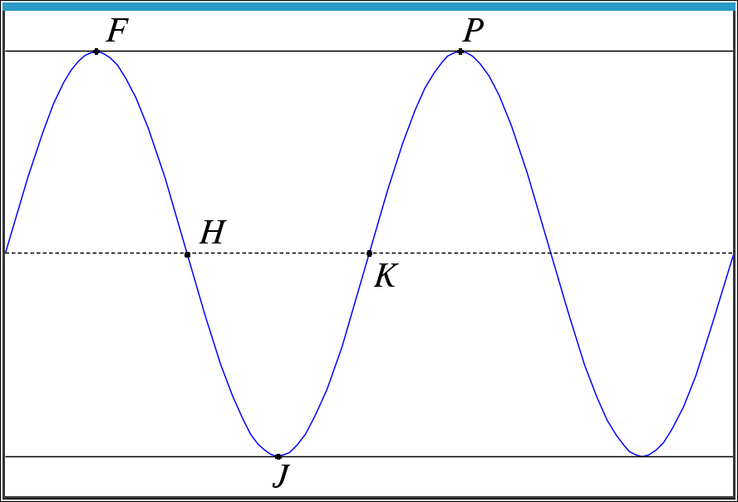
Possible Solutions:

F__(12, 10)__ H __(18, 5)__ J __(24, 0)__ K __(30, 5)__ P __(36, 10)__

- The function $g$ can be written in the form $g\left(t\right)=a\cos\left(b\left(t\right)\right)+d$. Find values of the constants a, b, and d.

Possible Solution: $g\left(t\right)= -5\cos\left(\frac{π}{12}t\right)+5$

- Using the points from the graph above, when is $g(t)$ positive and increasing? Positive and decreasing?

Solutions: Positive and increasing: From J to P or $\left(J, P\right)$
Positive and decreasing: From F to J or $(F, J)$

- How is the rate of change of $g(t)$ changing for the intervals found in question 12?

Solutions: For the interval $\left(J, P\right)$, the function’s rate of change is increasing from J to K
(concave up) and then decreasing from K to P (concave down).

For the interval $\left(F, J\right),$ the function’s rate of change is decreasing from F to H
(concave down) and increasing from H to J (concave up).

Extension:

How can you model the London Eye using a sine function?

Wrap Up

Upon completion of the discussion, the teacher should ensure that students are able to understand:

• The type of function modeled by the height of a capsule on an observation wheel.

• Parameters of a cosine function.

• How to determine the amplitude, angular frequency, period, and midline of a cosine function when given information in verbal or graphical form.

• How to use parameters to write an equation in the form y = –A · cos(Bx) + D.

TI-Nspire Navigator

Note 1
Question 1, Class Capture and Live Presenter
As students begin this activity, use Class Capture to be assured that each student is able to play the animation. You can choose one student to display their work on this and future problems and discuss the results.

Note 2 Question 3, 4, Class Capture
You can choose to use Class Capture to share the work for these problems.

Note 3 Whole Document, Quick Poll
Quick Poll can be used throughout the lesson to assess student understanding.

