Problem 1 – Rolling Two Number Cubes
List the 10 sample means found by your simulation.
For the 50 sample means, record the mean and standard deviation.
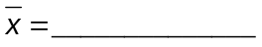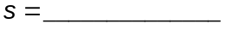
Sketch the histogram of the 50 sample means.

Problem 2 – Rolling Four Number Cubes
List the 10 sample means found by your simulation.
For the 50 sample means, record the mean and standard deviation.
Sketch the histogram of the 50 sample means.

Problem 3 – Rolling Seven Number Cubes
List the 10 sample means found by your simulation.
For the 50 sample means, record the mean and standard deviation.
Sketch the histogram of the 50 sample means.

Problem 4 – Bringing It All Together
What happened to the histograms as the sample size, n, increased?

What happened to the standard deviations as n increased?

What is true about the means of the sample means?

Find 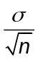 for n = 2, 4, and 7, where 

