Creating an APPVAR: TRIINEQ

After turning on your handheld press  | Select CabriJr.  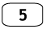
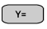scroll to New | 
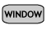 | Now select three points and draw the triangle.

Place the triangle in the bottom half of your screen.  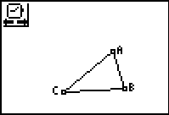 | Label the vertices 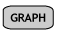  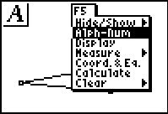
Move the cursor to a vertex so that the vertex becomes “active” press ENTER to create a text cursor and name the point.  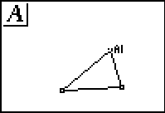 | Continue until all vertices are labeled.
Find the measures of AC, AB, and BC   | Once you have the measures drag them to an open area and write an appropriate label.  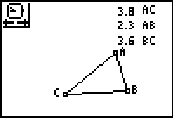

Now find the sum of two sides using the calculate tool. | Finding the sum AB+BC  Select the measure of AB by moving the cursor over the number  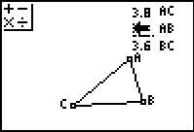
Now move the cursor over the measure of BC and press  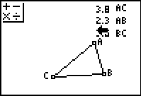  You will notice that both numbers are “flashing” | Press  and drag the result on line with the measure of AC  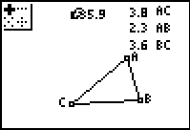  Continue for the remaining sums
Make appropriate labels and positions  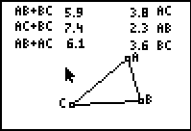 | This is the finished product that the student should receive and work with to answer the questions on the student worksheet.

For student exploration you will want to give them the finished product. Creation of the APPVAR is a good extra credit project.

