Math Objectives  - Students will explore the relationship between rational functions and both vertical and horizontal asymptotes. They will examine these relationships graphically and algebraically.  - Students will be asked to create sliders on the handheld to help in  their exploration and discussions.  - Students will try to make a connection with how to understand these topics in IB Mathematics courses and on their final assessments.  Vocabulary  - Sliders • Vertical Asymptotes • Input  - Output • Horizontal Asymptotes  About the Lesson  - This lesson is aligning with the curriculum of IB Mathematics Approaches and Analysis SL/HL  - This falls under the IB Mathematics Content Topic 2 Functions:  2.8: (a) The reciprocal function 𝑓𝑓(𝑥𝑥) = 1 , 𝑥𝑥 ≠ 0, its graph and  𝑥𝑥  self-inverse nature.  - Rational functions of the form 𝑓𝑓(𝑥𝑥) = 𝑎𝑎𝑥𝑥+𝑏𝑏 and their  𝑐𝑐𝑥𝑥+𝑑𝑑  graphs.  - Equations of vertical and horizontal asymptotes.  As a result, students will:  - Apply this information to real world situations.  TI-Nspire™ Navigator™  - Transfer a File.  - Use Class Capture to examine patterns that emerge.  - Use Live Presenter to demonstrate.  - Use Teacher Edition computer software to review student documents.  - Use Quick Poll to assess students’ understanding  Activity Materials  Compatible TI Technologies: TI-Nspire™ CX Handhelds, TI-Nspire™ Apps for iPad®, TI-Nspire™ Software | 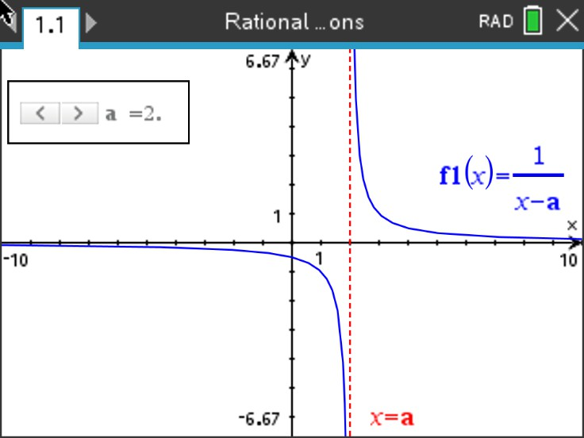  Tech Tips:  - This activity includes screen captures taken from the TI- Nspire CX II handheld. It is also appropriate for use with the TI-Nspire family of products including TI-Nspire software and TI-Nspire App. Slight variations to these directions may be required if using other technologies besides the handheld.  - Watch for additional Tech  Tips throughout the activity for the specific technology you are using.  - Access free tutorials at  http://education.ti.com/calcul ators/pd/US/Online- Learning/Tutorials  Lesson Files:  Student Activity  Nspire-RationalFunctions- Student.pdf  Nspire-RationalFunctions- Student.doc

In this activity, you will explore the properties of

functions of the forms 𝑓𝑓(𝑥𝑥) = 1
𝑥𝑥−𝑎𝑎
and

𝑓𝑓(𝑥𝑥) = 𝑎𝑎𝑥𝑥+𝑏𝑏 , and learn to create sliders that
𝑐𝑐𝑥𝑥+𝑑𝑑
allows you to dynamically examine these rational functions generated by quotients of linear functions.

Using the handheld, students will discover, or re-discover, the connection between a rational function, transformations, and both vertical and horizontal asymptotes. To accomplish this, they will be creating and using a dynamic tool called a slider.

Let’s review the idea behind vertical and horizontal asymptotes. A vertical asymptote is a vertical line that guides the graph of the function but is not part of it. It can never be crossed by the graph because it occurs at the x-value that is not in the domain of the function. A function may have more than one vertical asymptote. A horizontal asymptote is a horizontal line that the graph of a function approaches as the magnitude of the input increases without bound in either a positive or negative direction. A function may cross a horizontal asymptote for finite values of the input.
Teacher Tip: If this is you and/or your students first time using a slider, some extra prep time may be needed before doing this activity, especially when changing the settings of the sliders.

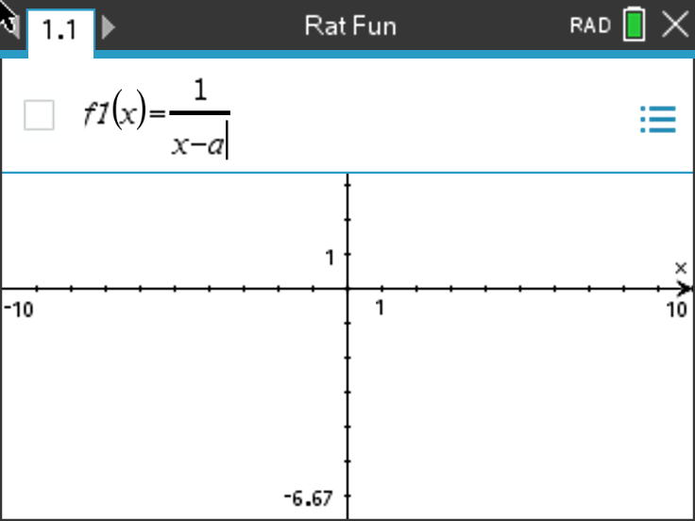
Problem 1 – Testing the Slider with Vertical Asymptotes
From the home screen on the handheld, press
1 New (Document) and press 2 Add Graphs. In
1

the f1(x) =, type the fraction

𝑥𝑥−𝑎𝑎
. Once you

press enter a box will pop up and ask if you would like to create a slider for the variable a, press ok.

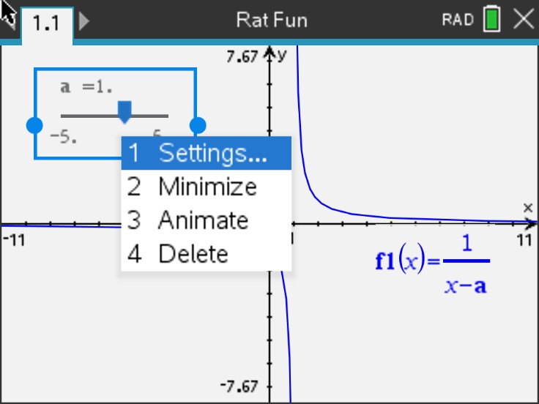
Now that the slider has appeared, you can customize it to your liking. The default slider has a minimum a value of -5 and a maximum of 5. It also contains an arrow that you can manipulate to change the a value. If you would like to change anything about the slider, press ctrl menu to alter the settings, minimize to a button slider, or animate the slider.

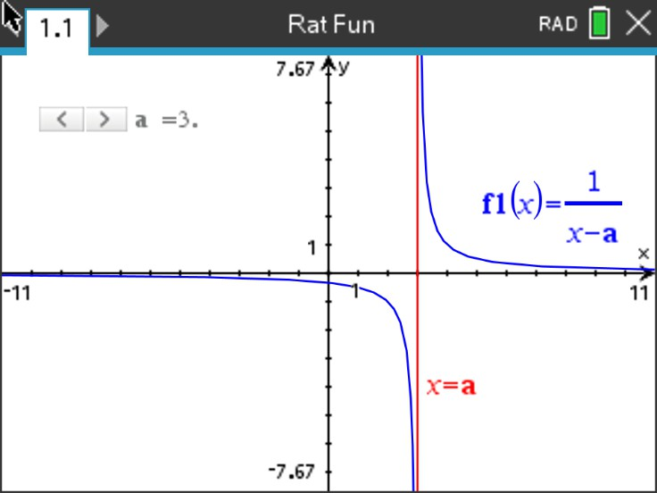
Let’s add one more piece to the slider puzzle to really enhance the connection to asymptotes. While on the Graphs page, press menu, 3 Graph Entry/Edit, 3 Equation Templates, 1 Line, 2 Vertical Line x = c. Type a into the template box and press enter.

Discussion Questions

- With a classmate, press or move the slider and discuss what you see. Write an explanation and share with the class what you notice about the relationships between the rational function and the vertical line.
Possible Explanation: As you press the slider buttons, the curve and vertical line moves left and right and there seems to be a relationship with the a value in the slider and the a value in the denominator of the function.

- Find the value of x where the function 𝑓𝑓1(𝑥𝑥) = 1
𝑥𝑥−2
is undefined.

Solution: x = 2

- Find the value of x where the function 𝑓𝑓1(𝑥𝑥) = 1
𝑥𝑥+1
is undefined.

Solution: x = -1

- Find the value of x where the function 𝑓𝑓1(𝑥𝑥) = 1
𝑥𝑥−𝑎𝑎
is undefined.

Solution: x = a

- Find the value of x where the function 𝑓𝑓1(𝑥𝑥) = 1
𝑥𝑥−𝑎𝑎
has a vertical asymptote. With a classmate,

come up with a rule to find the vertical asymptote.
Solution: Vertical asymptote at x = a. Possible rule: Set the denominator equal to zero and solve for x.

Extension Question:
- Discuss with a classmate what you notice about what happens horizontally as you move the slider left and right. Write an explanation and share with the class.

Possible Discussion and Explanation: No matter how far left or how far right you move the rational function, the curves seem to approach the x-axis, or y = 0. This could possibly represent a horizontal asymptote.

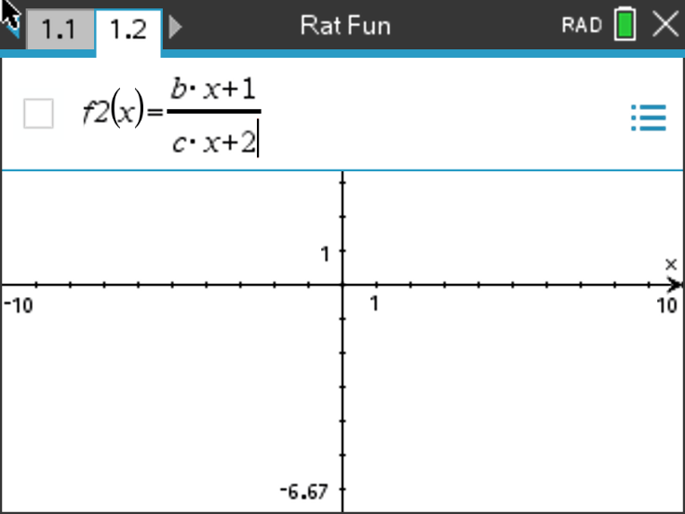
Let’s repeat the procedure from Problem 1, but this time we will add two sliders. Press ctrl, doc
and add another Graphs page. Enter the

fraction ^{𝑏𝑏∙𝑥𝑥+1}
𝑐𝑐∙𝑥𝑥+2
into f2(x) = and press enter.

When the box pops up and asks if you would like to create a slider for the variables b and c, press ok.

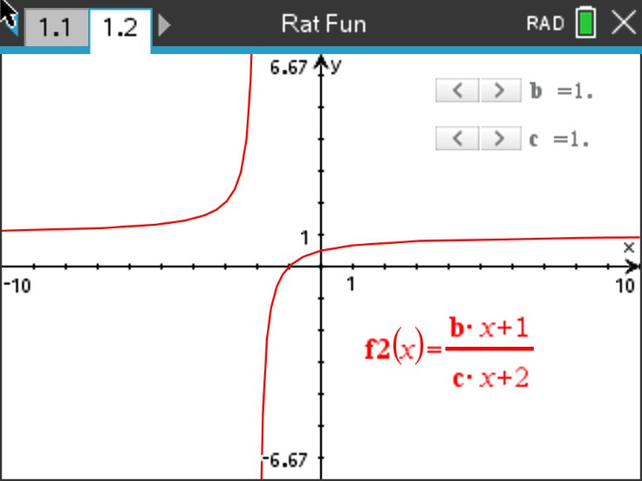
Problem 2 – Using Sliders to Make Connections to Horizontal Asymptotes
Now that the slider has appeared, you can customize it to your liking by pressing ctrl menu. The picture at the right shows minimized sliders and they have been moved to the first quadrant.

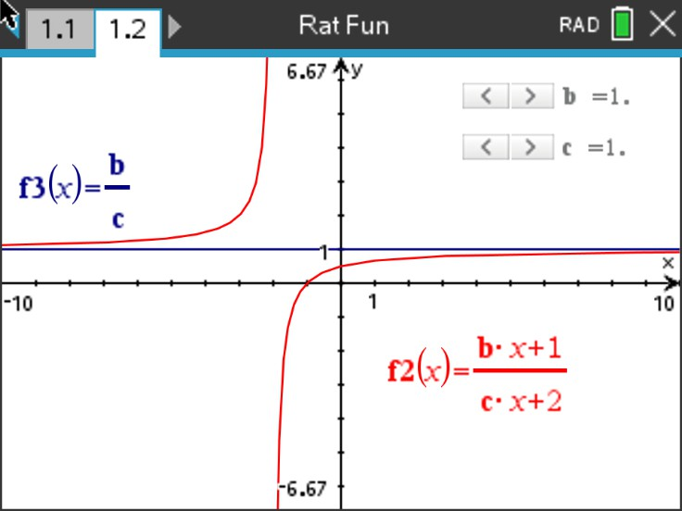
To make the connection once again to
asymptotes, we will add a line. Press tab and enter the fraction ^{𝑏𝑏} into f3(x) = and press enter.
𝑐𝑐

Discussion Questions
- With a classmate, press or move the sliders and discuss what you see. Write an explanation and share with the class what you notice about the relationships between the rational function and the horizontal line.
Possible Explanation: As you press the slider buttons, the curve and horizontal line moves up
and down and there seems to be a relationship with the b and c values in the slider and the ^{𝑏𝑏}
𝑐𝑐
value of the function.

- Find the value of 𝑓𝑓2(𝑥𝑥) that the function seems to approach as the input values approach both positive and negative infinity when 2(𝑥𝑥) = 2𝑥𝑥+1 .
3𝑥𝑥+2

Solution: 𝑓𝑓2(𝑥𝑥) = 𝑦𝑦 = 2
3

- Find the value of 𝑓𝑓2(𝑥𝑥) that the function seems to approach as the input values approach both positive and negative infinity when 2(𝑥𝑥) = 4𝑥𝑥+1 .
𝑥𝑥+2
Solution: 𝑓𝑓2(𝑥𝑥) = 𝑦𝑦 = 4 = 4
1

- Find the value of 𝑓𝑓2(𝑥𝑥) that the function seems to approach as the input values approach both positive and negative infinity when 2(𝑥𝑥) = 𝑏𝑏𝑥𝑥+1 .
𝑐𝑐𝑥𝑥+2
Solution: 𝑓𝑓2(𝑥𝑥) = 𝑦𝑦 = 𝑏𝑏
𝑐𝑐

- Find the value of 𝑓𝑓2(𝑥𝑥) that the function 𝑓𝑓2(𝑥𝑥) = 𝑏𝑏𝑥𝑥+1 has a horizontal asymptote. With a
𝑐𝑐𝑥𝑥+2
classmate, come up with a rule to find the horizontal asymptote.
Solution: 𝑓𝑓2(𝑥𝑥) = 𝑦𝑦 = 𝑏𝑏. Possible rule: Since the rational function is made up of a linear
𝑐𝑐
function divided by a linear function, the horizontal asymptote is the leading coefficient of the numerator divided by the leading coefficient of the denominator.
Teacher Tip: For this further IB application, in addition to asymptotes, students will be required to find zeros and an inverse function, these topics many need to be reviewed.

Further IB Application
The function 𝑓𝑓 is defined by 𝑓𝑓(𝑥𝑥) = 8𝑥𝑥−8 for 𝑥𝑥 ∈ ℝ, 𝑥𝑥 ≠ 2.
3𝑥𝑥−6

  - Find the zero of 𝑓𝑓(𝑥𝑥).
Solution: Factor the numerator and denominator to see if there is a hole.
𝑓𝑓(𝑥𝑥) = 8𝑥𝑥−8 = 8(𝑥𝑥−1), factors cannot cancel, no hole.
3𝑥𝑥−6 3(𝑥𝑥−2)
Set the numerator equal to zero and solve for x.
8𝑥𝑥 − 8 = 0
𝑥𝑥 = 1

  - For the graph of 𝑦𝑦 = 𝑓𝑓(𝑥𝑥), write down the equation of
    - the Vertical Asymptote;
Solution: Set the denominator equal to zero and solve.
3𝑥𝑥 − 6 = 0
𝑥𝑥 = 2

    - the Horizontal Asymptote.
Solution: Since the degrees of the numerator and denominator are equal, divide the leading coefficients.
𝑦𝑦 = 8
3

  - (i) Find 𝑓𝑓⁻¹(𝑥𝑥), the inverse function of 𝑓𝑓(𝑥𝑥).
Solution: Switch x and y and solve for y.

𝑥𝑥 = 8𝑦𝑦−8
3𝑦𝑦−6
(cross multiply)

3𝑥𝑥𝑦𝑦 − 6𝑥𝑥 = 8𝑦𝑦 − 8 (bring y terms to one side)
3𝑥𝑥𝑦𝑦 − 8𝑦𝑦 = 6𝑥𝑥 − 8 (factor out a y)
𝑦𝑦(3𝑥𝑥 − 8) = 6𝑥𝑥 − 8 (solve for y)
𝑓𝑓⁻¹(𝑥𝑥) = 𝑦𝑦 = 6𝑥𝑥−8
3𝑥𝑥−8

(ii) Hence, or otherwise, find the value of 𝑓𝑓⁻¹(0).
Solution: Substitute zero into your answer to part c(i) or use the answer to part (a).
𝑓𝑓−1(0) = 6(0)−8 = −8 = 1
3(0)−8 −8
or
Since 𝑓𝑓(1) = 0, then 𝑓𝑓⁻¹(0) = 1.

Teacher Tip: Throughout this activity, the students are asked to discuss with classmates and explain how they achieved their answers. This is a wonderful opportunity to create a student led classroom. As you float around the room, listen to what they are saying, add to their discussions, and give them leading questions to see how they respond.

Teacher Tip: Basic understanding of the TI-Nspire CX II is needed to navigate through pages and menus, especially the Graphs page. It may be a good idea to review these before the activity.

TI-Nspire Navigator Opportunity: Quick Poll (Open Response)
Any part to any Problem in the activity would be a great way to quickly assess your student’s understanding of finding and discussing both forms of Scientific Notation and Expanded Form.

**Note: This activity has been developed independently by Texas Instruments and aligned with the IB Mathematics curriculum, but is not endorsed by IB™. IB is a registered trademark owned by the International Baccalaureate Organization.

