In these activities you will work together to use double number lines to solve problems. After completing each activity, discuss and/or present your findings to the rest of the class.
Activity 1 [Page 1.3]
1. The goal is to find the cost of 32 cans of juice. For each ratio of number of cans to cost, describe what the ratio means. Then predict which numbers you might divide by that will lead to the cost of 32 cans of juice. Check your predictions using the TNS lesson.
a. 6 cans:$5

b. 8 cans:$9

2. Change the goal to 30 cans of juice. How much would it cost for 30 cans of juice in each of the following? Check your thinking using the TNS lesson.
a. If 12 cans cost $5; how much will 30 cans cost?

b. If 10 cans cost $7, how much will 30 cans cost?

3. Timon claimed that his strategy for using a double number line to find the second value in an equivalent ratio worked every time: divide both values in the given ratio by the first value, and then multiply by the goal. Do you agree or disagree with Timon? Explain why or why not and give an example supporting your answer.

4. A television station has 5 minutes of advertising for every 12 minutes of programming. Marsie used the double number line below to answer the question: How many minutes of programming would there be for 18 minutes of advertising? The picture below shows the double number line adapted for her problem.
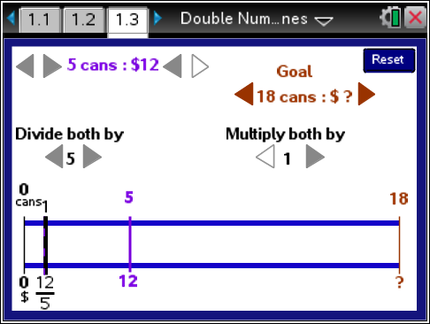
What would you say to Marsie?

5. Units are important in working with double number lines. Which of the following might be solved by using a double number line? Explain why or why not.
a. If 18 pounds of grass seed cost $10 dollars, how much will 50 pounds of grass seed cost?

b. If the garden store recommends 3 pounds fertilizer per 10 pound bag of grass seed, how many pounds of fertilizer would be needed for 35 pounds of grass seed?

c. Orangeade juice calls for 3 cups of water for every 2 cups of orange concentrate. How many cups of concentrate will be needed for 25 cups of juice?

d. Shelly ran 5 meters in 2 seconds. How long would it take her to run 18 meters?

Activity 2 [Page 2.1]
1. Consider the question: How long would it take a pulse to beat 27 times?
a. How is this question different from the pulse question you solved in the Class Discussion?

b. What is your answer? Explain how you found it.

Use either page 1.3 or 2.1 to help you think about the following problems.
2. Given 12 inches per 1 foot, how many feet would be in 32 inches?
a. What is the ratio of inches to feet?

b. Describe how you could use the TNS lesson to answer the question.

3. TJ and Sam drove at the same speed along the same road. It took TJ 5 minutes to drive 3 miles. How long did it take Sam to drive 5 miles? Sara solved the problem reasoning that Sam drove 2 more miles so it should take him 2 more minutes than TJ; or 7 minutes to go 5 miles.
a. What would you say to Sara?

b. How would you solve the problem?

