Infestation to Extermination  ID: 11855 | Time Required  40 minutes

Activity Overview
In this activity, students will investigate exponential growth and decay through the situation of infestation and extermination. Students will review foundational understanding and learn the process of solving separable differential equations. Application questions are solved numerically and graphically. As an extension, students will explore other separable differential equations.

Topic: Exponential Growth & Decay
- Solving separable differential equations
- Differentiating between exponential functions for growth and decay

Teacher Preparation and Notes
- It is recommended that teachers read through the following pages to be ready to take advantage of discussion questions and consider what additional connections they will make.
- The last section of this activity goes beyond exponential growth and decay. The CAS utility of deSolve allows students to explore the solution to differential equations.
- After finishing this activity students should be better equipped for AP* exam questions like 2006BC form B #5a, 2006AB form B #5c, and multiple-choice questions like 1998AB #21and #84.
- To download the student worksheet, go to education.ti.com/exchange and enter “11855” in the keyword search box.

Associated Materials
- InfestationToExtermination_Student.doc

Suggested Related Activities
- Exponential Growth & Decay (TI-Nspire CAS technology) — 12359
- Slope Fields Forever (TI-Nspire CAS technology) — 12321
- Differential Equations (TI-Nspire CAS technology) — 8998
- Differential Equations and Slope Fields (TI-89 Titanium) — 4279

*AP, College Board, and SAT are registered trademarks of the College Board, which was not involved in the production of and does not endorse this product.

Part 1 – Warm Up
Students review foundational understanding and are asked questions that will help them make connections between what they know and what they need to know to understand the process of solving separable differential equations.
Students should set their graphing calculators in Split Screen mode. To change the screen settings, press . Change Split Screen to LEFT-RIGHT, Split 1 App to Y= Editor, and Split 2 App to Table. Then press  to save changes.  Students should enter x^n in y1 and e^(x) in y2. They will compare exponential functions and power functions using the table on the right side of their screen. | 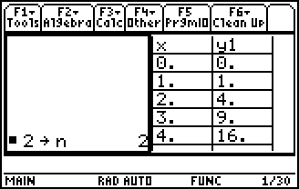
Students can use the table or CAS functions on the HOME screen to answer exercises 2 and 3.  For further thought and discussion  - When n is 7, how big does x have to be so that e^{x} is greater than x^{n}? When x is 22, e^{x} > x⁷.  - For larger values of n, which function increases at a faster rate? y = e^{x}  - What is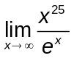? zero | 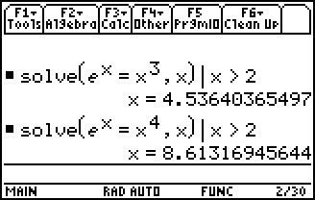
Students will also strengthen their understanding of the difference between exponential growth and decay.
The final exercise in Part 1 helps students see how to solve for the constant k. Ask students to discuss the process with their neighbor.
After completing Part 1, students should return their calculator screen to full screen mode.

Student Solutions
1. y = e^{x} is always increasing
2. x > 4.537
3. x > 8.614
4. For growth a > 0 and b > 1
5. For decay a < 0 and 0 < b < 1
6. k = 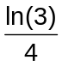

Part 2 – Infestation (Exponential Growth)
In Part 2, students examine the example of infestation of bugs in order to be introduced to the process of solving a separable differential equation.  The worksheet will encourage students to take note of the steps so they can repeat it on their own for Part 3.  When students are solving the DE, point out or ask about the general solution. It is the solution that has the constants in it. The initial conditions have not been applied.  The step that gives students the most difficulty is the getting rid of the absolute value by defining the constant to be a value such that b is positive.  Students can answer application questions graphically using Trace or on the HOME screen. | 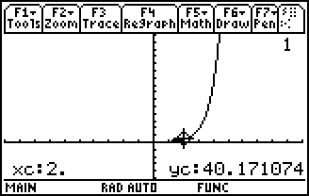  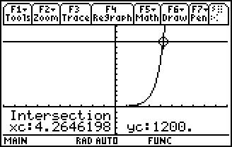
Student Solutions
1. 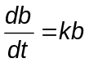
2. 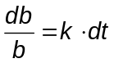
3. ln|b| = kt + C
4. The “+ C” on the right includes of “+ C” on the left.
5. 3 = k(2), so k = 1.5
6. b(t) = 2e^{1.5t}
7. b(2) = 40, b(3) = 180
8. Just over 4.25 days. Solve 1200 = 2e^{1.5t} for t.

Part 3 – Extermination (Exponential Decay)
Students apply what was learned from “Infestation” to “Extermination.” Students see the similarity between exponential growth and decay. They graphically, numerically, or with the aid of CAS, solve several application questions.  Students may need help solving the first problem and finding the constants from the initial condition. | 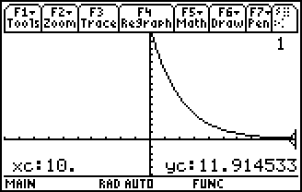
For further thought and discussion
- What would have to be a characteristic of the poison, so that exponential decay occurs during this time? The poison must also block further reproduction at the previous exponential growth rate.

Student Solutions
1. d(t) = 1600e^{–0.49t}
2. d(10) = 12
3. Yes, you need another application because there are still bugs left once the poison is gone.
4. Just over 15 days

Part 4 – Extension (CAS deSolve)
Part 4 introduces students to the use of deSolve. The syntax is demonstrated and students use the command on the HOME screen to confirm their previous solutions. Other separable differential equations are explored. Through this, students may discover that differential equations are not all as intimidating as they may have thought.  Student Solutions  1. b = @1 ∙ e^{k ∙ t} or b = C₁ ∙ e^{k ∙ t}  2. 2  3. b = 2 ∙ e^{k ∙ t} or b = 2 ∙ 4.481689^{t}  4. y² = –x² + C  5. Circle  6. The constant @1, means C₁, @2 means C₂, etc. AND, the constants are different.  7. a. y² = x² + C  b. y = Cx  c. y = x² + C  d. y = 2x³ + C | 

