About the Lesson  This activity examines the motion of a ball as it falls under the influence of gravity. The parameters in the vertex form of the quadratic equation y = a(x – h)² + k are determined to describe the behavior of a ball bounce. As a result, students will:  - Collect motion data and graph scatter plots.  - Determine the quadratic equation for a ball bounce.  - Determine the value of the coefficient a in the vertex form of a quadratic equation.  - Explore the effect of a on the shape of the graph.  - Interpret the meaning of the value of a in the context of the problem situation as one half of the acceleration due to gravity.  Vocabulary  - Vertex  - Vertex form of a quadratic function  - Vertical reflection, vertical stretch, and vertical compression  Teacher Preparation and Notes  - Students should have worked with translations, reflections, and vertical stretches and compressions of functions.  - This activity provides an opportunity for math-science connections.  - This activity is best performed with at least three students: one to hold the CBR™ 2 and press the trigger, one to release the ball, and one to run the calculator.  Activity Materials  - CBR™ 2 motion sensor, USB CBR 2 to handheld cable, and TI-Nspire CX II  - Bouncing ball (Avoid using a soft or felt-covered ball such as a tennis ball.)  - Recommended: TI-Nspire™ CX Premium Teacher Software or TI-Nspire™ CX CAS Premium Teacher Software |  | 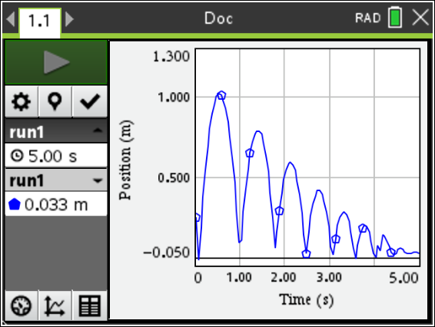  Tech Tips:  - This activity includes screen captures taken from the TI-Nspire™ CX II. It is also appropriate for use with the rest of the TI-Nspire CX family. Slight variations to these directions may be required if using other handheld models.  - Access free tutorials at http://education.ti.com/calculators/pd/US/Online-Learning/Tutorials
This activity could be demonstrated using the TI-Nspire™ CX Premium Teacher Software so the entire class can see the process. If you only have one CBR 2 motion sensor, send the data to each student’s handheld after collecting the data. If you have enough CBR 2 devices, have students work in small groups and collect data.
Setup
See directions in the Student Activity.
Data Collection
See directions in the Student Activity.
Data Collection Questions
- What quantity is represented along the horizontal axis? Answer: time
What are its units? Answer: seconds
- What quantity is represented along the vertical axis? Answer: position or height
What are its units? Answer: meters or feet
- What does the highest point on the plot represent? Answer: the maximum height of the ball
What does the lowest point represent? Answer: the floor
Select a Region of the Graph
See directions in the Student Activity.
Data Analysis
Method 1 – Vertex Form of a Quadratic Function; Determining the Value of a
See directions in the Student Activity.
Data Analysis Method 1 Questions
- For any one bounce, a plot of distance vs. time has a parabolic shape. One form of the equation that describes this motion is y = a(x – h)² + k where (h, k) is the vertex of the parabola and a is the vertical stretch or compression factor of the graph. This equation is called the vertex form.
Record the x- and y-coordinates of the vertex as h and k here:
h = ______ k = ______
Sample Answer: Answers will vary.

- Before storing a value for a, predict what the graph would look like if a = 1.
Answer: The graph will be concave up. It needs to be vertically reflected and vertically stretched to match the bounce.

- Before storing a value for a, predict what the graph would look like if a = 0.
Answer: The graph will be the horizontal line y = k.
- Record the value of a that works best: a =
Answer: Answers will vary but the value of a should be approximately one-half the acceleration due to gravity, −4.9 meters/second² or −16 feet/second².

- Using this value of a and the h and k values you reported in Step 2, write the vertex form of the quadratic equation. y =
Answer: Answers will vary but should be of the form y = a(x – h)² + k.

- What effect does each have on the graph of the parabola?
  - The sign (positive or negative) of a?

Answer: Positive a value, the graph opens up; negative a value, the graph opens down. If a < 0, the graph is concave down; if a > 0, the graph is concave up.

  - |a| > 1?
Answer: If |a| > 1, the graph is a vertical stretch of y = x².

  - |a| < 1?
Answer: If |a| < 1, the graph is a vertical compression of y = x².

- For the same bounce, press Menu > Analyze > Graph Trace, and trace along the plot to identify the x- and y-coordinates of a point that is not the vertex. Record the coordinates here.
x = ________ y = ________ (to 2 decimal places)
Answer: Answers will vary.
- Substitute the coordinates of the vertex ( from Step 2) and the coordinates of a point on the plot of the parabola ((x, y) from Step 11) into the vertex form of a parabola, y = a(x – h)² + k, to solve for the value of a.
a =
Record the equation of the parabola in vertex form.
y =
Answers: Answers will vary but the value of a should be approximately one-half the acceleration due to gravity, −4.9 meters/second² or −16 feet/second².
- How does the value of a from Question 8 compare to the value of a from Question 12? Which graph (f1(x) or f2(x)) provides a better fit for the bounce? Explain.
Sample Answer: Answers will vary.

Method 2 – Quadratic Regression
Quadratic Regression Questions
- What is your regression equation? _________________________
Answer: Answers will vary but the value of a should be approximately one-half the acceleration due to gravity, −4.9 meters/second² or −16 feet/second².

- How does the value of a in the regression equation compare to the values of a you determined in Method 1?
Answer: Answers will vary.

Extension:
- Would you expect your classmates to have the same value of a for their trials, or do you think the a value would vary? Explain your answer.
Sample Answer: Same; student explanations will vary depending on their previous experiences.

- Determine the values of a found by other groups of students in your class. How do these values compare to your value of a?
Sample Answer: Same or very close.

- If a ball that was more or less bouncy was used, would it affect the value of a in the equation? Explain your response.
Answer: No, it would only affect the vertices of the bounces.

Lead students into a discussion about the acceleration of falling objects due to gravity.
- Remember, the ball was not thrown; it was dropped. After an object is released, it is acted upon by gravity (neglecting air resistance). So a depends on the acceleration due to gravity, −9.8 meters/second² or −32 feet/second².
- The negative sign indicates that the acceleration is downward.
Note: Depending on students’ knowledge of physics, decide how far to take this discussion.

