Activity Overview  In this activity students explore models for the elliptical orbit of Jupiter. Problem 1 reviews the geometric definition of an ellipse as students calculate for a and b from the perihelion and aphelion of Jupiter. Students then graph an ellipse using the Cartesian equation and discuss the shortcomings of this method. Problem 2 develops the concept of a parametric curve by using a data capture to discover the coordinate equations of an ellipse. Problem 3 applies these equations to model of the orbit of Jupiter.  Topic: Conics & Polar Coordinates  - Graph the equation of any conic expressed in parametric form and identify its properties.  Teacher Preparation and Notes  - This activity is appropriate for an Algebra 2 or Pre-calculus classroom.  - Students should have experience graphing ellipses and basic trigonometric functions.  - This activity is intended to be teacher-led with students in small groups. You should seat your students in pairs so they can work cooperatively on their handhelds. You may use the following pages to present the material to the class and encourage discussion. Students will follow along using their calculators.  - To download the calculator program and student worksheet, go to education.ti.com/exchange and enter “10034” in the keyword search box. | 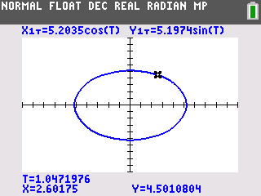  This activity utilizes MathPrintTM functionality and includes screen captures taken from the TI-84 Plus C Silver Edition. It is also appropriate for use with the TI-83 Plus, TI-84 Plus, and TI-84 Plus Silver Edition but slight variances may be found within the directions.  Compatible Devices:  - TI-84 Plus Family  - TI-84 Plus C Silver Edition  Associated Materials:  - OrbitOfJupiter_Student.pdf  - OrbitOfJupiter_Student.doc  - EXPLPARA.8xp  Click HERE for Graphing Calculator Tutorials.

Pages 2–5 contain directions that are intended to be handed out to each group of students to follow along with. The students will record their answers to the questions on the student worksheet. Solutions to the questions are found on pages 6–7.

Problem 1 – A Cartesian Model
Jupiter’s perihelion, is 4.952 A.U. (astronomical units). This means that when Jupiter is closest to the sun in its orbit, it is 4.952 A.U. away.
Jupiter’s aphelion, is 5.455 A.U. (astronomical units). This means that when Jupiter is furthest to the sun in its orbit, it is 5.455 A.U. away.
Use this information to draw a picture of Jupiter’s orbit on your worksheet and answer the questions there.
Now that we have an equation in terms of y =, we are ready to graph the orbit of Jupiter. Actually, we will need to graph two equations.  Enter the two equations in Y1 and Y2. Change the color of Y2 to blue.  Press  and select ZStandard to view the graph. | 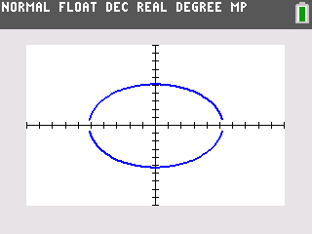
We can animate a point on the graph to represent Jupiter. On the □ screen, arrow over to the left of Y1. Press  until the circle symbol appears.  Repeat with Y2.  View the graph. Answer the questions on your worksheet to evaluate this model. | 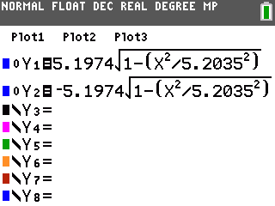
This is not a very good model of Jupiter’s orbit for many reasons. It does not take time into account. Jupiter is at a certain place relative to the sun at a certain time, but time does not figure into our equations.
- It requires two functions instead of one.
- It does not appear as a continuous curve.
- It relies on the square root function, which has a limited domain.
In the next problem, you will make a better model—a parametric model!

Problem 2 – A Parametric Model
This ellipse is one of many curves that cannot be expressed as a single equation in terms of only x and y. A better way to represent this type of curve is to use parametric equations. Instead of defining y in terms of x ( y = f(x) ) or x in terms of y ( x = g (y) ) we define both x and y in terms of a third variable called a parameter as follows.
x = f(t) y = g(t)
These equations are called parametric or coordinate equations. The third variable is usually denoted by t and often represents time. This makes parametric equations an especially good choice for the orbit of Jupiter.
Imagine taking snapshots of the position of Jupiter at different times as it orbited the sun. Then on each snapshot, measure the horizontal and vertical distance of Jupiter from the center of its orbit.
You could write a function that describes how the horizontal distance changes over time: x = f(t).
You could also write a function that describes how the vertical distance changes over time: y = g(t).
Each value of t defines a point (f(t), g(t)) that we can plot. The collection of points that we get by letting t be all possible values is the graph of the coordinate equations and is called the parametric curve.
But what are the coordinate equations? Let’s take another look at the ellipse.  Return to the □ screen. Arrow to the left of Y1 and press  to change the graph type back to line. Repeat for Y2 and view the graph. Answer the questions on your worksheet to explore the coordinate equations. |  | 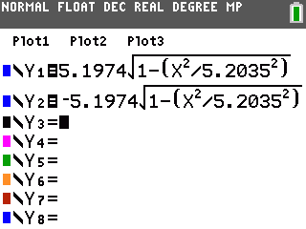
Make sure that the calculator is in Radian mode.  Run the program EXPLPARA by pressing  choosing it from the list.  Enter 12 for the value of a and 5 for the value of b. Other values for a and b can also be entered (Note that this program will not work properly with other conic sections—only ellipses centered on the origin.) |  | 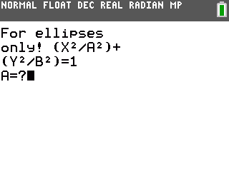
The program graphs your ellipse as two functions in x and y and displays the graph in Trace mode.  (Note: you must select an appropriate window for your graph before starting the program. If your curve is not visible, exit the program by pressing  and choosing Quit, adjust the window, then run the program again.) |  | 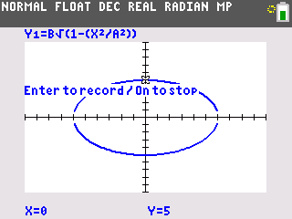
Move around the graph to the rightmost point on the ellipse, where y = 0. Starting at this point and moving counterclockwise, record at least 5 points from each quadrant of the ellipse.  To record a point, press . This will store the horizontal and vertical distance of the point on the curve to the center of the ellipse.  Use the up and down keys to move between the two functions. Each time you record a point, the program will return to the upper half of the ellipse. When recording points on the lower half of the ellipse, you will need to press down each time.  As you move around the ellipse, note how the value of t changes.  Press  and choose Quit to exit. |  | 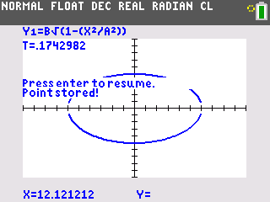  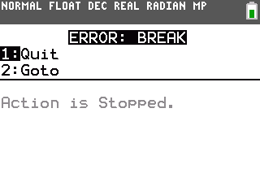
View the data you collected. Press   to enter the list editor.  The t-values are stored in L1.  The x-values are stored in L2.  The y-values are stored in L3.  Answer the questions about t on your worksheet. |  | 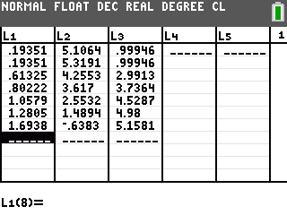
Plot the x-values versus the t-values as a scatter plot. Press  . Set the Plot to On and choose the appropriate XList and YList. |  | 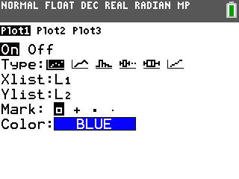
Press  and choose ZoomStat to view the plot in a appropriate window. Answer the questions on your worksheet about this plot.  (Note: You may wish to turn off the functions Y1 and Y2 to make the graph easier to read.) |  | 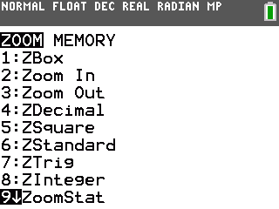
Change the plot so that it shows the y-values versus the t-values. Answer the questions on your worksheet about this plot. |  | 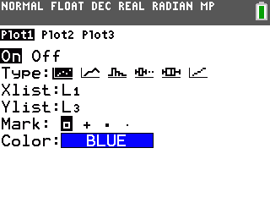
Now that you have found the coordinate equations for Jupiter’s orbit, graph the parametric curve. Press  and press  on PARAMETRIC to change the graphing mode to parametric equations. |  | 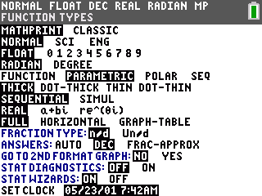
Enter the coordinate equations for Jupiter’s orbit in X1(T) and Y1(T). |  | 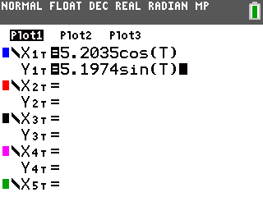
Press  and choose ZStandard to view the curve in a standard window. The standard parametric window settings are shown. In addition to setting the x and y intervals, the values used for T are also specified. Usually, T ranges from 0 to 2π. |  | 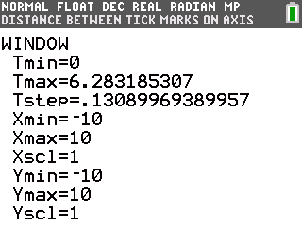
Press  to trace the curve. Observe the values of t.

Change the graph type to an animated point that travels on the curve.
View your improved model of Jupiter’s orbit!
Solutions—Problem 1
Building the Cartesian Model
- (0.2515, 0) | - (–0.2515, 0) |  | - 5.2035 A.U.
- The sum of the distances from any point on the ellipse to the two foci is always equal. The point (5.2035, 0) is on the ellipse. (It is the rightmost point.) The distance from this point to the “sun” focus is the perihelion, 4.952 A.U. The distance from this point to the other focus is the aphelion, 5.455 A.U. Therefore the sum of the two distances, which will remain constant for every point on the ellipse, is 10.407, or 2a. The distance from point P to the “sun” focus is equal to the distance from point P to the other focus. Because the sum of these two distances must be 2a and the distances are equal, each segment has length a.
- This equation actually represents two functions because of the ± symbol. If we choose +b, we get one function. If we choose –b, we get another.

Evaluating the Cartesian Model
- Yes and no. It is shaped like an ellipse, but the ends do not appear to line up.
- No. As x-increases, a point would move from left to right, then have to jump back to the left and start over again on the other function.
- It does not take time into account. Jupiter is at a certain place relative to the sun at a certain time, but time does not figure into these equations. It requires two functions instead of one. It does not appear as a continuous curve. It relies on the square root function, which has a limited domain.
Solutions—Problem 2
Exploring Coordinate Equations
- Decreases to 0; increases to a,
- The distance begins at 0, increases to b, decreases back to 0, decreases further to –b, and increases back to 0. Then the pattern repeats as Jupiter orbits again.
About t
- t increases from 0 to 2π

Plot of x-values vs. t-values
- a cosine curve
- 12 and –12. These are the values of a and –a for the ellipse.
- x(t) = a cos(t)
Plot of y-values vs.ty-values
- a sine curve
- 5 and –5. These are the values of b and –b for the ellipse.
- y(t) = b sin(t)
Checking the coordinate equations
- x(t) = 5.2035 cos t; y(t) = 5.1974 sin t

