Topic 3: Geometry and Trigonometry | 3D Surface Area and Volume
A teacher is designing a treasure chest to hold rewards for her students to select from for good deeds and correct responses during the school day. See her design below. She is trying to figure out how much brown paint she will need to paint with when it is constructed.
The treasure chest’s dimensions of the rectangular base are a length of 80 cm, width of 30 cm, and height of 25 cm. The lid is in the shape of a half cylinder.
The entire chest exterior is to be painted. Find the area to be painted.
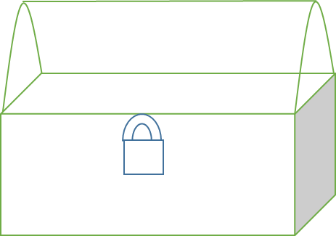30 cm 80 cm
25 cm
Diagram not to scale.

Mark scheme:  90 x 30 (= 2700)  2 x 30 x 25 (= 1500) and 2 x 80 x 25 (= 4000)  r = 15  π x 15² (= 225π, 706.858…)  use of curved surface area formula  15π x 80 (= 1200π, 3769.91…)  12,700 cm² (12676.769…) |  | (A1)  (A1)  (A1)  (M1)  (M1)  (A1)  (A1)  [7 marks]

