Open the TI-Nspire™ document Exploring_Transformations_of_a_Function.tns.  In this activity, you will explore transformations of an absolute value function. You will use the table feature to examine the effect that stretching and translating has on the coordinates of the graph. | 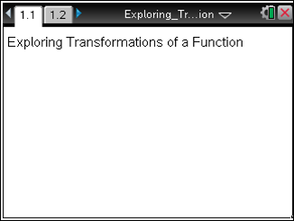

Move to page 1.2. | Press / ¢ and / ¡ to navigate through the lesson.
Step 1:
The dashed graph is f1(x) =and the solid graph is f2(x) = .

Step 2:
Study the graphs, and then record the coordinates of the two functions in the tables below. To place the cursor in the table, you may need to press / e (you can also use the touchpad mouse to click on a cell). Then use ¢ £ to maneuver through the table.

Step 3:
Double-click on the cell containing 3abs(x). Replace the 3 with –3, press ·, and complete the third table below.

Step 4:
Repeat the previous step to replace –3 with 2, and then complete the fourth table.

x | f1(x) = |  | X | f2(x) = 3 |  | x | f2(x)= –3 |  | x | f2(x)= 2
–1 |  |  | –1 |  |  | –1 |  |  | –1
0 |  |  | 0 |  |  | 0 |  |  | 0
1 |  |  | 1 |  |  | 1 |  |  | 1
2 |  |  | 2 |  |  | 2 |  |  | 2

Answer these questions.

- How does changing the coefficient of affect the x-coordinates? Justify your answer.

- How does changing the coefficient of affect the y-coordinates? Justify your answer.

- If f1(x) =contains the point (x, y), what corresponding point will be found on the graph of f2(x)=?
Step 5:
Given f1(x) =, change the definition of the function f2(x) to f2(x) = .

Step 6:
Complete the first table below.

Step 7:
Repeat the process by changing the definition of the function to f2(x) = + 1, and then complete the second table.

x | f2(x) = 1 – 2 |  | x | f2(x) = 1 + 1
–1 |  |  | –1
0 |  |  | 0
1 |  |  | 1
2 |  |  | 2

Answer these questions.

- How does changing the constant affect the y-coordinates? Justify your answer.

- If f1(x) =contains the point (x, y), what corresponding point will be found on the graph of f2(x) =1 + c?

