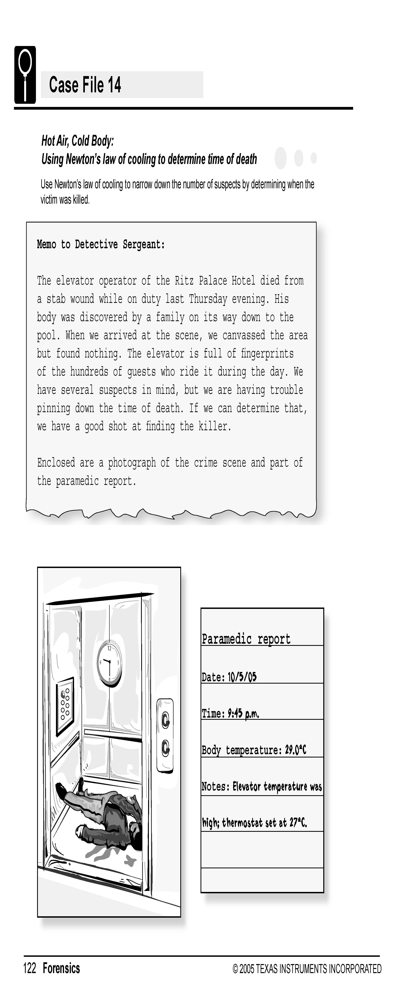
Science Objectives
- Determine the time of death of a person who has died within the last few hours.
- Create a temperature vs. time graph for cooling.
- Model the temperature data with an exponential function.
- Use the model to estimate time of death.

Activity Materials
- TI-NspireTM technology  - Case 14 Hot Air Cold Body file  - Case_14_Hot_Air_Cold_Body.doc student activity sheet  - DataQuest App | - EasyTemp Probe  - ring stand with clamp  - test tube and test tube rack  - a “body”
Procedure
Open the TI-Nspire document Case 14 Hot Air Cold Body.tns.  In this data-gathering activity, you will create a temperature vs. time graph for cooling, model temperature data with an exponential function, and then use the model to estimate time of death. |  | 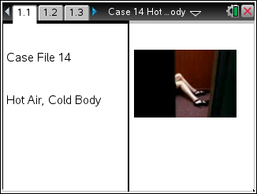
Part 1 – Collecting Data to Model the Cooling of a Body
Move to pages 1.2–1.4.
1. Look at the paramedic report above. Record the temperature of the body and the time the body temperature was measured into the Evidence Record.
2. Obtain a "body" and begin warming it in your hands by holding it tightly. DO NOT let go until we begin data collection! You need to warm it for at least 5 minutes.

3. Connect the EasyTemp Probe to the TI-Nspire. DataQuest should recognize the EasyTemp probe and display the ambient (room) temperature.
a. Hold the Temperature Probe in the air away from heat sources and sunlight. Make sure the tip of the probe is not touching anything warmer or cooler than room temperature (such as your hand).
b. Record the room temperature in your Evidence Record.
4. Press home and open a new document. To change the data collection set-up for the longer term needed, press the menu key.
Select Experiment > Set-Collection. On the Meter screen, tap Length. Change the data-collection units to minutes. Change the length to 1200 seconds. Change the data-collection rate to 20 samples/minute. Select OK.

5. Attach the EasyTemp Probe to the clamp on your ring stand. Add 20 mL of the 50°C water to the test tube "body" and place the test tube in the test tube rack. Adjust the clamp to place the temperature probe in the water. Position the probe so that it is near the center of the test tube and away from the sides of the test tube.
6. Wait for the temperature sensor to stabilize. Start data collection. When data collection is complete, clean up and return all "bodies" to your teacher.

Part 2 – Modeling the Data with an Exponential Function
Move to pages 3.1–3.4.
7. Newton’s law of cooling is an exponential relationship that states:
T = T₀ ^{e–kt} + T_{room}
where T is temperature of the object at any time t, T₀ represents the temperature difference between the initial temperature of the object and the room temperature, k is a constant that represents the cooling rate, and T_{room} is the room temperature.
8. The following keystrokes are needed to enter Newton’s Law of Cooling. You must enter in your collected data for A (ambient room conditions), I (initial temperature) F final room temperature and T the amount of time between the high and low temperature.

nsolves(0=/p1¤k¢*Õ/p(I-A)¤(F-A)¢-T¢/µ ñ I= and A= and F= and T= ,K)\

Your screen should look like this:
$$nsolve\left(0=\frac{1}{k}*ln\left(\frac{(I-A}{\left(F-A\right)}\right)-T |I+?and A=?and F=?and T= ?,K\right)$$

Once you press enter, you will have your k value.
9. Next, apply your value of k to the crime scene data:
To do this, enter the following key strokes, filling in your values from the crime scene case and the k value from above.

“nsolves(0=/p1¤k¢*Õ/p(I-A)¤(F-A)¢-T¢/µ ñ I= and A= and F= and K= ,T)\

Note: There must be a space before and after the and.

$$\left(0=\frac{1}{k}*ln\left(\frac{(I-A}{\left(F-A\right)}\right)-T |I+?and A=?and F=?and K= ?,T\right)$$
OR

10. Fit an exponential function to the data.
- Press the menu key and then choose Analyze > Curve Fit. Choose Natural Exponential as the Fit Equation.
- The fit parameters for the equation are displayed. Enter the values for A, B, and C in the Evidence Record.
- Select OK.
11. The fitted curve represents a model that predicts what the temperature of the body will be as it cools to room temperature. The graph is scaled to show this model to when the sample approaches room temperature. You will examine the fitted curve to estimate the time that it would take your sample to cool to 26°C. Note: In order to complete this step, you may need to choose Graph Options from the Graph and change the axes endpoints:
- Press the menu key choose Analyze > Interpolate.
- Use the mouse to the point where the temperature is 37°C (body temperature). Record the time in minutes in the Evidence Record.
- Tap the point where the temperature is 26°C. Record the time in minutes in the Evidence Record.
- Calculate the elapsed time and record it in the Evidence Record.

Evidence Record
Temperature of body (ºC)
Time body temperature was measured
Modeling the Cooling in the Lab
Ambient (room) temperature in the lab (ºC)
Variables from the Fitted Curve
A
C
B
Temperatures and Times from the Fitted Curve
Time that the water was at 37ºC (minutes)
Time that the water was at 26ºC (minutes)
Elapsed time (minutes)

Case Analysis
Move to pages 4.1–4.7.
Answer the following questions here, in the .tns file, or both.
1. Match the variables A, B, and C in the fitted equation to the terms T0, k, and Troom, in the expression of Newton’s law of cooling.
From Newton’s Law of Cooling
T0
Cooling constant, k
Troom

2. The term Troom represents the room temperature. How closely does this term match the room temperature in the lab experiment?

3. The T0 term represents that initial difference between the water temperature and the room temperature. How closely does this term match your data?

4. Use the elapsed time for your sample to cool to 26ºC to estimate the time of death in the case.

5. The experiment performed to model the cooling of a victim is much simpler than the actual cooling at a crime scene. What other facts would affect the cooling rate of a victim?

