Math Objectives  - Students will understand the role of the values of a and b in the equation $r=a±b*sin\left(θ\right)$ and $r=a±b*cos\left(θ\right)$ where $a>0$ and $b>0.$  - Students will discover the four different types of limaçon curves and their relationship to the ratio of $\frac{a}{b}.$  - Students will understand the relationship between the equation of a polar curve, called a limaçon, and the equation of a corresponding sinusoidal function.  Vocabulary  About the Lesson  - Students will investigate the effect of changing the values of a and b in the equation $r=a±b*sin\left(θ\right)$ and $r=a±b*cos\left(θ\right).$  - Students will generalize the roles of a and b in the equation $r=a±b*sin\left(θ\right)$ and $r=a±b*cos\left(θ\right).$  - Students will compare the graphs of the sinusoidal function, $f\left(x\right)=a±b*sin\left(x\right),$ and the polar curve, $r=a±b*sin\left(θ\right)$ and make generalizations about the relationship between the graphs.  - Students will compare the graphs of the sinusoidal function, $f\left(x\right)=a±b*cos\left(x\right),$ and the polar curve, $r=a±b*cos\left(θ\right)$ and make generalizations about the relationship between the graphs.  TI-Nspire™ Navigator™  - Transfer a File.  - Use Class Capture to examine patterns that emerge.  - Use Live Presenter to demonstrate.  - Use Teacher Edition computer software to review student documents.  - Use Quick Poll to assess students’ understanding  Activity Materials  Compatible TI Technologies:  TI-Nspire™ CX Handhelds,   TI-Nspire™ Apps for iPad®,  TI-Nspire™ Software | 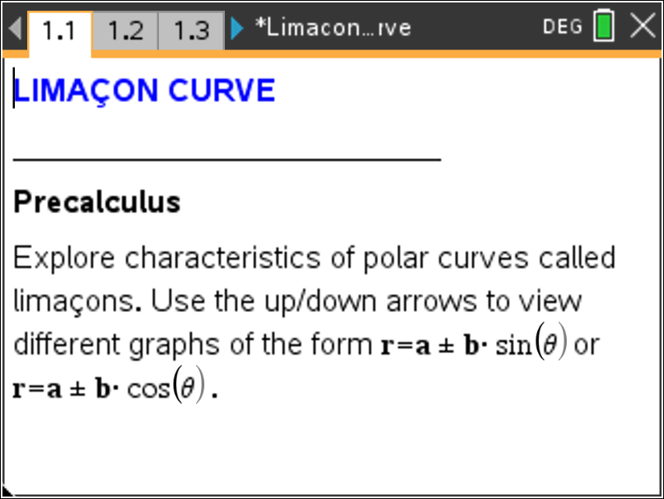  Tech Tips:  - This activity includes screen captures taken from the TI-Nspire CX II handheld. It is also appropriate for use with the TI-Nspire family of products including TI-Nspire software and TI-Nspire App. Slight variations to these directions may be required if using other technologies besides the handheld.  - Watch for additional Tech Tips throughout the activity for the specific technology you are using.  - Access free tutorials at http://education.ti.com/calculators/pd/US/Online-Learning/Tutorials  Lesson Files:  Limacon_Curve_Student.pdf  Limacon_Curve_Student.doc  Limacon_Curve.tns
  - limaçon | - cardioid
  - sinusoidal function | - dimpled limaçon
  - convex limaçon | - inner loop limaçon
In this activity, you will investigate the effect of changing the values of a and b in the polar equations $r=a±b*sin\left(θ\right)$and $r=a±b*cos\left(θ\right)$, where $a>0$ and $b>0$. You will also explore the relationship between the polar curve $r=a±b*sin\left(θ\right)$ (or $r=a±b*cos\left(θ)\right)$and the sinusoidal function $f\left(x\right)=a+b*sin\left(x\right)$ (or $f\left(x\right)=a±b*cos\left(x\right)$).

Discussion Points and Possible Answers

Polar curves called limaçons have equations of the form $r=a±b*sin\left(θ\right)$ or $r=a±b*cos\left(θ\right)$. On page 1.2 are special kinds of limaçon graphs called cardioids. Use the up/down arrows to see all the graphs.

Move to page 1.2.
- Why do you think these graphs are called cardioids?  Answer: The graphs form a curve that looks somewhat like a heart.  The graphs on page 1.2 are:  $i) r1=1+1*sin\left(θ\right)$ $ii) r1=1-1*sin\left(θ\right)$  $iii) r1=2+2*sin\left(θ\right)$ $iv) r1=2-2*sin\left(θ\right)$  $v) r1=3+3*sin\left(θ\right)$ $vi) r1=3-3*sin\left(θ\right)$ |  | 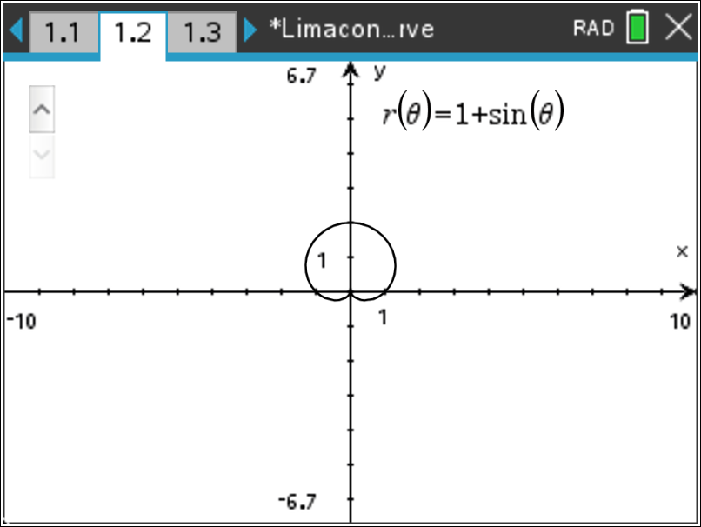  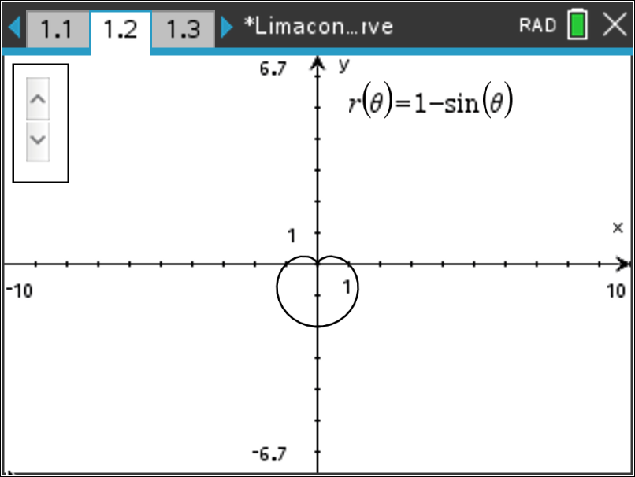  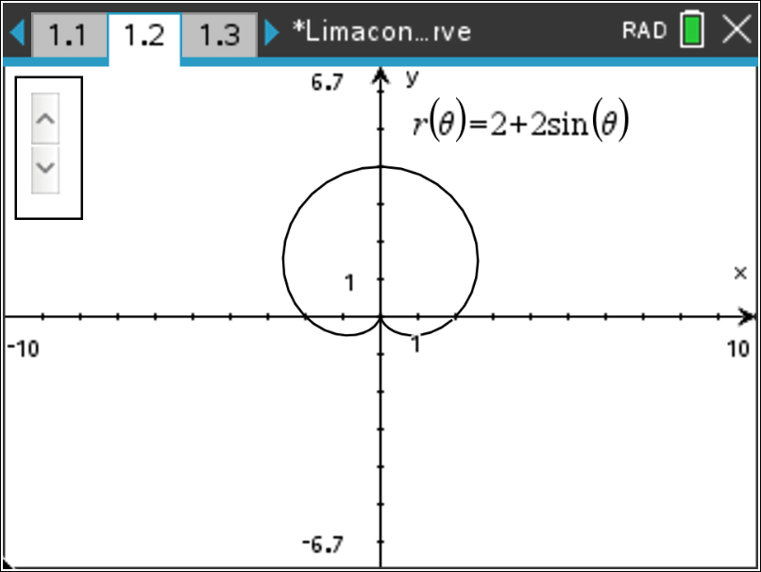  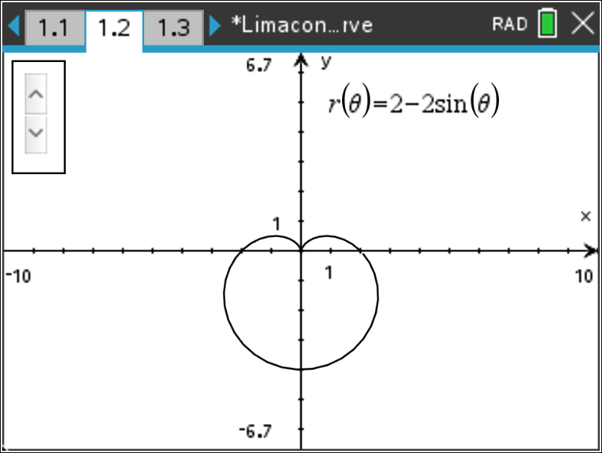  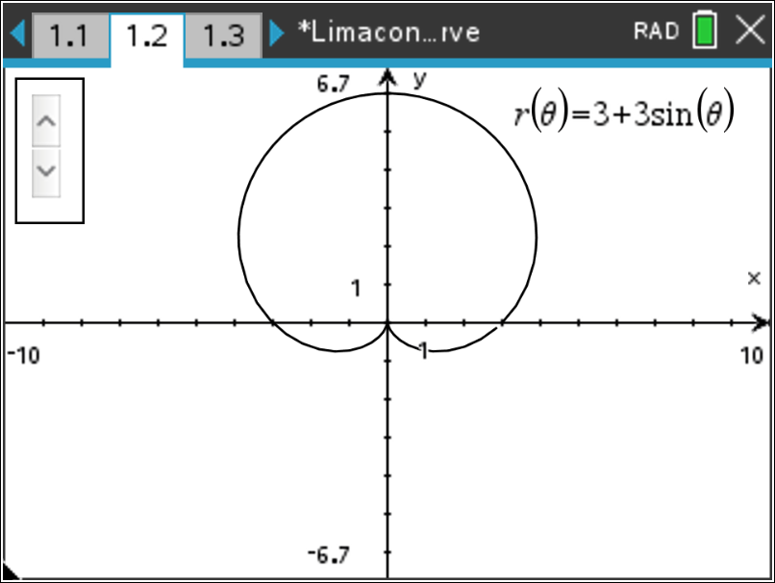  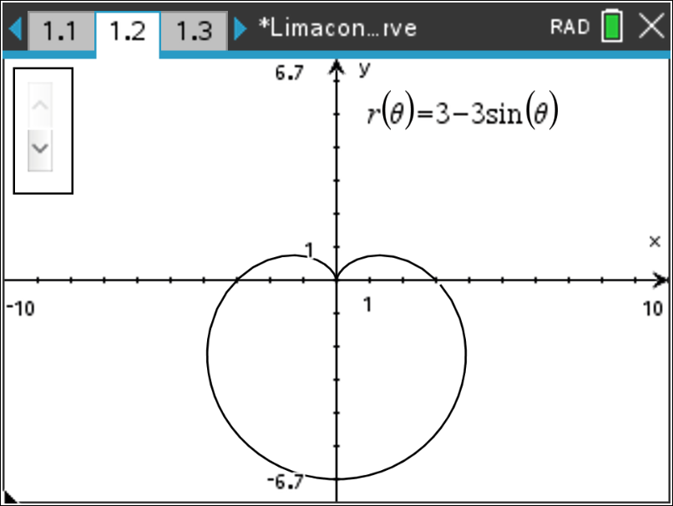
Teacher Tip: The purpose of these sets of graphs is for students to see:
1) how the addition and subtraction signs affect the graph, 2) when a and b are equal the shape of the graph stays the same, and 3) when the value of the numbers increase, the size of the graph also increases.

- What similarities do you notice about the equations of the six graphs?

Sample Answer: Answers may vary. Students should notice that in each equation the values of a and b are the same. Also, each equation contains the trigonometric function sine.

- How do the addition and subtraction signs affect the graphs?

Answer: In the graphs with equations containing the addition sign, the heart shape is pointing down. In the graphs with equations containing the subtraction sign, the heart shape is pointing up.

Move to page 1.3.

Use the up/down arrows to see all the graphs.

- How are the equations different from those on page 1.2? How does this difference affect the graph?  Answer: The difference between these equations and the ones in Problem 1 is the trigonometric function sine has been replaced with trigonometric function cosine. Now the heart shape is pointing either left or right depending on the sign, instead of up or down. If the equation contains an addition sign, the heart shape points left. If the equation contains a subtraction sign, the heart shape points right.  The graphs on page 1.3 are:  $i) r1=1+1*cos\left(θ\right)$ $ii) r1=1-1*cos\left(θ\right)$  $iii) r1=2+2*cos\left(θ\right)$ $iv) r1=2-2*cos\left(θ\right)$  $v) r1=3+3*cos\left(θ\right)$ $vi) r1=3-3*cos\left(θ\right)$ | 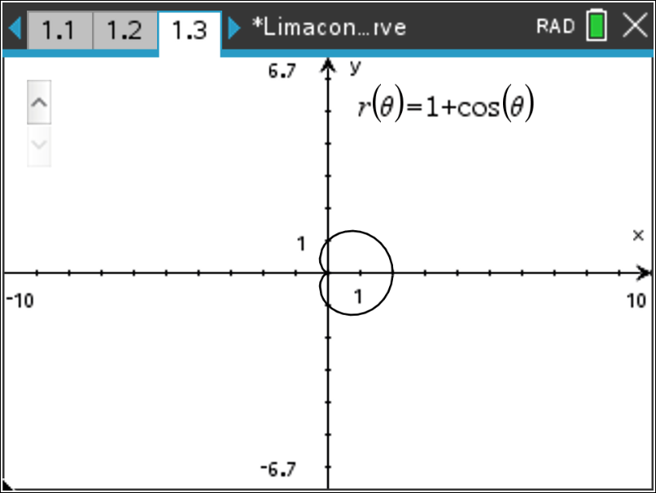  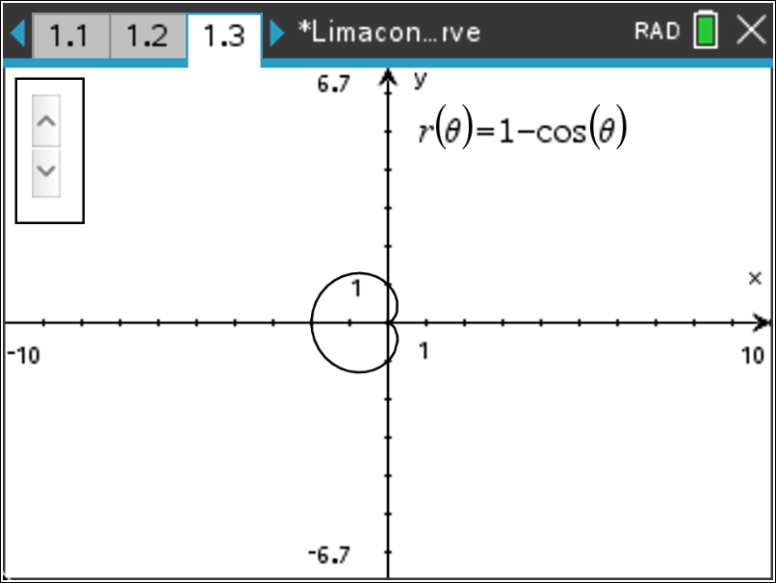  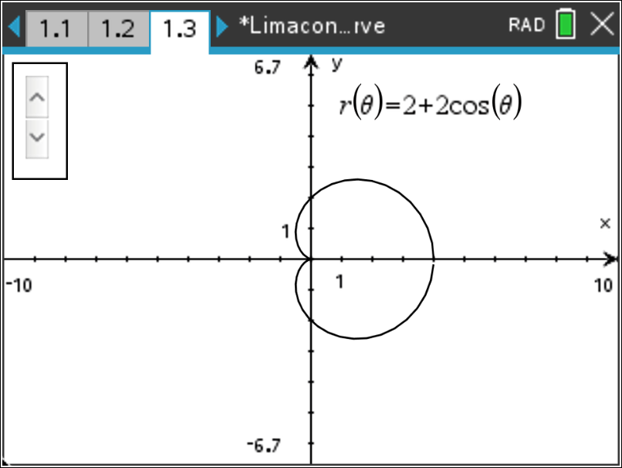  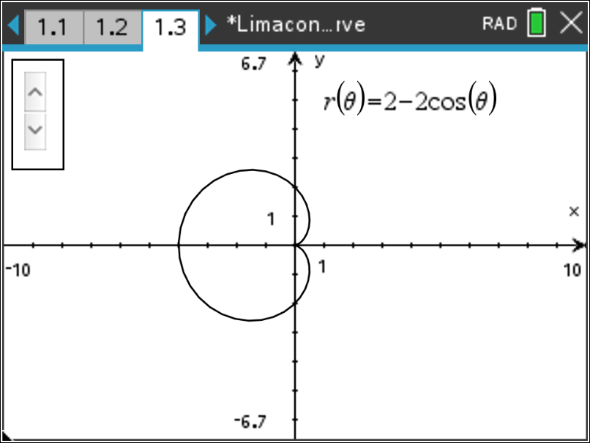  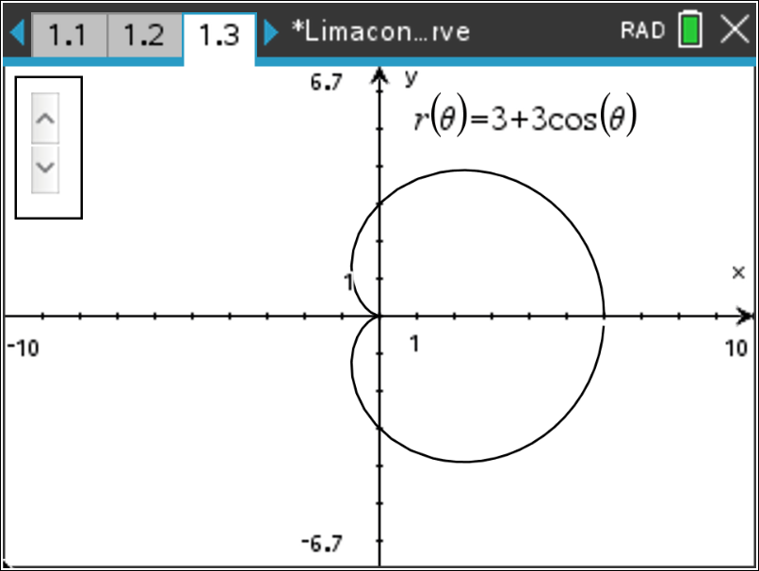  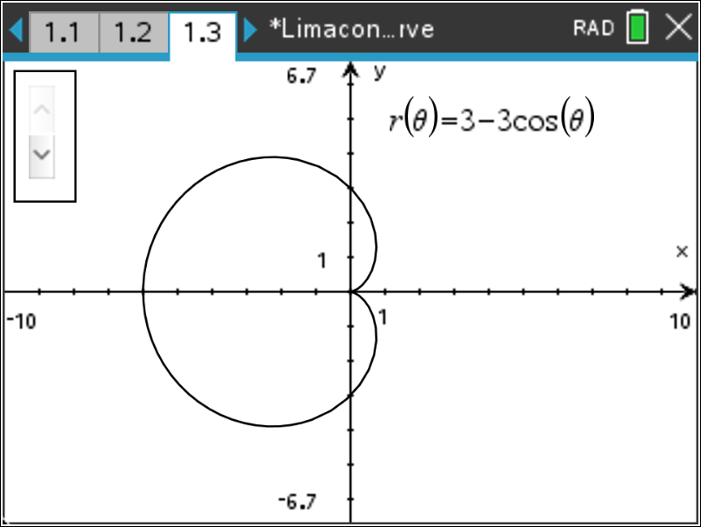
Teacher Tip: The purpose of these graphs is for students to see how replacing the sine function with cosine affects the graph of the limaçon.

Limaçons have different shapes depending on the ratio $\frac{a}{b}$. We have already seen the cardioid graph that is the result when $a=b$ (or $\frac{a}{b}=1$).

Move to page 1.5.

Graph the polar functions shown in the table by changing $a$ and $b$. Complete the table with the values of $a$, $b$, and $\frac{a}{b}$ as you observe each graph. Use the up/down arrows to change the values of $a$ and $b$.

- Some of the limaçons in the table above have the ratio $\frac{a}{b}<1$. Write an equation of another polar curve for which $\frac{a}{b}<1$. Graph your limaçon and describe the shape of the limaçon.  Answer: Equations and descriptions may vary. A limaçon in which the ratio of a and b is less than 1 results in an inner loop.  Sample equation: $r=2+4*cos\left(θ\right)$  - One of the polar curves in the table above has a ratio which satisfies $1<\frac{a}{b}<2$. Write an equation of another polar curve for which $1<\frac{a}{b}<2$. Graph your limaçon and describe the shape of the limaçon.  Answer: Equations and descriptions may vary. A limaçon in which the ratio of a and b is between 1 and 2 results in a dimpled shape or, it may be described as a kidney bean shape.  Sample equation: $r=4+3*cos\left(θ\right)$  - Some of the limaçons in the table above have the ratio $\frac{a}{b}>2$. Write an equation of another polar curve for which $\frac{a}{b}>2$. Graph your limaçon and describe the shape of the limaçon.  Answer: Equations and descriptions may vary. A limaçon in which the ratio of a and b is greater than or equal to 2 results in a convex shape that is almost circular.  Sample equation: $r=5+2*cos\left(θ\right)$ |  |  | 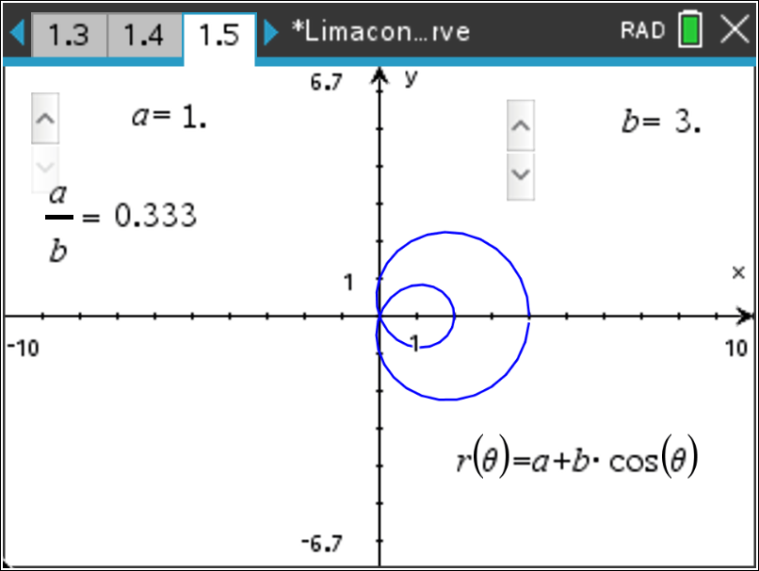  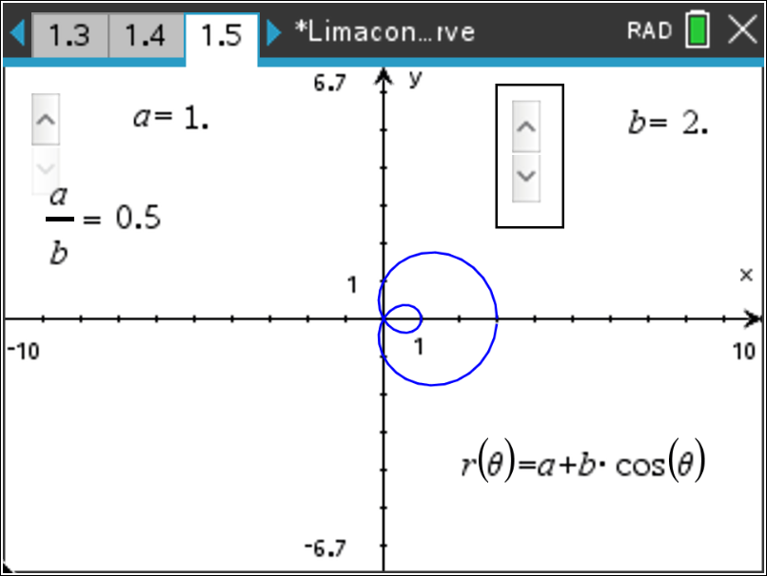  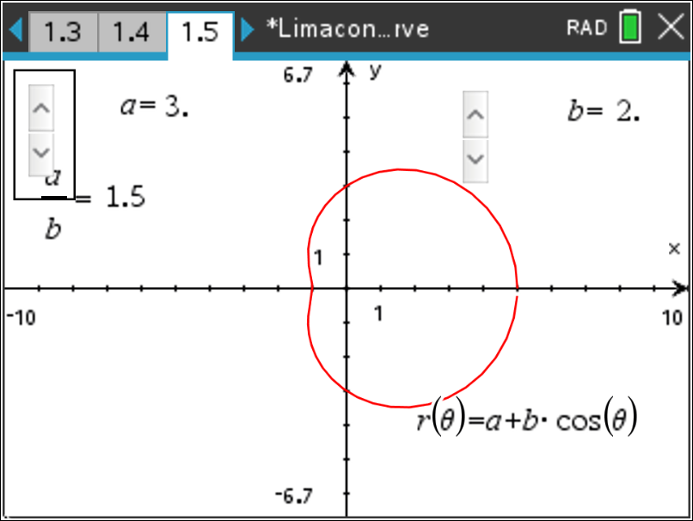  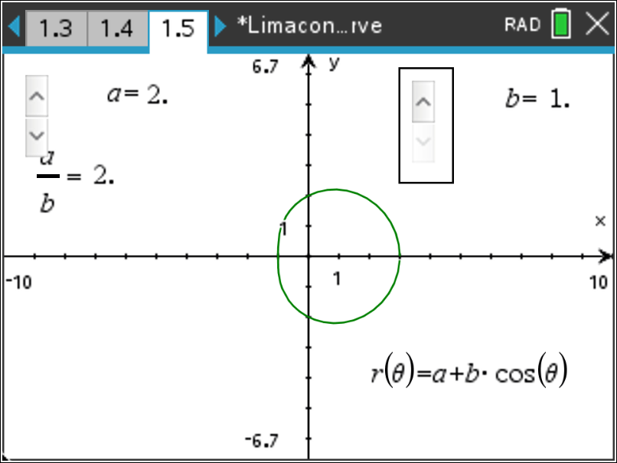  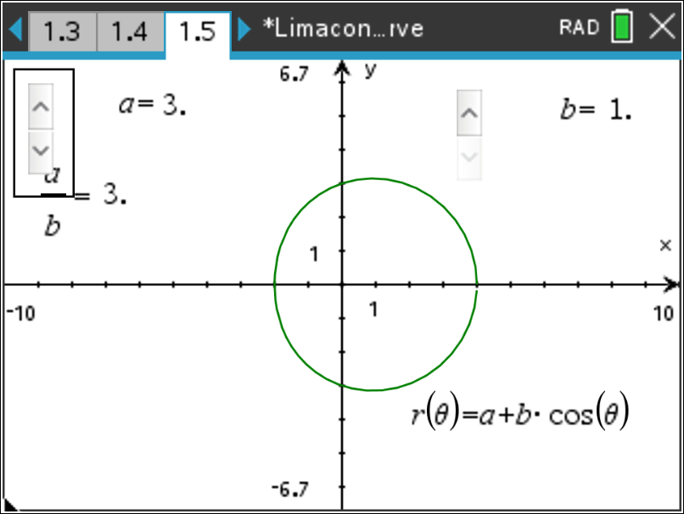
  Limaçon | $$a$$ | $$b$$ | $$\frac{a}{b}$$
  $$i) r1=1+3*cos\left(θ\right)$$ | 1 | 3 | 0.333
  $$ii) r1=1+2*cos\left(θ\right)$$ | 1 | 2 | 0.5
  $$iii) r1=3+2*cos\left(θ\right)$$ | 3 | 2 | 1.5
  $$iv) r1=2+1*cos\left(θ\right)$$ | 2 | 1 | 2
  $$v) r1=3+1*cos\left(θ\right)$$ | 3 | 1 | 3
Teacher Tip: The purpose of these graphs is for students to see how the values of a and b affect the graph of the limaçon. You may want the students to graph some of these with the sine function.
Move to page 2.2.

Teacher Tip: Students may want to set the Trace Step to π/12 when tracing the polar graphs in Problems 8, 9, and 10.

- The graph of the sinusoidal function $f\left(x\right)=2+2*sin\left(x\right)$ on the interval $0≤x≤2π$ is shown below. The x-scale is π/6.  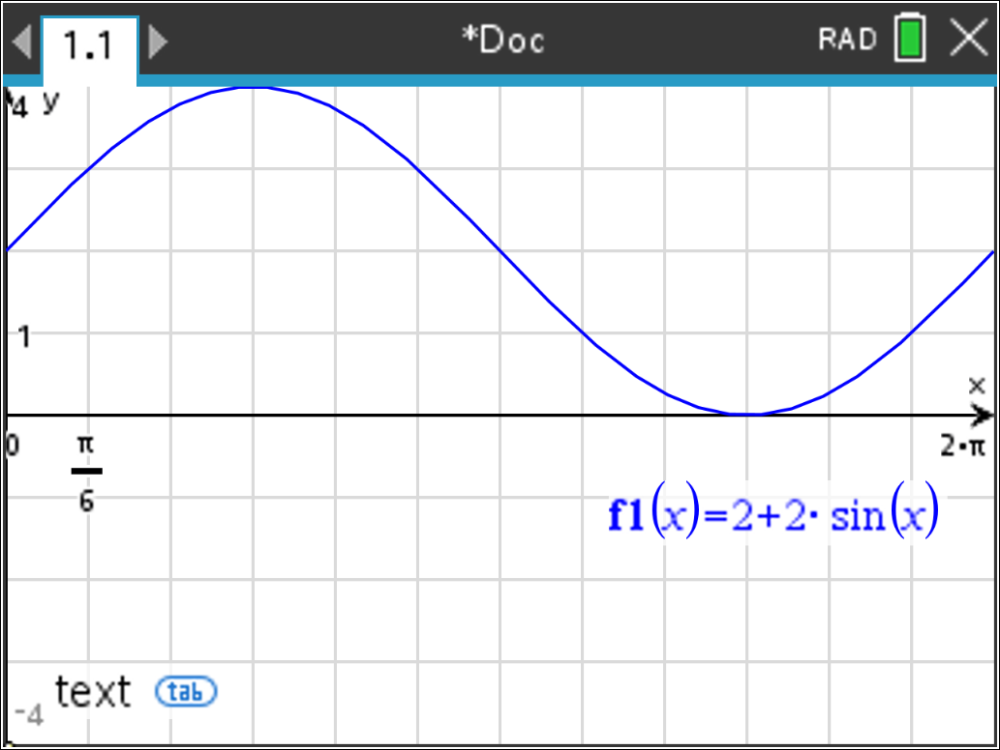  Graph the limaçon given by $r1(θ)=2+2*sin\left(θ\right)$. Press b and select 3 Graph Entry/Edit and then 5 Polar. Now press b and select 5 Trace and then 1 Graph Trace. Use the right arrow to move your cursor. Observe the change in the r and θ values.  On the interval from x = 0 to x = 2π of the sinusoidal function, the maximum occurs at $x=\frac{π}{2}$ ($≈1.57 rad)$and the minimum occurs at $x=\frac{3π}{2}$ ($≈4.71 rad).$  How do the $y-$values at these two points correspond to the $r-$values on the cardioid?  Answer: The maximum of the sinusoidal function graph is located at the point $\left(\frac{π}{2},4\right)$ and this point corresponds to the point on the cardioid that is furthest from the pole. The minimum of the sinusoidal function graph is located at the point $\left(\frac{3π}{2},0\right)$ and this corresponds to the point at the pole. |  |  | 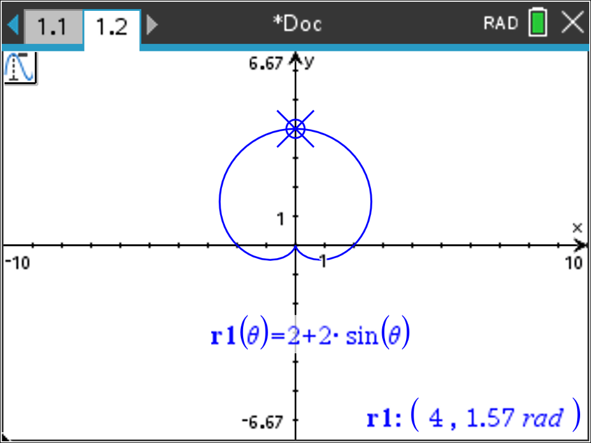  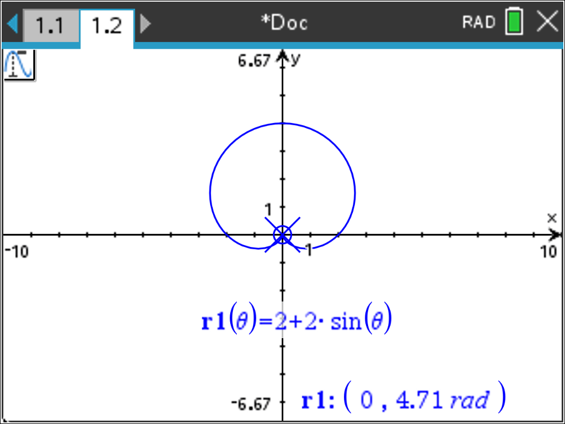
Teacher Tip: Students should edit the polar function in r1. They may want to move the Trace cursor back to $θ=0.$
- The graph of the sinusoidal function $f\left(x\right)=1+2*sin\left(x\right)$ on the interval $0≤x≤2π$ is shown below. The x-scale is π/6.  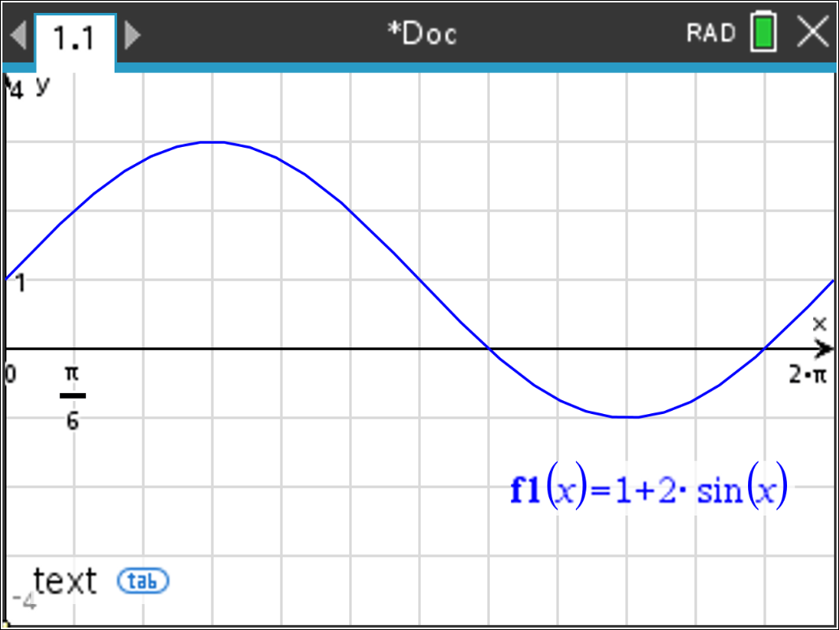  Graph the limaçon given by $r1(θ)=1+2*sin\left(θ\right)$. Trace along the graph of the limaçon. Observe the change in the r and θ values. Explain why the polar curve $r=1+2sin\left(θ\right)$ has an inner loop in the interval $\frac{7π}{6}≤ θ ≤\frac{11π}{6}$ ($θ$ between $≈3.67 rad$ and $≈5.76 rad)$.  Answer: The graph of the sinusoidal function has negative y-values in the interval $\frac{7π}{6}< θ<\frac{11π}{6}$. These correspond to the negative r-values of the polar function and form the inner loop of the limaçon. The limaçon graph passes through the pole at $θ=\frac{7π}{6}≈3.665…$ and $θ=\frac{11π}{6}≈5.759….$ |  |  | 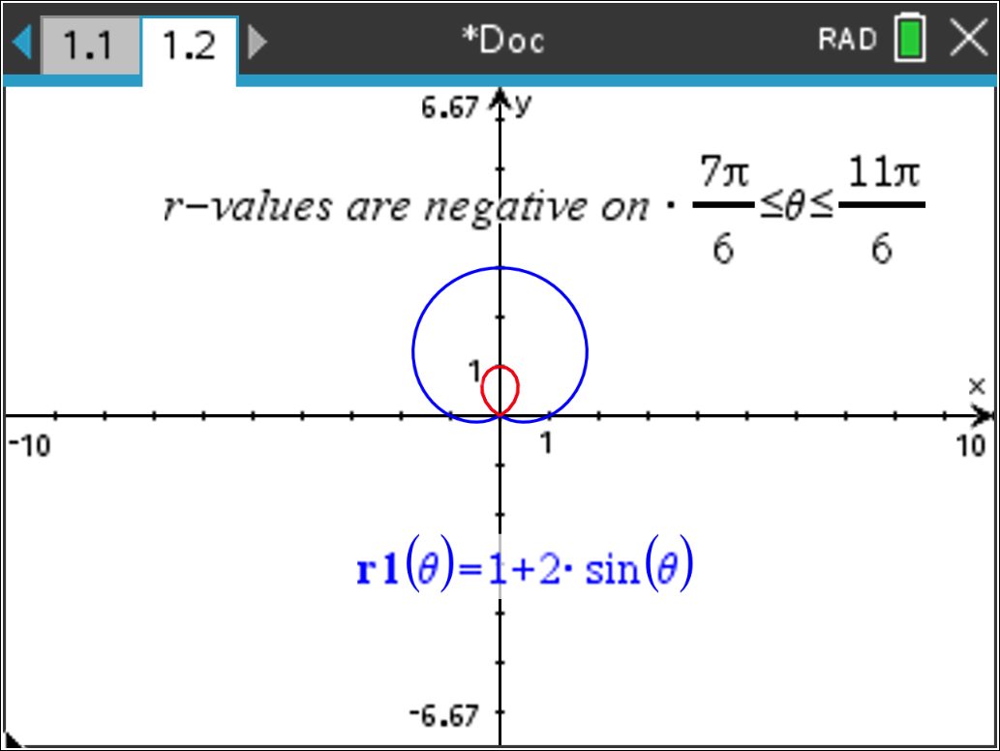  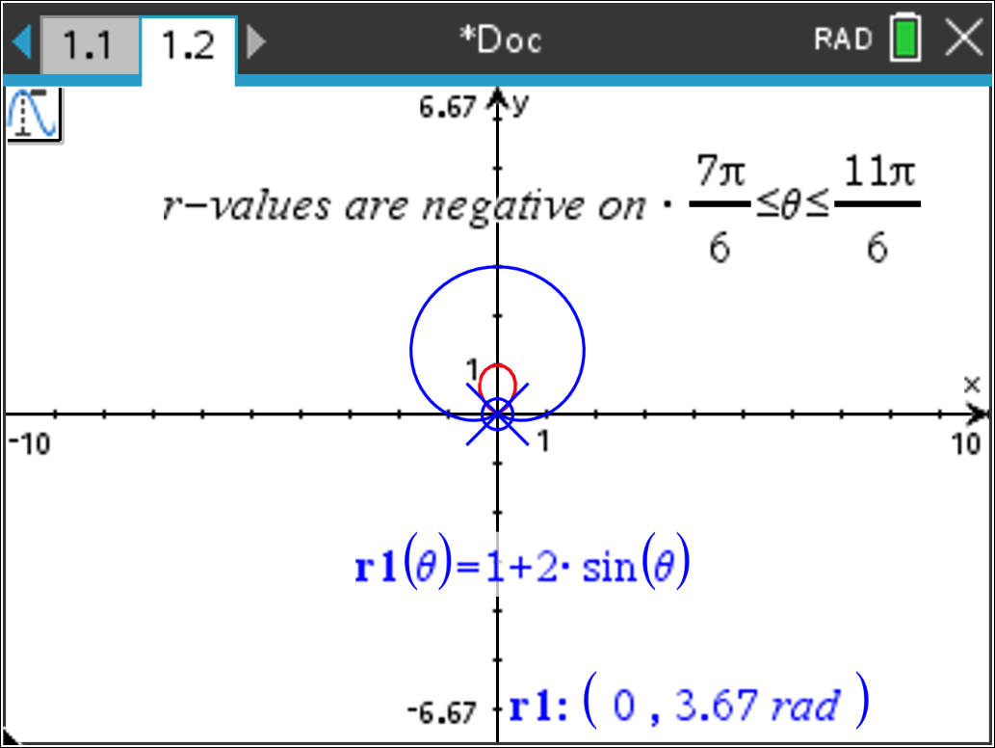  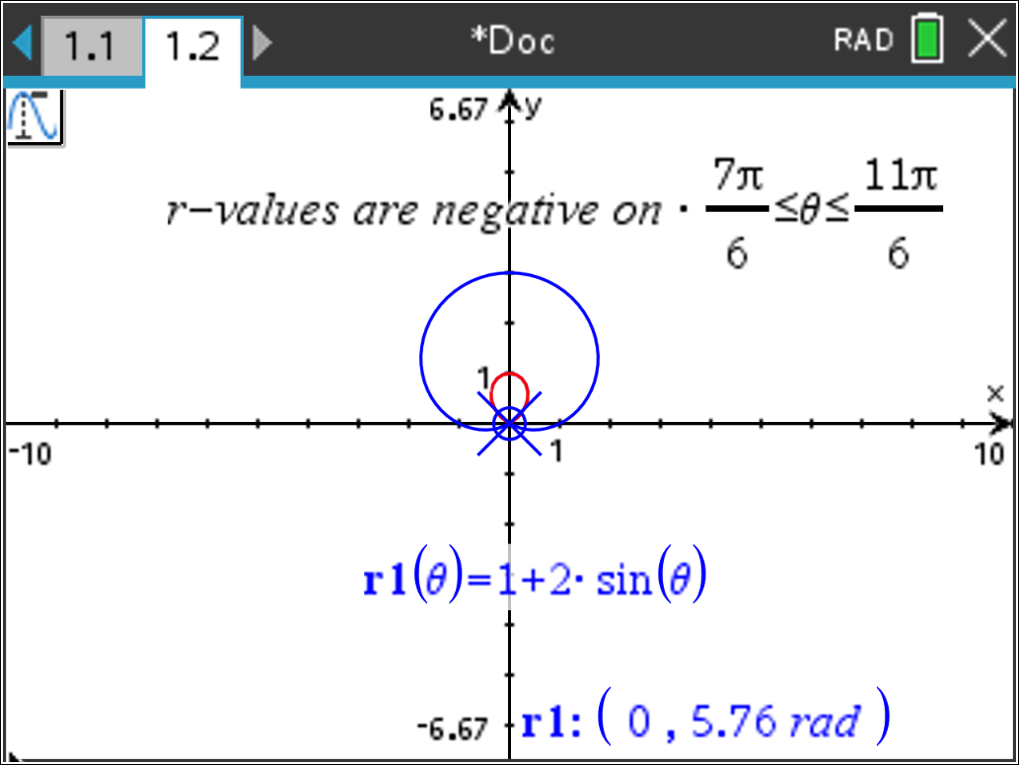
Teacher Tip: While tracing around the limaçon, $r=0$ may not appear. Mention that a display of a value such as R = 7.252E-10 is approximately zero. Students may want to set the Trace Step to π/12.

- The graph of the sinusoidal function $f\left(x\right)=2+1*sin\left(x\right)$ on the interval $0≤x≤2π$ is shown below. The x-scale is π/6.  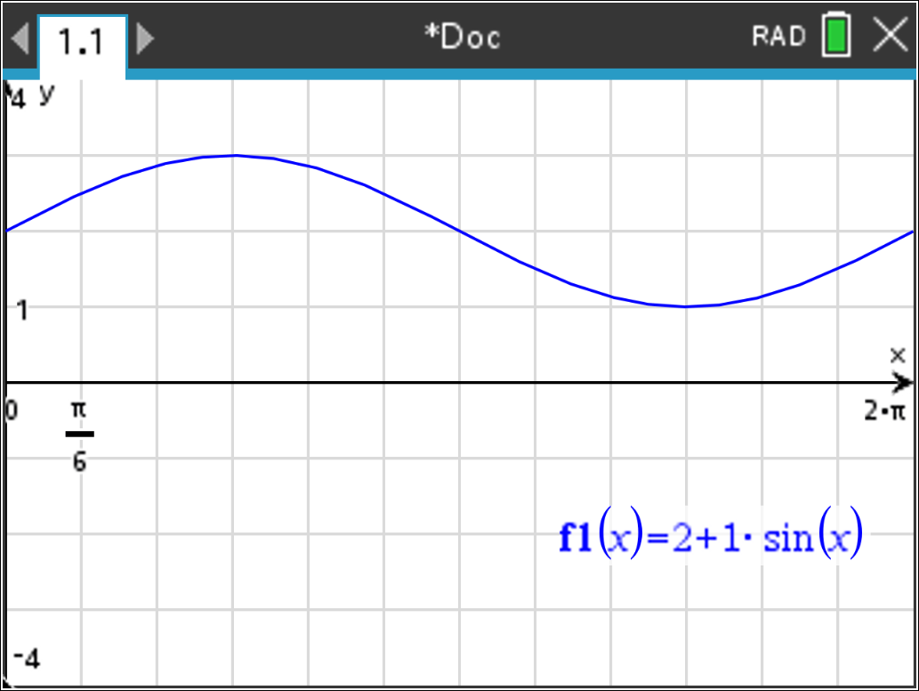  Graph the limaçon given by $r1(θ)=2+1*sin\left(θ\right)$. Trace along the graph of the limaçon. Observe the change in the r and θ values. Explain why the polar curve does not contain the point located at the pole.  Answer: The graph of the sinusoidal function has positive y-values for the entire interval $0≤ θ ≤2π$. These correspond to the positive r-values of the limaçon. Since $r≠0$, the limaçon does not pass through the pole. |  |  | 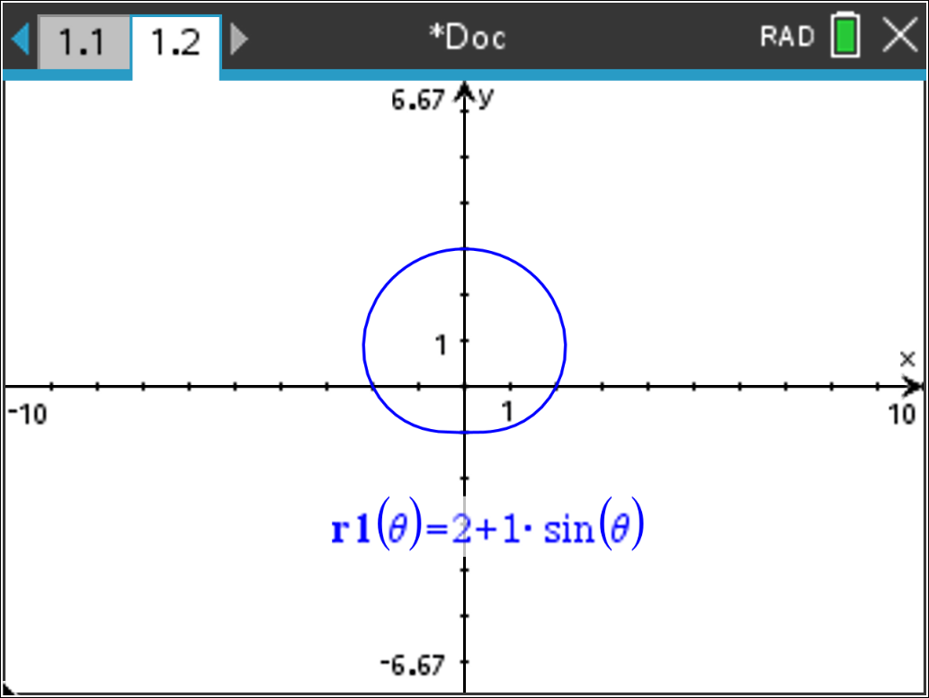

Wrap Up
Upon completion of the discussion, the teacher should ensure that students understand:
- The general form of the equation for polar limaçon curves.
- How each of the parameters of the equation affects the graph of the limaçon curve.
- That the type of limaçon curve can be determined by the ratio of a and b.
- There are four different shapes of limaçon curves.
- How the equation of a limaçon curve is related to the equation of a sinusoidal function.

