Name: Date:

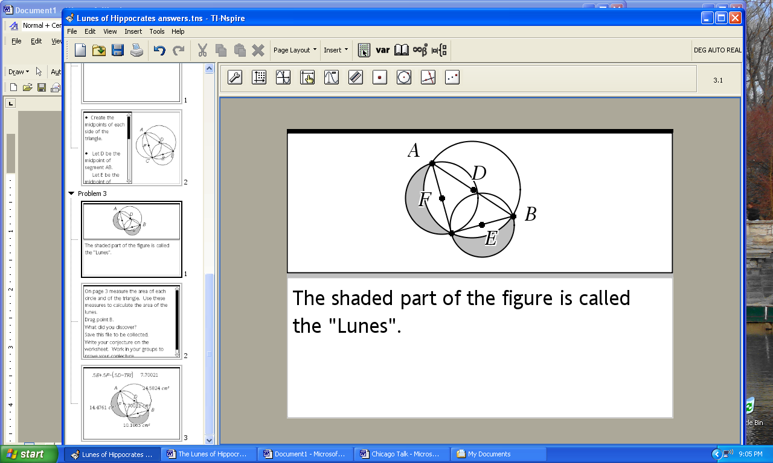

In this activity you will investigate an historical figure called The Lunes of Hippocrates.
The shaded regions in the figure above show the lunes.

Do you think there is anything special about the lunes? Discuss your answer with your group.

- Open the document “Lunes of Hippocrates”. Look at ΔABC. What kind of a triangle is ΔABC?
There are at least 4 ways you could convince me of your answer. Discuss the different methods with your group. On pages 2-5 on your handheld, show me at least three different methods.

- Go on to Problem 2 and follow the steps to create the figure.

- Go on to Problem 3. Write you conjecture below.

- Do you think your conjecture is true for all kinds of triangles? Insert a new problem and investigate different kinds of triangles? Summarize your results.

- Write your conjecture about the lunes and prove your conjecture.

Conjecture:

Proof:

6. Save and submit your document.

