Math Objectives  - Students will identify the effects of changing the sides and angles on the sine, cosine, and tangent ratios.  - Students will apply the properties of similar triangles to develop the definitions of trigonometric ratios in right triangles.  - Students will connect the terms sine, cosine, and tangent with appropriate ratios in a right triangle.  - Students will construct arguments and defend their reasoning with mathematical examples and counterexamples.  Vocabulary  - sine ● cosine  - tangent ● hypotenuse  - adjacent leg ● opposite leg  - similar right triangles  About the Lesson  - This lesson involves manipulating the angles and sides of a right triangle.  - As a result, students will:  - Observe the conditions under which the ratio does not change.  - Define the trigonometric ratios of sine, cosine, and tangent.  TI-Nspire™ Navigator™  - Send out the Trig_Ratios.tns file.  - Monitor student progress using Class Capture.  - Use Live Presenter to spotlight student answers.  Activity Materials  - Compatible TI Technologies: TI-Nspire™ CX Handhelds, TI-Nspire™ Apps for iPad®, TI-Nspire™ Software | 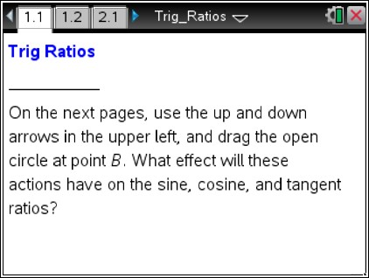  Tech Tips:  - This activity includes screen captures taken from the TI- Nspire CX handheld. It is also appropriate for use with the TI- Nspire family of products including TI-Nspire software and TI-Nspire App. Slight variations to these directions may be required if using other technologies besides the handheld.  - Watch for additional Tech Tips  throughout the activity for the specific technology you are using.  - Access free tutorials at  http://education.ti.com/ calculators/pd/US/Online- Learning/Tutorials  Lesson Files:  Student Activity  - Trig_Ratios_Student.pdf  - Trig_Ratios_Student.doc  TI-Nspire document  - Trig_Ratios.tns

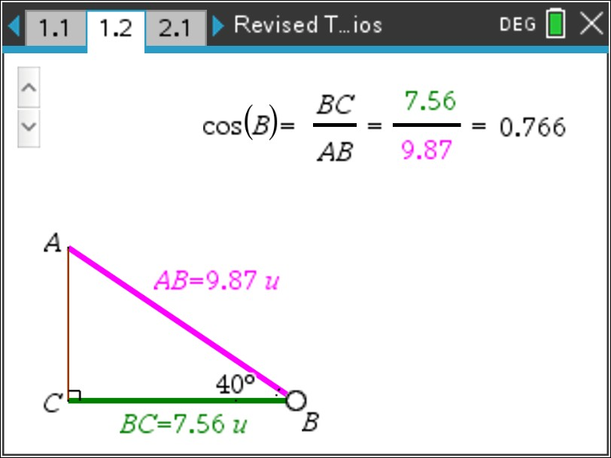

Discussion Points and Possible Answers
Tech Tip: If students experience difficulty dragging a point, check to make sure that they have moved the cursor until it becomes a hand (÷) getting ready to grab the point. Select / x to grab the point and close
the hand ({).

Move to page 1.2.

- Use the up and down arrows in the upper left.

  - What measures shown on ABC stay the same?

Answer: BC and m∡C (right angle)
b. What measures shown on ABC are changing?

Answer: m∡B and AB; AC and m∡A
2. a. Observe all the triangles you see as you select the up and down arrows. Are all of the triangles similar? Explain your thinking.

Answer: No, the triangles are not similar. The ratios of the side lengths are changing, and for triangles to be similar, these ratios must stay the same. Also, in similar triangles, the angle measures of corresponding angles must be congruent. The corresponding angles in each triangle change as you select the up and down arrows, so the triangles cannot be similar.
Teacher Tip: Encourage students to construct arguments and defend their reasoning by considering examples and counterexamples for their arguments. For example, if students say that not all of the triangles are similar, ask students whether some of the triangles are similar. Can students think of any possible examples of triangles on page 1.2 which might be similar? If not, have students think about how they would need to
modify this model in order to obtain some examples of similar triangles.

TI-Nspire Navigator Opportunity: Class Capture
See Note 1 at the end of this lesson.
b. What do you observe about the ratio BC : AB as you select the up and down arrows?

Answer: This ratio is changing.
- Drag the open circle at point B.

  - What measures shown on ABC stay the same?

Answer: All the angle measures stay the same.
b. What measures shown on ABC are changing?

Answer: The length of each side changes.
c. What is the measure of ∡A? Explain how you found this measure.

Answer: m∡A = 90° – m∡B. Explanations may vary.
Teacher Tip: Provide students an opportunity to notice that angles A and B are the acute angles of the triangle.
4. a. Observe all the triangles you see as you drag the open circle at B. Are all of the triangles similar? Explain your thinking.

Answer: Yes, corresponding angles are congruent. (Students may also mention that corresponding sides are proportional.)
b. What do you observe about the ratio BC : AB as you drag the open circle at B?

Answer: This ratio stays the same.

5. When will the ratio of BC : AB be constant even though AC , BC , and AB change?

Answer: The ratio will stay the same as long as the measures of the angles remain constant.
6. The side of a right triangle opposite the right angle is called the hypotenuse. The leg that has point B as one of its endpoints is called the side adjacent to ∡B, and the other leg is called the side opposite ∡B.
The ratio BC : AB is called the cosine of angle B and is written as cos B.
a. Describe cos B as a ratio, using the terms measure of hypotenuse, measure of adjacent leg,
and/or measure of opposite leg.

Answer: 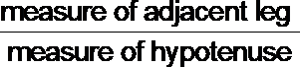
b. Express cos A as a ratio using the side lengths AC, AB, and/or BC of the triangle on page 1.2.
Answer: AC

AB
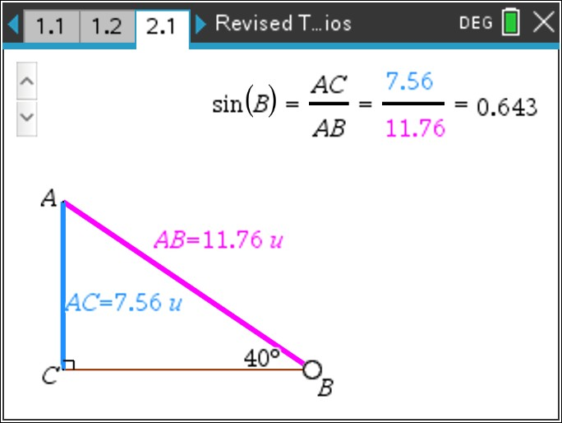
TI-Nspire Navigator Opportunity: Quick Poll
See Note 2 at the end of this lesson.
Tech Tip: Once you use the up and down arrows on the slider – make sure you release the slider by hitting the esc key. This will allow you to move the open circle ONLY.

Move to page 2.1.

7. Use the up and down arrows and drag the open circle at point B. When is the ratio of AC : AB constant even though AC , BC , and AB change?

Answer: The ratio is constant when the measure of the angles is constant.

- The ratio AC : AB is called the sine of angle B and is written as sin B.

  - Describe sin B using the terms measure of hypotenuse, measure of adjacent leg, and/or measure of opposite leg.
Answer: measure of opposite leg measure of hypotenuse
b. Express sin A as a ratio using the side lengths AC, AB, and/or BC of the triangle on page 2.1.
Answer: BC

AB
TI-Nspire Navigator Opportunity: Quick Poll
See Note 3 at the end of this lesson.
Move to page 3.1.

9. Use the up and down arrows and drag the open circle at point B. When is the ratio AC : CB constant even though AC , BC , and AB change?

Answer: The ratio is constant when the measure of the angles is constant.
- The ratio AC : CB is called the tangent of angle B and is written as tan B.
  - Describe tan B using the terms measure of hypotenuse, measure of adjacent leg, and/or measure of opposite leg.

Answer: measure of opposite leg measure of adjacent leg
b. Express tan A as a ratio using the side lengths AC, AB, and/or BC of the triangle on page 3.1.

Answer: BC

AC
11. What is the connection between similarity of right triangles and the sine, cosine, and tangent ratios?

Answer: Similar right triangles will have the same sine, cosine, and tangent ratio values for
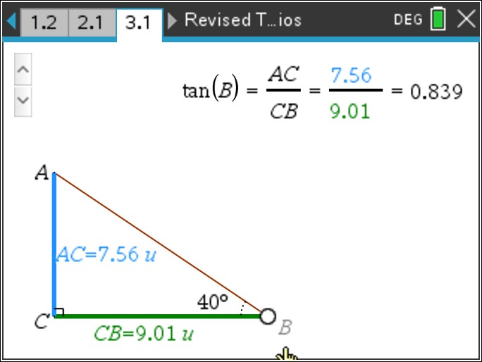

corresponding angles because their corresponding side lengths form a proportion.

Extension:
Have students move back to page 2.1.

On this page, students found that sin B = AC : AB.

- a. Write an expression for cos A.
  - What is the relationship between angles A and B?

Answer: Students should notice that cos A = sin B and that angles A and B are complementary.

Have students move back to page 1.2.

On this page, students found that cos B = BC : AB.

- a. Write an expression for sin A.
  - What is the relationship between angles A and B?

Answer: Students should notice that cos B = sin A and that angles A and B are complementary.

- In right triangle ABC with right angle C and sin A = 5/13, what is cos B?

Answer: cos B = 5/13

Wrap Up
Upon completion of the discussion, the teacher should ensure that students understand:
- Trigonometric ratios in right triangles are based on similarity.
- The ratio of the measure of the side opposite an acute angle of a right triangle to the measure of the hypotenuse of that right triangle is called the sine of that acute angle.
- The ratio of the measure of the side adjacent to an acute angle of a right triangle to the measure of the hypotenuse of that right triangle is called the cosine of that acute angle.
- The ratio of the measure of the side opposite an acute angle of a right triangle to the measure of the side adjacent that acute angle is called the tangent of that angle.

Assessment

A right triangle has vertices P, Q, and R. The right angle has vertex at point R. The hypotenuse ( PQ ) measures 5 units. Leg PR measures 3 units and leg RQ measures 4 units. Sketch this triangle and find the following:
sin P, sin Q, cos P, cos Q, tan P, tan Q

Answers: sin P = 4
5
, sin Q = 3
5
, cos P = 3
5
, cos Q = 4
5
, tan P = 4
3
, tan Q = 3
4

Note 1
TI-Nspire Navigator

Question 2a, Class Capture: Take a Class Capture as students are changing the angle so that they can see multiple triangles at the same time that have the same measure for a leg but different angle measures to verify that the triangles are not similar.

Note 2
Question 6b, Quick Poll: Send students an Open Response Quick Poll: In triangle ABC, what is cos A if AB = 17 and BC = 8?

Answer: 15
17

Note 3
Question 8b, Quick Poll: Send students an Always/Sometimes/Never Quick Poll: In triangle ABC, sin A = sin B.

Answer: Sometimes. The ratios will be equal when the triangle is a right isosceles triangle.

