Algebra Date ____ Hour ____ Name ______________________

What’s My Equation Quad 2

For each problem you are to press TAB or Ctrl G to get a function entry line. Arrow down to the second line which says f2(x)= and enter in the values that correspond to the equation y = a *(x-b)²+c. Keep changing them until your parabolas are the same.
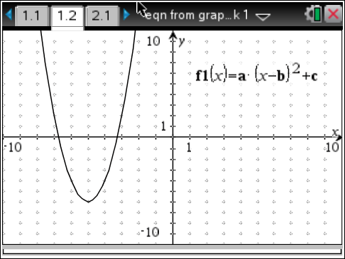  Equation _____________________________ | 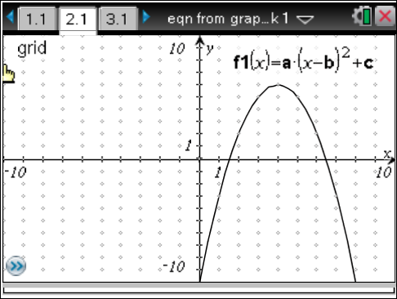  Equation _____________________________
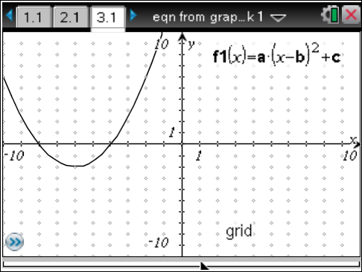  Equation _____________________________ | 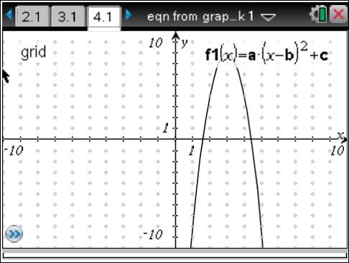  Equation _____________________________
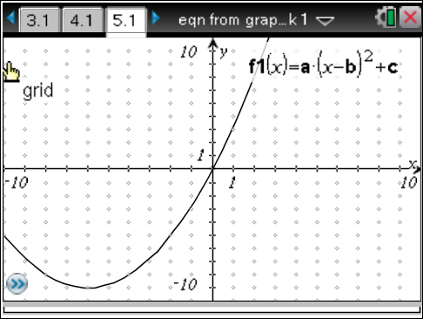  Equation _____________________________ | 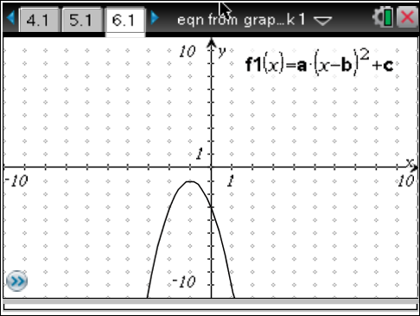  Equation _____________________________
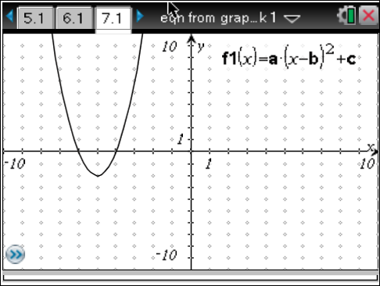  Equation _____________________________ | 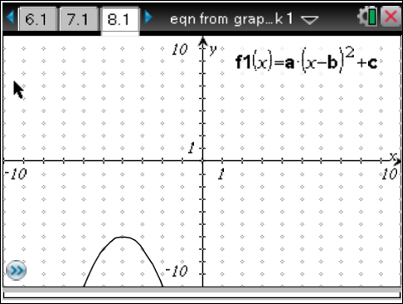  Equation _____________________________
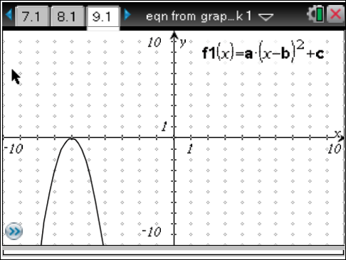  Equation _____________________________ | 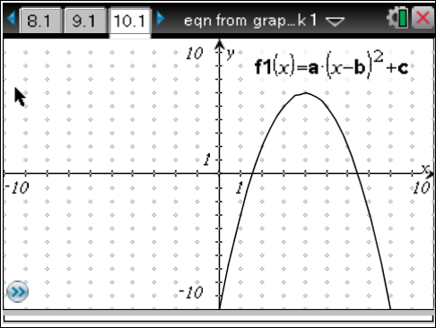  Equation _____________________________
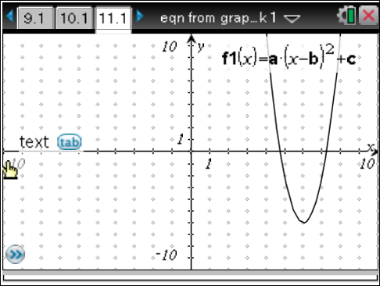  Equation _____________________________ | 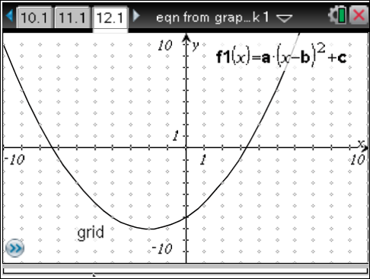  Equation _____________________________

