Activity Overview
In this activity you will match your motion to a given graph of position versus time and to a graph of velocity versus time. You will apply the mathematical concepts of slope and y-intercept to a real-world situation.
Materials
- TI-Nspire™ CX II or TI-Nspire™ CX handheld or TI-Nspire™ CX Premium Teacher Software
- CBR™ 2 motion sensor
- USB CBR 2-to-calculator cable
Note: To plug the CBR 2 into the computer, a mini-standard USB adaptor is needed.

Part 1—Step-by-step Setup
To utilize the built-in, easy-to-use Motion Match feature, first turn on the TI-Nspire CX II handheld. Open a New Document, and press d. Then, plug in the CBR 2. The Vernier DataQuest™ app for the TI-Nspire CX will automatically launch. The position displayed is the distance from the CBR 2 to the closest object.  - Hold the CBR 2 so that it points toward a smooth surface like a wall or door. Move forward and backward to observe the reading changes.  - How far are you from the wall? _________  Record all the digits that are given, as well as the units.  - You will set up an experiment for 10 seconds. Move the cursor over the Duration area on the left side of the screen and click. A dialog box will appear. Change the duration to 10 seconds, and press · or click OK. | 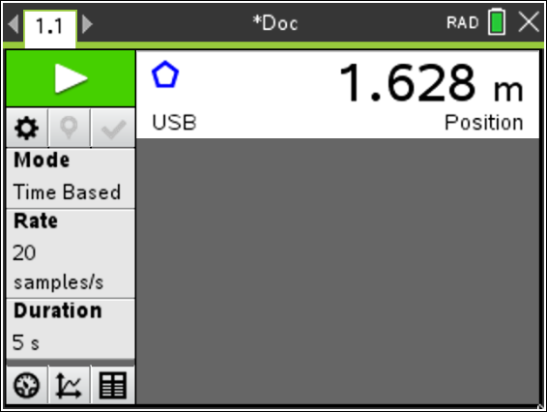  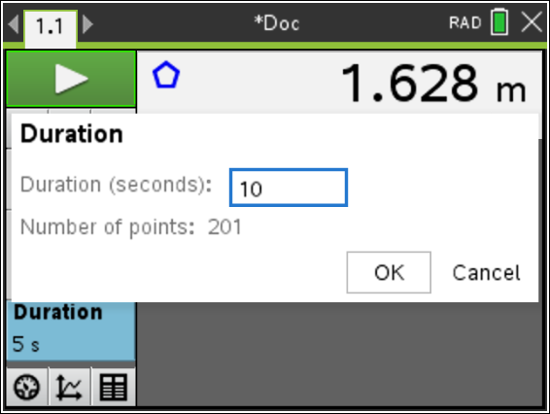

- Select Menu > View. There are three views. The first view displayed was Meter. Choose the Graph View for additional menu options. (Alternatively, click on the Graph View icon at the bottom of the screen.)  Part 2 – Position Match  - Press Menu > Analyze > Motion Match > New Position Match. (Alternatively, hover over the graph, and press ctrl > Menu > Motion Match > New Position Match.)  A graph should be displayed.  - Before walking, draw your Position Match graph on the grid to the right.  - Describe the motion necessary to match the position versus time graph displayed on your handheld. |  | 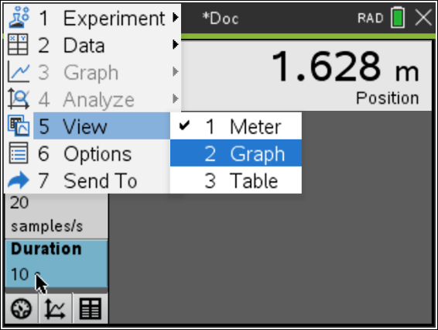  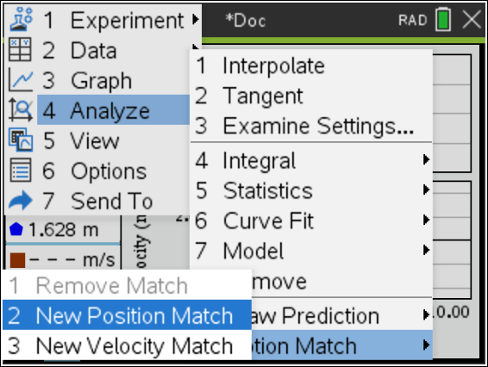  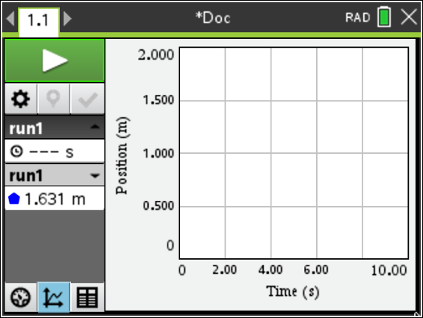
- Record your observations about the graph by answering the following questions:
- What is the y-intercept?

- What does the y-intercept represent physically?

- At approximately what distance from the wall should the motion detector be located to match the initial position in the motion graph?

- The slope is the change of position with respect to time or the velocity of the walker. Between what times does the graph depict the slowest motion? Between what times does the graph depict the fastest motion?

- Is there a time when the walker should stand still? If so, when is that time?
- Click the Start Collection arrow in the upper-left corner of the screen. Point the CBR 2 at a wall, and move back and forth until your graph matches the Position Match graph as closely as possible. If you are not pleased with your first attempt, press Enter to try again. You may want to review the information that you wrote about the graph to assist you.

- Describe the parts of your graph that were difficult to match and any adjustments, based on your graph of your walk, made to make a better match in the next attempt.
Now, look at the graph shown at the right.  - Describe how you would need to walk in order to match that graph with your motion. Be sure to include information about the y-intercept, position at various times, velocity, and direction. For what times does the graph depict the slowest motion? The fastest motion?  - Describe the graph with the round dots that was created by a walker. Contrast the graph of position versus time that should have been created with what actually happened. Write at least two observations. |  | 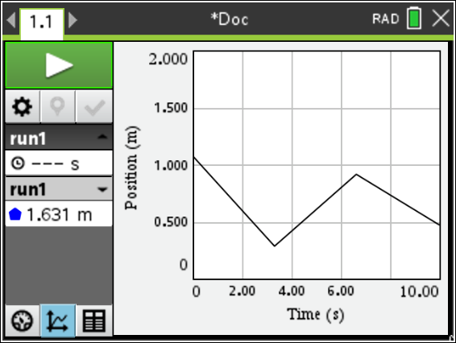  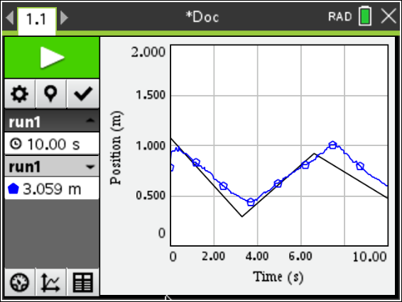
Part 3—Extend and Explore
- To display a new Position Match, press Menu > Analyze > Motion Match > New Position Match.

- Consider how to walk to match the graph.

- Click Start Collection, and walk to match the graph.

- If you are not pleased with your first attempt, press Enter to repeat.

- Discuss your new match with a classmate.
Part 4 – Velocity Match
- Press Menu > Experiment > New Experiment. If asked if data should be cleared, select Yes.

- Move the cursor over the Duration area on the left side of the screen and click. A dialog box will appear. Change the duration to 10 seconds, and press · or click OK.

- Select Menu > View. Choose the Graph View for additional menu options. (Alternatively, click on the Graph View icon at the bottom of the screen.)
- Press Menu > Analyze > Motion Match > New Velocity Match.  - Draw your Velocity Match graph on the grid to the right.  - Before walking, describe the motion necessary to match the velocity versus time graph displayed on your handheld. | 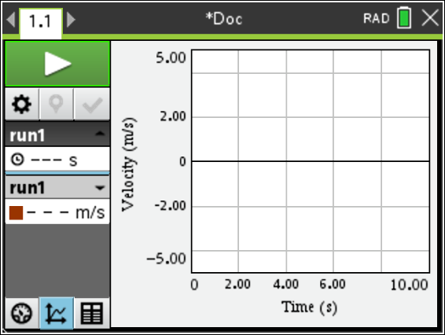
- Click the Start Collection arrow in the upper-left corner of the screen and walk to match the velocity versus time graph.

- To try again with the same graph, press Enter.

- Describe the parts of the graph that were difficult to match, and any adjustments made to make a better match in the next attempt.

- Select other Velocity Match graphs to match. For each Velocity Match graph, first describe the motion necessary to match the graph displayed on your handheld.

Challenge:  An example of a velocity versus time graph is shown at the right. How should a person move to match this graph? | 