Focus: Read data in a picture graph.
Reading Picture Graphs
Collecting and Organizing Data
Favorite Fruit
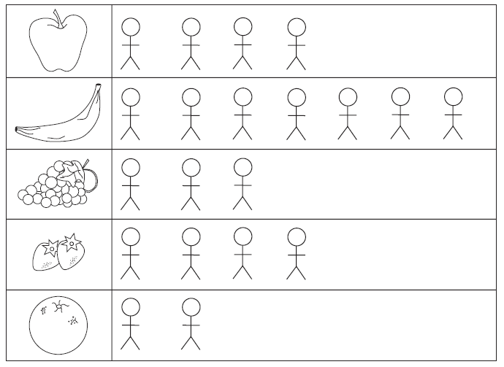
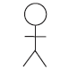means 5 children
Patterns we found while we were doing this activity:

