Math Objectives  - Students will use multiple-linked, geometric (2D and 3D), and numeric representations to model a classic optimization problem.  - Students will make sense of problems and persevere in solving them.  - Students will model with mathematics. (CCSS Mathematical Practice).  Vocabulary  - optimization • maximum  - volume • rate of change  About the Lesson  - This lesson takes the classic optimization box problem and uses multiple mathematical representations to maximize the volume of the box.  - As a result, students will:  - Create an algebraic model from geometric parameters.  - Create a volume function from the algebraic model.  - Find the maximum volume of a box based on the length of the side of the squares cut from each corner of a given piece of cardboard.  TI-Nspire™ Navigator™  - Transfer a File.  - Use Class Capture to examine patterns that emerge.  - Use Live Presenter to demonstrate.  - Use Teacher Edition computer software to review student documents.  - Use Quick Poll to assess students’ understanding  Activity Materials  Compatible TI Technologies: TI-Nspire™ CX Handhelds,   TI-Nspire™ Apps for iPad®,  TI-Nspire™ Software | 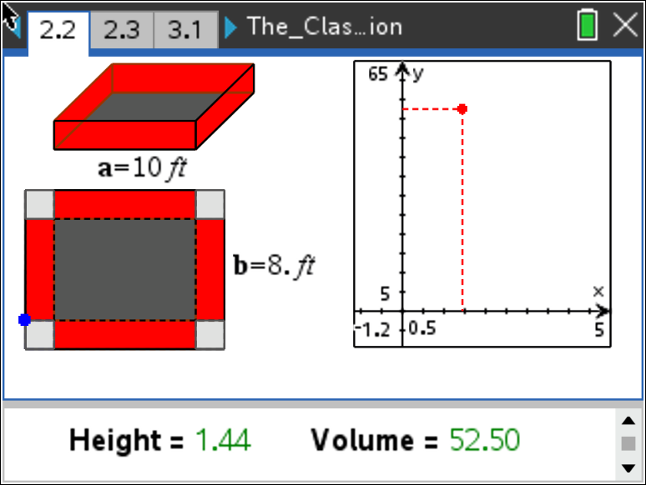  Tech Tips:  - This activity includes screen captures taken from the TI-Nspire CX II handheld. It is also appropriate for use with the TI-Nspire family of products including TI-Nspire software and TI-Nspire App. Slight variations to these directions may be required if using other technologies besides the handheld.  - Watch for additional Tech Tips throughout the activity for the specific technology you are using.  - Access free tutorials at http://education.ti.com/calculators/pd/US/Online-Learning/Tutorials  Lesson Files:  Student Activity  The_Classic_Box_Problem_Exploration_Nspire_Student.pdf  The_Classic_Box_Problem_Exploration_Nspire_Student.doc  The_Classic_Box_Problem_Exploration.tns
Open the TI-Nspire document The_Classic_Box_Problem_Exploration.tns.  In this activity, you will create an open-box by taking an 8 ft by 10 ft sheet, cutting out square corners with sides of length x, and then bending up the sides. The goal of this activity is to figure out how to determine the size of the squares that result in the largest volume for the box. | 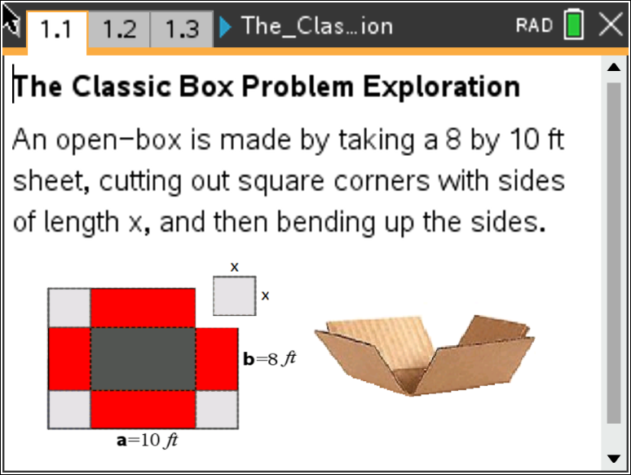
____________________________________________________________________________________

Problem 1 – Creating the Box

Move to page 1.3.

- Before we start the actual box problem, answer this question on page 1.3. If you graphed the volume versus length of x, what shape do you think the graph will take? Explain your choice.
Possible Solution: The function that best models the volume is a cubic, which would be the third graph, but this question should be used as a way to get students talking about what the volume function looks like and why they believe it to look that way. Open discussion is key here.

Move to page 2.1

Follow the directions on this page to help navigate through the box problem on page 2.2.

- As you observe what happens to the plotted values of volume versus length of x, discuss with a classmate why doesn’t the graph only increase. Record your discussion on page 2.3.
Possible Solution: Because the length, x, is affecting both the length, width, and height of the box. Changing each of these will dramatically change the shape of the resulting box. You must have a realistic domain to create the function. An x to small makes the box very shallow and wide, while an x to big makes the box deep and narrow. You are trying to find that optimal volume. Before that optimal volume, the graph will increase and after the optimal volume, it will decrease.

Move to page 3.1

Now, create a formula for volume of the box using the 8x10 ft sheet. With respect to x…

- What is the expression that represents width?

Solution: width = $(8-2x)$ or width = $(10-2x)$

- What is the expression that represents length?

Solution: length = $(10-2x)$ or length = $(8-2x)$

- What is the expression that represents height?
Solution: height = $x$

Move to page 3.2

- Put it all together. What is the function that represents the volume?
Solution: $V\left(x\right)=(10-2x)(8-2x)(x)$ or $V\left(x\right)=4x^{3}-36x^{2}+80x$

Move to page 3.3

Check your function by graphing it on the right side of this page, then grab the point on the left side of
the page and drag it to see if your function matches the data points. Explain what you notice.

Possible Solution: The point should follow along the function almost exactly, increasing before
the maximum and decreasing after the maximum. Students could discuss
how the rate of change of $V\left(x\right)$ is positive before the maximum and negative
after the maximum.

Tech Tip: On the graph side of the screen, press ctrl, G or tab to display $f2(x)$ and enter the equation of the model. If the model fits, when you grab and move the point on the sheet again, the dynamically-linked plot point on the right should trace out the graph!

Tech Tip: On the graph side of the screen, double tap in the open space to display $f2(x)$ and then enter the equation of the model. If the model fits, when you grab and move the point on the sheet again, the dynamically-linked plot point on the right should trace out the graph!

Problem 2 – Optimization of the Box Problem

A square of side x-inches is cut out of each corner of a 10 in. by 14 in. piece of cardboard and the sides are folded up to form an open-topped box. $V(x)$ represents the volume of the box formed with respect to $x$.

- Write the value of $V$ as a function of $x$.
Solution: $V\left(x\right)=x∙\left(10-2x\right)∙(14-2x)$ or $V\left(x\right)=4x^{3}-48x^{2}+140x$

- State the domain of the function $V(x)$.
Solution: $0<x<5$ (This needs to be found using one half the smaller length of the
cardboard. If it is larger than 5, one side of the box would not exist.)

- Graph the function to find the maximum volume of the box. What is the maximum volume and what value of $x$ gives the maximum volume?

Solution: Maximum Volume: $120.164 {in.}^{3}$
The $x$-value that gives the maximum volume: $1.918 in.$
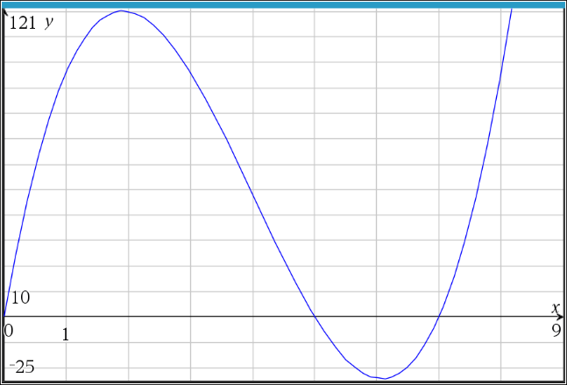

- How can you tell that this is the maximum value? Explain what is happening to the function, $V(x)$, before this maximum value and after the maximum value.

Solution: The function, $V(x)$, is increasing before the maximum, which means that the rate of
change of the function is positive. The function is decreasing after the maximum,
which means that the rate of change of the function is negative.

